(3) Steaming and curving solid wood

Objectives
This module was prepared as part of the All Hands On Deck (AHOD) project, activity IO2A3. The substantive transmission of the manual is the absolute minimum of sailing knowledge necessary to build a small boat in workshop conditions. This portion of the message should be assimilated by every hobbyist of sailing. This is also what every enthusiast of this sport should know to understand roughly the principles of sailing boat construction. Every sailing enthusiast should improve their skills, looking for the best technique for building their dreamboat. This can be learned in two ways: either through practice or from public experience. For those who prefer the desire to acquire reliable knowledge over to the written word, further chapters are intended.

Duration
All model duration was estimated to be 30 hours. Below, the module was divided into specific subitems, according to the duration of every individual topic:
- Unit 1. Acquire theoretical basic knowledge about curve elements in wooden boats (3),
- Unit 2. Knowing methods of making wooden curves elements for ships and boats (2),
- Unit 3. Knowledge about use naturally curved elements of trees in ship and boat constructions (1),
- Unit 4. Acquiring knowledge about cutting and gluing wood and wood-based materials to obtain curvilinear elements (2),
- Unit 5. Acquiring knowledge about bending of wood by steaming in order to obtain curvilinear elements of the skeleton and planking of ships and boats (4),
- Unit 6. Theoretical knowledge about changes occurring in wood during the steaming and control of steaming process (2),
- Unit 7. Knowledge about tools and equipment using in bending process (5),
- Unit 8. Bending of steamed wood on moulds (frames) and on hull (planks) (8),
- Unit 9. Gaining knowledge on assembly, joining and fastening of bent elements (3).

Outcomes
Autcomes of the module as bullet points.
- Outcome 1:
- Outcome 2:
- …

Training content

Practices

Theory

(please remember to refresh the summary by right clicking on it > “actualising” when the coursebook is finished)

Summary
(3) Steaming and curving solid wood 1
Objectives 1
Duration 1
Outcomes 1
Training content 1
Practices 2
Theory 2
Summary 3
Unit 1. Acquire theoretical basic knowledge about curve elements in wooden boats 6
1.1. The concept of bending 7
1.1.1. Bending moment 7
1.1.2. Moment of inertia 10
1.2. Bending strength 10
1.1.3. Strength index 10
1.1.4. Beam deflection 12
1.2. Mechanics of Bending 13
Unit 2. Knowing methods of making wooden curves elements for ships and boats 18
2.1. The process of wood bent 19
2.2. Selecting bending stock 21
2.3. Seasoning bending stock 23
Unit 3. Knowledge about use naturally curved elements of trees in ship and boat constructions 24
3.1. Ancient uses of thermo-hydro-mechanical processes 24
2.3 THM-processing in the construction of wooden vessels 30
2.5 The industrialization of solid wood bending 37
Unit 4. Acquiring knowledge about cutting and gluing wood and wood-based materials to obtain curvilinear elements 38
4.1. Wood cutting 38
4.1.1. Saw teeth opening 39
4.1.2. Sharpening the teeth of the saw. 39
4.1.3. Teeth alignment 40
4.1.4. Tools for finishing operations 41
4.1.5. Mechanical tools 43
4.2. Gluing wood 46
4.3. Wood bending 47
Unit 5. Acquiring knowledge about bending of wood by steaming in order to obtain curvilinear elements of the skeleton and planking of ships and boats, 51
5.3. Wood Modification 51
5.1.1 Reasons for thermo-hydro-mechanical processing 52
5.1.2 Modification of wood 53
5.3.3 Chemical modification 54
5.3.4 Thermo-hydro and thermo-hydro-mechanical modification of wood 55
5.4. Thermo-hydro wood processing 58
5.5. Thermo-hydro-mechanical wood processing 61
5.6. Bending of solid wood in woodland craft 64
Unit 6. Theoretical knowledge about changes occurring in wood during the steaming and control of steaming process 66
6.1. Common techniques of bending wood 67
Unit 7. Knowledge about tools and equipment using in bending process, 69
7.1. Machining bending stock 69
7.3. Plasticizing With Chemicals 73
7.4. Bending With End Pressure 74
7.5. Bending Laminated Members 79
7.6. Types of Bending Failures 80
7.7. Removal of Discolorations Caused in Bending 83
7.8. Repair of Pieces Damaged in Bending 84
7.8. DRYING AND FIXING (SETTING) THE BEND 84
7.9. Effects of Drying and Fixing 86
7.10. Conditions for Drying Bent Stock 88
7.11. Behavior of Bent Members 89
Unit 8. Bending of steamed wood on moulds (frames) and on hull (planks), 90
8.1. Types of planking 90
8.1.1. Clinker-built planking 90
8.1.2. Carvel planking 94
8.1.3. Strip planking 96
8.1.4. Cold-moulded planking 96
8.1.5. Double planking 97
8.1.6. Epoxy Strip Planking 98
8.2 The Planking Process 101
8.2.1. Lining out the sheer planking 102
8.2.2. Fitting the forward port sheer strake 105
8.2.3. Fastening the sheer strake 108
8.2.4. Fitting a butt block 109
8.2.5. Seam bevels 110
8.2.6. The spilling batten 112
8.2.7. The planking process from the garboard up 113
8.2.8. Fitting the garboard plank 116
Unit 9. Gaining knowledge on assembly, joining and fastening of bent elements. 121
9.1. Parallel connections 121
9.1.1. Connecting with a notch 121
9.1.2. use of nails 124
9.1.3. Drilling and riveting 126
Literature 133

Unit 1. Acquire theoretical basic knowledge about curve elements in wooden boats
In the beginning, reference should be made to the specialized language used by sailors. Each sailing yacht consists of a hull with bodywork and accessories. These are the parts that are used to set it in motion and maneuver it (poles, ropes, sails). The front of the yacht is called the bow, the rear stern, and the sides of the yacht, while the right and left sides are the ones we see on the right and left looking from the stern to the bow. All parts of the hull and gear are named. This script only contains selected terminology, without which further explanations would not be transparent. The basic terminology describing a single-mast sailing yacht was presented in Figure 1.

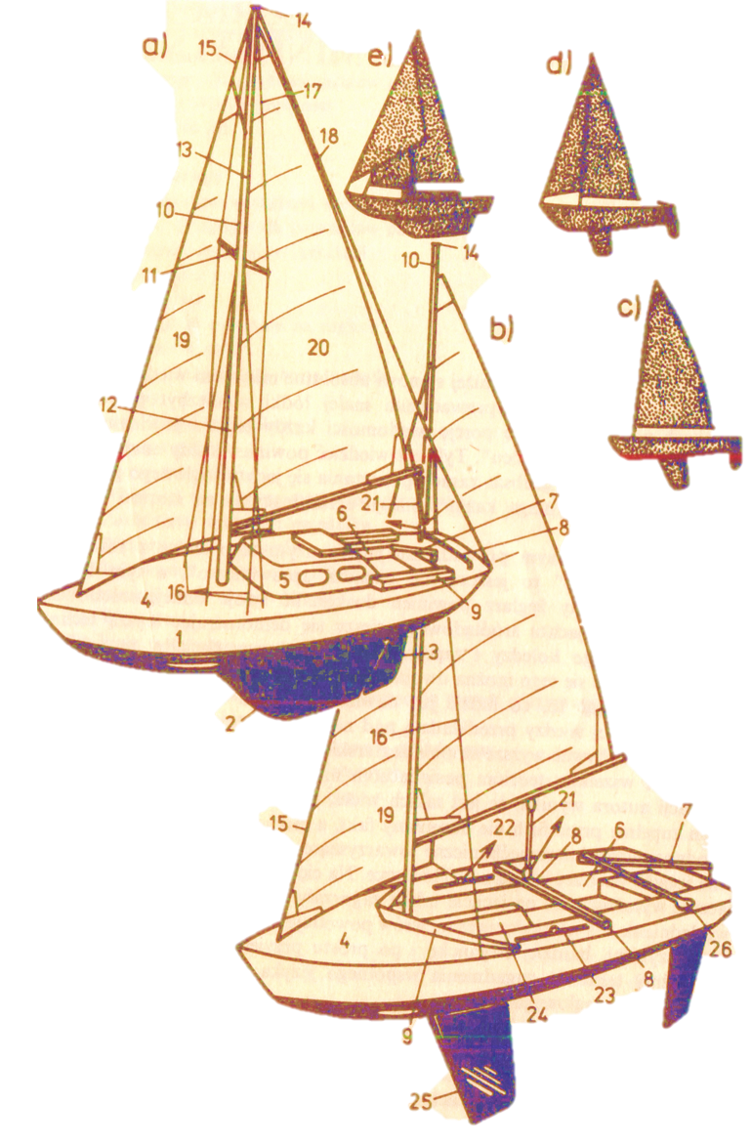
Figure 1. Single-mast sailing yacht a) ballast sea yacht, b) daggerboard, c) ket, d) sloop, e) cutter. 1 - hull, 2 - ballast fin, 3 - rudder, 4 - deck, 5 - superstructure, 6 - cockpit, 7 - tiller, 8 - mainsail guide, 9 breakwater, 10 - mast, 11 - spreader , 12 - mast pillar, 13 - stenga, 14 --- masthead, 15 - stays, 16 - twigs, 17 - topwings, 18 achterstag, 19 - jib (jib), 20 - mainsail (mainsail), 21 - mainsail sheet, 22 - jib sheet, 23 - kips, 24 sword chest, 25 - sword, 26 - tiller extension.
Source:

Everything mentioned above applies to a sailing yacht. The sailing yacht can be considered as any watercraft used for tourist and sports purposes, the main propulsion of which are sails, i.e. one that, using only this means of propulsion, is able to safely and effectively sail in the water area and in meteorological conditions as defined in its safety documents regardless of the type and performance of other propulsion means installed on it (auxiliary engine, oars). Pursuant to the above definition, we will not consider as a sailing yacht a vessel admitted to Baltic navigation without restrictions, which is not able to effectively manoeuvre on sails above a certain wind force and must use an auxiliary engine for this purpose. However, we will call any small sailboat a yacht as long as it meets the above requirement.

1.1. The concept of bending

1.1.1. Bending moment
The structure of the boat is based on its streamlined shape during the design. This is the result of a physical approach that used the available laws and axioms, allowing the prepared boat to move in relation to the water plane. The basic laws of physics are responsible for all stages, from speeding the boat to its steering, which is why adjusting the dimensions, curvature and displacement is so important during designing.
One of the basic machining processes that result in shaping the boat is bending. This process is the result of the deformation of the material that has been subjected to the action of two pairs of forces with equal moments and opposite directions. Theoretically, the bending moment in any section of the beam is the algebraic sum of the moments of all external forces acting in a separate element of the section under consideration. The beam loaded with the active force F, in which the reactions at points A and B arose, are shown in Figure 1.

Figure 2. The beam subjected by the active F and passive R_{a} i R_{b} forces

The bending moment is the moment, that added in the beam section maintains its equilibrium. By mentally cutting the beam into two equal parts, the force Ra and the counterbalancing (opposite) force T act on the left, creating a pair with the moment Ra x. In order to prevent rotation of the separated part, a pair of forces must occur with the moment M, equal to Ra x. just the opposite. A pair of forces can only be balanced by the second pair of forces with an equal and opposite momentum. We see that the forces of this pair are perpendicular to the cross-section. There will also be a shear force in the cross-section in order to give caution to the described beam. In order to analytically determine the values of the shear forces and bending moments in the beam, the following procedure should be performed:
- Use the equilibrium equations to determine the reactions.
- The bending moments at the points of application of concentrated forces should be determined.
- Adopt a scale for the values of bending moments and put segments on the diagram. Positive moments are posted above the axis and negative moments below the axis.
- The shear forces in the individual beam compartments must be calculated. A section of a beam between two adjacent forces is considered a compartment.
- Adopt a scale for the shear force values and put on the diagram the horizontal sections at distances from the axes equal to the individual shear forces. We place positive shear forces above the axis and negative forces below the axis.

By mentally dividing the beam into layers arranged one on the other, we can see a certain dependence in the manner of their bending. The layers can be specified when a beam with asymmetrical (e.g. square) cross-section on supports is loaded with certain forces. All beam layers above the beam axis will shorten and bend, and all layers below it will extend and bend. An inert layer is a layer that bends as a result of deformation, but will not be lengthened or shortened. The neutral axis is the trace of the neutral layer on the cross-section of the beam. It is also worth noting that the layers most distant from the neutral layer are subject to the greatest deformation (lengthening or shortening). The arrangement of layers is presented in Figure 2.

A
B
A
B
The inert layer
Neutral axis

Figure 3. Layout in a bent beam
In the symmetrical cross-section with respect to the neutral axis, the distances of the outermost layers are the same. In addition, the position of the neutral axis may also depend on the way the material is loaded. In the asymmetric cross-section, the outermost layers are unequally spaced from the neutral axis. In a T-section, the center of gravity of the beam is not halfway up, therefore the outermost layers (upper and lower) of the cross-section are not equally distant from the neutral axis. The load characteristic of a T-section beam is presented in Figure 4.

The inert layer
Neutral axis

Figure 4. Load characteristics of a T-beam

It was already mentioned, that the highest in absolute terms stress values occur in the extreme layers, in contrast to the layers closer to the neutral axis, which transmit lower stresses. In the neutral layer, the normal stress is equal to zero. By dividing the beam with the I-I section into two parts and considering the equilibrium of the left part, it can be noticed what deformation in bending of the beam occurs on both of its sides. On one side of the neutral layer of the beam, there are normal compressive (compression) stresses, and on the other side normal tensile (tension) stresses. An example of a beam section is shown in Figure 5.

M
The inert layer
Neutral axis
I
I
M
0

Figure 5. Example of a cross-section of an I-l beam

1.1.2. Moment of inertia
At this stage, the concept of the moment of inertia should be mentioned as it is at a later stage of the beam deflection calculations that indirectly takes into account the normal stresses induced during the operation of this process. The moment of inertia is denoted by the letter J with the appropriate index at the bottom, for the axis it is l, for the pole 0. The moment of inertia of the figure with respect to any pole 0 is the sum of the products of the individual elementary fields and the squares of their distances from this pole. The moment of inertia of the figure with respect to any axis l is the sum of the products of the individual elementary fields (Δ𝑆1 … Δ𝑆𝑛) and the squares of the distance from that axis. The formula for the moment of inertia is given below.

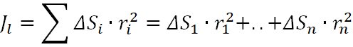

1.2. Bending strength

1.1.3. Strength index
When designing a beam for bending, it is necessary to take into account the strength index. The factor of the bending strength of a section is the ratio of the moment of inertia of this section with respect to the neutral axis to the distance of the outermost layers from this axis. The bending section modulus is marked with the letter W with the appropriate index at the bottom, characterizing the moment axis. The formula for the durability index is given below.

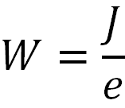

where:
J - moment of inertia of the beam section about the neutral axis in cm⁴
e - distance of the outermost layers (the farthest ones) from this axis in cm

Depending on the cross-section of the analyzed structure, various dependencies apply. For example, in the case of a square cross-section, both distances from the end layer are equal. The formulas for the moments of inertia for the square cross-section are presented below.

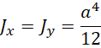

y
x
a
a

In the case of a rectangular section, this time J_{x} does not equal J_{y}. For a rectangular section, we take h into account for x, and for y we take into account b. Formulas for moments of inertia for a rectangular section.

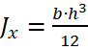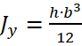

y
x
b
h

In order to determine the strength index for a selected section, the formulas determining the moment of inertia for a given section should be taken into account. The formula for the bending strength index for the square cross-section is presented below.

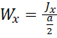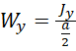
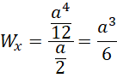

In order to calculate the bending strength index for a rectangular section, the following relationship should be used.

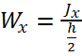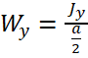
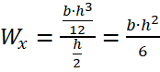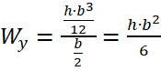

The values of normal stresses in the cross-sections of the beam depend on the bending moment as well as the dimensions and shape of the beam. In order to meet the safety condition of the bending beam, the stresses in the beam must not exceed the allowable bending stress k_{g}. The k_{g} value is most often determined during experimental tests, during a static tensile or compression test (k_{g}>k_{r}). Allowable stresses in bending beams should not exceed the critical values, which means that the following relationship should be maintained.

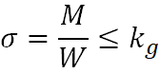

There are two basic strength conditions that must be met while bending. Strength condition - a given part must not be damaged during operation. Stiffness condition - deformations of a given part must be as small as possible, and certainly elastic. The first of the conditions will be met when the real stresses in the beam sections are lower than the allowable stresses. During operation, the beam deforms (from rectilinear to curvilinear) in a controlled manner, which is referred to as the deflection line of the beam axis.

1.1.4. Beam deflection
The beam deflection is the displacement of the center of gravity of the section in the direction perpendicular to the beam axis. The beam deflection arrow f defines the place of the greatest deflection of the beam. It is assumed that the arrow f does not exceed a certain value. Therefore, in practice, the deflection arrow f of the beam is looked for, because it proves the beam's stiffness. The permissible deflection, depending on the type and purpose of the structure, should not exceed 1/1000 to 1/200 of the beam span. The beam deflection line is presented in Figure 6.

Figure 6. Beam deflection line

In beams of uniform bending strength, the normal stresses in each section are equal. For construction purposes, the design of a beam with uniform bending strength requires the use of a variable cross section of the beam, where at each point the ratio of the bending moment to the section modulus is equal to the allowable bending stress. This use of a variable cross-section of the beam allows an economical approach to the design of the beam being bent, while maintaining a uniform bending strength.
Individual structural elements transfer certain loads during operation. Therefore, certain stresses (known as real) prevail in these elements. These actual stresses must be smaller than the strength limit, but also below the yield strength. When strength is calculated, there is needed to remember about:
- Strength condition - a given part must not be damaged during operation,
- Stiffness condition - deformations of a given part must be as small as possible, and certainly elastic.

1.2. Mechanics of Bending
Success in the bending of wood is dependent on the prevention by properly regulated end pressure of tensile stresses that tend to stretch the wood. This is usually done by using bending straps and end fittings. The importance of this requirement is made clear by an analysis of the forces that come into action during the bending operation. The wood is prevented from stretching, and the whole cross section is forced to assume a compressive deformation by using a thick metal strap and strong end blocks and reverse levers. Assuming that:
- the stress curve in the wood is a straight line,
- the metal strap does not slip on the wood,
- the end block is in good contact with the end of the stick at the s tart of the bending.

The tensile stress in the strap, and therefore the thickness, since the stress curve in the wood is not a straight line. When an end block equipped with a reversed lever is used, the force required to bend the stick may be applied anywhere beyond the point of tangency of the stick to the form. The total pressure applied to the end of the stick through the bearing on the end plate that is necessary to compress or deform the wood is equal to the sum of the differential stresses over the thickness of the stick. The total pressure is equal to the tension in the steel strap.
The research of white oak has been conducted. White oak pieces 1 by 2 inches in dimension were steamed at a moisture content of about 30 percent for 20 minutes at atmospheric pressure. They were bent to a 2¼ -inch radius through an arc of 180 degrees. One of the end blocks mas equipped with a hydraulic gage for measuring the total pressure developed. The pressure in - creased from practically zero at the start to a maximum when the bend was about one-half completed. From this point on, the pressure remained practically constant. The mean maximum gage pressure for several hundred pieces that were bent was about 2,200 pounds, or 1,100 pounds per square inch. At the half point of the bend, the distance from the point of attachment to the point of tangency of the stick to the form was about 17 inches. Using bellow equation the bending force, if applied at right angles to the stick, was calculated as follows.

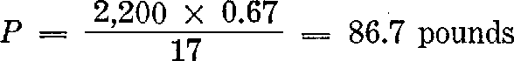

Since the pressure remained approximately constant after about the half point of the bend, the bending force had to be increased as the operation progressed, because the distance from the point of attachment to the point of tangency decreased. The total end pressure required can be calculated for any stick if the compressive stress -strain relation for the steamed wood is known. The required end pressure can be obtained from equation.

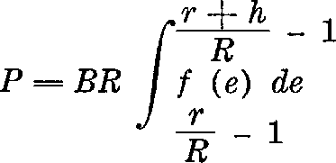

Where:
P - total pressure (compressive),
B - width of piece,
R - radius of the neutral axis of the bent piece,
f(e) - the function relating stress to strain and is obtained from stress -strain curves, e is strain, r is radius of the form, h is thickness.

If the compression strain at failure is known for the plasticized stick, it is not necessary to calculate the total pressure by the use of equation to determine the limits of bending. Endwise - compressibility values are rough indices of bending quality. The use of the mean endwise -compressibility value gives the calculated radius to which a given species of wood, plasticized in a specified way, can be bent with an expectation that 50 percent of the bends will be successful. Endwise-compressibility tests were performed at the Forest Products Laboratory on 2x2x3 inches, specimens steamed at atmospheric pressure for 40 minutes at a wood moisture content of 25 to 30 percent. The specimens were placed between the plates of a hydraulic press and compressed until failure occurred. A strain gage attached to the central 2 inches of a specimen permitted direct reading of the unit compressive strain at the point of failure. Since the measurements were made over the central 2 inches only, it is probable that the values obtained are somewhat low. The point of failure was detected by visual means and by means of a gage indicating the maximum pressure on the ram. Endwise-compressibility values by this method was determined in table 1.

Table 1. Endwise-compressibility values by this method
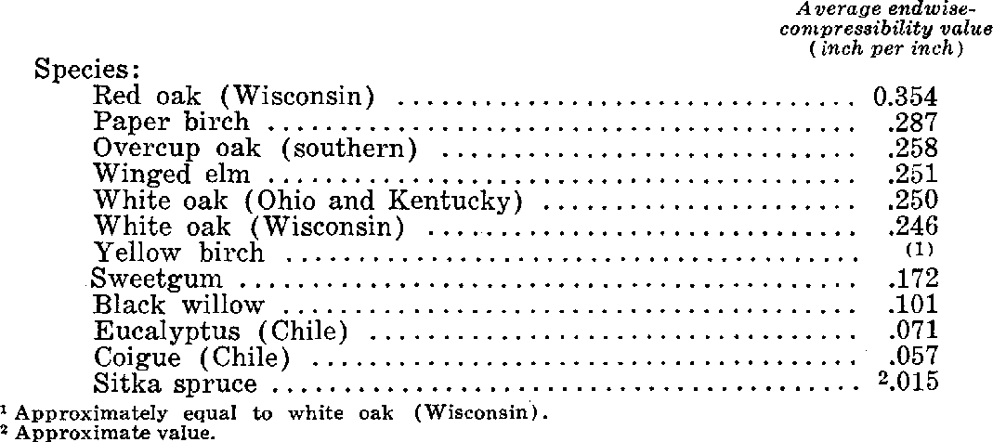

The values in this tabulation indicate that the wood of the species with values equal to or higher than those for Wisconsin - grown white oak should be suitable for making sharp bends, sweetgum and black willow for moderate bends, and eucalyptus and coigue for slight bends. The low value for Sitka spruce indicates that it is unsuited for bending. The mean endwise-compressibility value can be used in the following formula to estimate the minimum bending radius at which successful bends can be expected in 50 percent of the pieces for stock of a given thickness.

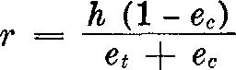

Where
r - the radius of the form, h is the thickness of the piece,
e_{c} is the compressive strain, just before failure, inch per inch, considered positive,
e_{t} - the tensile strain associated with ec, inch per inch, considered positive.

Where an efficient strap and end blocks are used, e_{t} becomes zero. When pieces are actually bent to the radius calculated by the use of formula, it is generally found that more than 50 per - cent of the bends are successful. This was illustrated in the bending of several hundred specimens of white oak, the average endwise - compressibility value of which, ec, is 0.25. By the use of above formula, the bending radius for 1 -inch thickness should have been 3 inches. The specimens were bent to a radius of 2¼ inches with 60 percent successful bends. Had a radius of 3 inches been used, the percentage of successful bends would presumably have been even greater than 60. It is not perfectly understood just why actual bending results exceed the expected when the bending radius is calculated by above formula. The value of e_{c} is probably conservative, however, because of the method used in making the endwise-compressibility test. A zone of weakness in the block used in the endwise-compressibility test will tend to lower the value of e_{c}, while a similar zone of weakness may have little influence on bending failure, unless it happens to be located on or near the concave face. It is also possible that some of the deformation required to accomplish bending is provided by shear deformation. No provision for shear is made in formula. Consequently, the actual results when bending to the calculated radius can be expected to be somewhat more favorable than the 50 -50 basis. If shear enters into bending, it means that cross-sectional planes do not remain perpendicular to the long axis of the stick.
When a piece of wood is bent, the compressive strain is probably never distributed uniformly over the length of the curved part. The distribution of the strain is presumably affected by nonuniformity of the wood along the length, local minor irregularities, friction be - tween the stick and parts of the apparatus, and the way the stick is forced and held against the form. Specimens of Wisconsin-grown red oak, 1 inch thick, were steamed at atmospheric pressure for 40 minutes and bent through an arc of 180 degrees to a radius of 2 5/8 inches. Parallel lines, 1 inch apart, were marked on the edges of the specimens before they were bent. After they were bent, the distance between these lines was measured on both convex and concave sides. The lengths of the lines across the thickness of the stick were also measured. The mean measurements for 11 sticks are shown in figure 7.

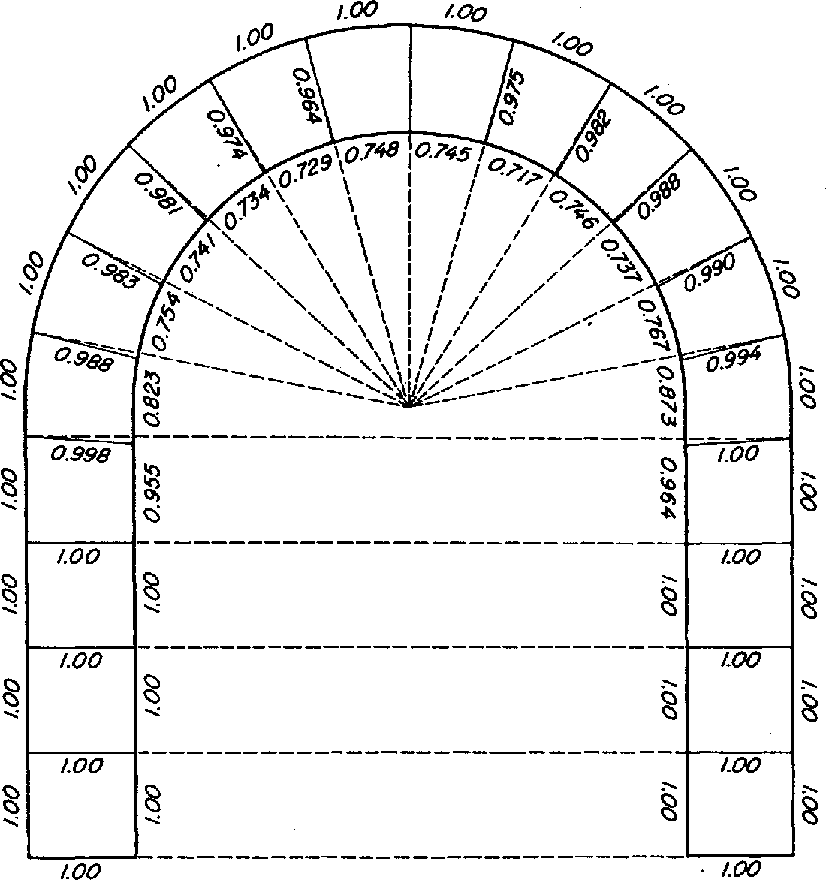
Figure 7. Distribution of compressive strain in a bent stick. The mean measurements for 11 sticks are shown.

The zones of maximum compression fall to the right and left of the center of the arc, but from 1 to 2 inches away from the center point. The pieces were clamped to the form at the center before bending commenced. The clamp may have increased the friction between the stick, the form, and the strap in the central portion. The increased friction may have prevented the central portion from assuming the full amount of compressive strain. The com pressive strain was not restricted to the curved portion of the stick but extended for about 1½ inches along each straight leg. Had the stick retained its full thickness of 1 inch during bending, the total amount of compressive strain needed to make the bend would have been about 3.14 inches. According to the measurements on the convex and concave sides, the total amount of compressive strain was 2.97 inches. The thickness of the curved part, however, was reduced during bending from 1 inch to an average of 0.979 inch. On the basis of the reduced thickness, the calculated amount of compressive strain required was 3.12 instead of 3.14 inches. The difference between the calculated amount of compressive strain needed and the strain was 0.15 inch, which may have been due to shear strain.

Unit 2. Knowing methods of making wooden curves elements for ships and boats
There are two broad classes of bends, those made without end pressure (free bends), and those made with end pressure. Free bending is feasible only for slight curvatures where the upset, or difference in length between the outer and inner faces of the bent piece, is less than 3 percent. Basket rims and hoops are made by a free-bending process. Boat frames and planking are often steamed or boiled and then bent when installed on the boat by being forced into position and fastened to other framing members. Thin strips for other products are also bent without end pressure.
Of course, wood can be bent to a slight curvature without a plasticizing treatment. When it is steamed before being freely bent, however, the advantage is taken of the fact that heat and moisture affect the stress-strain relation to a greater extent in compression than in tension. This makes it possible for the concave side to assume a certain amount of compressive strain before enough - tensile strain is developed to cause failure in the fibers of the convex side. In bending of this nature, it may be advantageous to over-plasticize the wood, thereby reducing the stress-strain value in compression. Rails, slats, and pickets are often bent in a hot-plate press without applying any end pressure. Bends made by the intrusion, or by forcing the stick or dowel into and through a split mold, are generally made without applying end pressure other than that obtained by friction.
Free bends are not highly permanent, even after drying and fixing, since the deformation obtained during bending is relatively slight. Consequently, it may be necessary to overbend slightly. To retain the curvature, it is usually necessary to fasten the ends of the strip together, as in a hoop, or to fasten the curved piece to other members of the structure. Some free-bent members, such as chair parts, are required to retain their curvature without restraint from other members.
Wood bending is an ancient craft that is of key importance in many industries today, especially in those that manufacture furniture, boats and ships, agricultural implements, tool handles, and sporting goods. Of the several methods commonly used to produce curved parts of wood, bending is the most economical of material, the most productive of members of high strength, and perhaps the cheapest.
Long experience has evolved practical bending techniques and skilled craftsmen to apply them. Yet commercial operations often sustain serious losses because of breakage during the bending operation or the fixing process that follows. There is a long felt need for more reliable knowledge about:
- Criteria for selection of bending stock;
- better methods of seasoning and plasticizing wood for bending;
- more efficient machines for the bending operation;
- techniques for drying and fixing the bent part to the desired shape;
- the effect of bending on the strength properties of wood.

2.1. The process of wood bent
It is common knowledge that a very thin strip of wood can be easily bent with the hands to quite sharp curvature. Thin veneers are bent by hand and held in place by weaving them together or attaching them to other parts. Such bending is done without treating the wood. In bending thick pieces of solid wood, however, softening with steam or hot water or plasticizing with chemicals is essential.
When a piece of wood is bent, it is stretched, or in tension, along the outer (convex side of the bend and compressed along the inner (concave) side. Its convex side is thus longer than its concave side. This distortion is accompanied by stresses that tend to bring the bent piece back to its original straightness. The purpose of softening wood with moisture and heat or plasticizing chemicals is to restrict the development of these stresses.
Plasticized wood can be compressed considerably but stretched very little. The objective in bending, therefore, is to compress the wood while restraining the stretching along the convex side. Although various devices are used to accomplish this, the most efficient yet found by the Laboratory is the tension strap, complete with end fittings such as end blocks or clamps and a reversed lever. Diagrammatic sketch of the mechanics involved in wood bending under end pressure was presented in Figure 8.

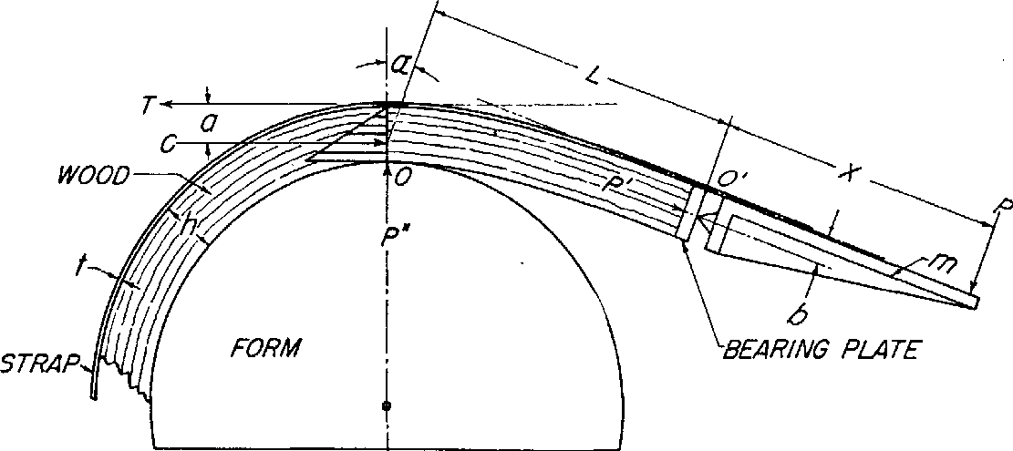
Figure 8. Diagrammatic sketch of the mechanics involved in wood bending under end pressure. (Device: A tension strap and an end block equipped with a pivoted bearing.)

The figure above illustrates what happens when wood is bent. Since X, representing the length of the end fitting, is a constant, the load P must also remain constant. However, P cannot remain constant, because as the stick is bent, the lever arm L + X becomes shorter. Therefore, P must be increased as the bending progresses. The resistance of wood to bending forces at the point of contact of the stick and the bending form, point 0, is approximately constant at all times as bending proceeds. In effect, the unbent part of the stick is a lever and point O a fulcrum as bending force is applied. As this lever arm, represented by the distance L + X, becomes shorter, the bending load ( P ) needs to be increased. At the same time, however, the resistance to end pressure, represented by P', is also constant, and as a result, PX must remain constant.
If P increases, PX increases, and the end pressure is thereby in - creased. Since the resistance to end pressure, P', remains constant, the increased end pressure must result in crushing of the end of the piece or in back bending or buckling. As a result, either too much end pressure is applied during the late stages of bending or too little during the early stages.
In spite of these shortcomings, apparatus of this type may produce successful bends, particularly bends with a small angle of curvature. A common fault of much commercial bending apparatus is in the lever arm that extends beyond the end block. If the lever arm to which the bending force is applied is relatively short, the moment that resists rotating or overturning of the end block may be too small. In such cases, it is impossible to keep the whole stick in compression even when bending to a small angle of curvature.
A simple device that automatically compensates for the higher end pressure induced by increased bending loads is a reversed lever. This device exerts pressure on the convex face of the stick, and so prevents the end block from overturning. Preventing the overturning of the end block assures the application of end pressure. Because the pressure against the block is generated by the stick itself as it is bent, the force required to make the bend has no effect on the amount of end pressure thus generated. Automatic regulation of end pressure was presented in figure 9.

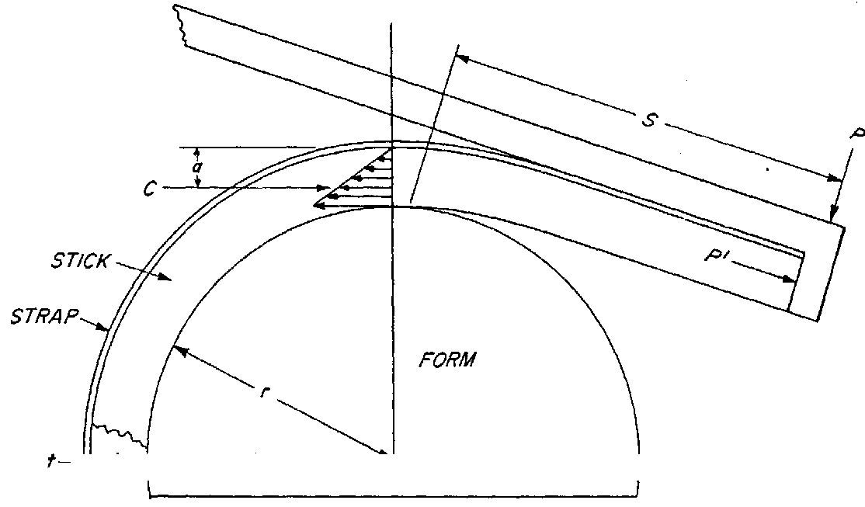

Figure 9. Automatic regulation of end pressure. (Device: A tension strap and an end block equipped with a reversed lever.)

The reversed lever must extend back as far as the last point of contact between the wood and the form in order to regulate end pressure and prevent reverse bending near the end of the stick. If the stick need not be bent throughout its length, the reversed lever will produce an almost uniform end pressure during the bending operation. With this device it is unnecessary to use a pivoted bearing.

2.2. Selecting bending stock
The selection of a species of wood to use in a manufactured product containing a bent member of slight to moderate curvature is largely governed by suitability and availability of the species for the product. If the curvature is to be severe, however, the species of wood must be selected primarily for its bending quality.
The bending quality of wood varies widely not only among the different species but also within the same species. Insufficient data are available, however, to permit the listing of species in the exact order of their bending qualities. As a rule, the bending quality of hardwoods is better than that of softwoods, and the latter are seldom used in bending operations. Yew and Alaska - cedar are exceptions ; Douglas-fir, southern yellow pine, northern and Atlantic white -cedar, and redwood are often bent to moderate curvature for ship and boat planking.
Stevens and Turner rated a few American species of known good bending quality in the following descending order: white oak, yellow birch, and white ash. Mahogany from Central America was rated as having moderately good bending quality and as superior to khaya, “African mahogany,” in this respect. These ratings are based on the radius of curvature for steamed 1 -inch material at which breakage does not exceed 5% when the wood is bent under end pressure. Numerous hardwood species were ranked at the United States Forest Products Laboratory on the basis of the percentage of breakage sustained during a uniform bending test made without end pressure. These species, in descending order of bending quality, were as follows: Hackberry, white oak, red oak, chestnut oak, magnolia, pecan, black walnut, hickory, beech, American elm, willow, birch, ash, sweetgum, soft maple, yellow -poplar, hard maple, chestnut, water tupelo, cottonwood, black tupelo, mahogany, American sycamore, buckeye, and basswood. The species commonly used in industry for making bent members are White oak, red oak, elm, hickory, ash, beech, birch, maple, walnut, mahogany, and sweetgum.
An extensive study of woodcuts from 20 white oak trees grown in four different localities in Ohio and Kentucky revealed that the bending quality of wood from the four localities varied. And, in most cases, the bending quality of the woodcut from trees in the same locality also varied. An attempt was made to correlate bending quality with specific gravity, rate of growth based on the number of growth rings per inch, end pressure developed during bending, and standard toughness values. No good correlation was found. In fact, the wood of the highest bending quality was almost identical to that of the lowest bending quality in specific gravity and rate of growth.
Despite the fact that little correlation has been found between basic physical properties and bending quality, stock can be selected with reasonable assurance that it will bend without undue breakage. The principal precaution is avoidance of stock that contains strength reducing defects. These defects are decay, cross-grain, knots, shake, pith, surface checks, and brash wood. Even wood containing incipient decay fails under slight tensile stress and cannot be compressed nearly so much as normal wood. A bent part of elm containing incipient decay. The impaired strength properties caused the piece to develop compressive failures in the form of abrupt wrinkles during bending was presented in the figure 10.

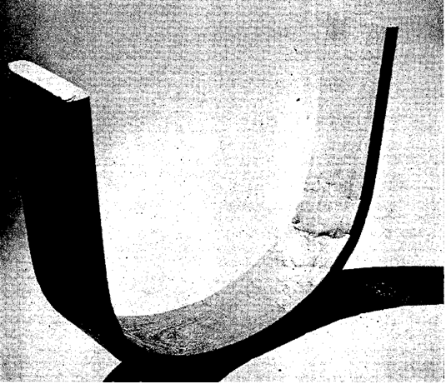
Figure 10. A bent chair part of elm containing incipient decay. The impaired strength properties caused the piece to develop compressive failures in the form of abrupt wrinkles during bending.

Straight-grained wood is much less likely to fail during bending than cross-grained wood. The grain should slope not steeper than 1 inch in 15 along the length of the piece. Local cross-grain is also to be guarded against; it is weak under bending loads. Knots are objectionable because they are invariably accompanied by a distorted grain and also because they resist compression.
Shakes, which are longitudinal separations parallel to the annual rings, are responsible for failures in shear during the bending operation. Pith introduces similar lines of weaknesses. Surface checks, which are cracks perpendicular to the annual rings, are likely to cause compressive failures if on the concave side of the piece. On the convex side, they are not so detrimental. Surface
checks in combination with cross-grain are likely to cause pyramid-shaped pieces to be forced out of corners that are in compression and slivers out of corners subjected to slight tension. Exceptionally lightweight wood is likely to be brash and fail during bending. Even if it is bent successfully, it may not have the necessary strength in service. Minor defects in the wood, such as small pitch streaks, burls, and small checks, are permissible if they are located beyond the part to be bent or on the convex side of either mild or severe bends. They may be allowed on the concave side of mild bends, but with severe bends, such defects cause concentration of stresses and compressive failures are likely to result.

2.3. Seasoning bending stock
From the standpoint of the bending operation alone, most curved members can be produced from green stock. However, the moisture content of bending stock should also be suitable for the drying and fixing of the bend and for the drying process needed to bring about a moisture content suitable for the finished product. If it is not, the wood is likely to check, split, and shrink excessively. For these reasons, green or partly seasoned stock is not suitable for many bent items. On the other hand, dry wood is not sufficiently plastic to bend well even when heated to a high temperature. Most kiln-dried lumber is not suited for bending unless it is steamed or boiled enough to absorb the moisture needed to make it sufficiently plastic to bend well. Soaking it in water before it is steamed or boiled is helpful.
To avoid both drying troubles with wood that is too green and bending difficulties with wood that is too dry, the stock should be seasoned to a moisture content that is optimum for the bending method and angle of curvature. For example, in hot-plate press bending, where the curvatures are relatively mild and the drying conditions severe, the optimum moisture content for the bending stock is lower than that for stock bent over forms by hand or machine. Forest Products Laboratory research shows that the optimum moisture content for bending southern oak back posts in a hot-plate press is 12 to 15 percent. For curved rails and slats of less severe curvature than curved posts, the optimum moisture content for bending in a hot-plate press is probably 12 percent. For furniture parts bent over forms, stock at a moisture content of 15 to 20 percent is preferred.
Ideally, bending stock should be air-dried to the desired moisture content, generally 12 to 20 percent, and stored under controlled conditions. A temperature of 70° to 80°F. and relative humidity of 80 percent will maintain wood at a moisture content of 15 to 16 percent. At the same temperature and relative humidity of 65 percent, wood will remain at a moisture content of about 12 percent. If bending stock is cut to length before drying, an end coating should be used to reduce end checking and splitting, The coating will prevent excessive absorption of moisture by the ends during the steaming process. It will also minimize the tendency to end check and split during the drying and fixing process.

Unit 3. Knowledge about use naturally curved elements of trees in ship and boat constructions

3.1. Ancient uses of thermo-hydro-mechanical processes
For thousands of years, wood has been used by man for the manufacture of tools, weapons, utility equipment and instruments, in addition to as a building material. With the collected experience of numerous generations, consideration has consciously been given to wood properties in many areas of processing and usage. The simplest and in most cases also the strongest woodwork takes advantage of the natural shape of the timber. Bends, forks and holes can all be exploited in many ways. Even on a large scale, such as the building of houses or wooden ships, greater structural integrity can be achieved by using a single piece of timber having grown into the right shape rather than by joining several smaller pieces together. The building of wooden ships and stave churches in old times as well as of utility goods in the old farmer community exemplifies that it has traditionally been common to use naturally shaped timber.
One of the most graceful chair designs is the horseshoe armchair, which originated more than 500 years ago in the time of the Ming Dynasty. The back rail and arms of the chair form a continuous semicircle, gently descending toward the front with the terminals of the arms bent slightly back in a rhythmic yet reserved curve. Often coupled with tapered, S-shaped side posts, the effect is of a spherical void being gently cradled, simultaneously giving a sense of emptiness and wholeness. These inspired forms grew out of the rich tradition of Chinese craftsmanship, and integrating of aesthetic preferences with the science of joinery.
Of the existing horseshoe armchairs, most of the curved armrests are made of three to five segments with joints that fit so snugly that no nails or glue are required. In making the curved arm-rest of the horseshoe chair, craftsman selected wood with a naturally curved grain that would follow the curvature of the rail, ensuring that the grain would be straight and strong at the joint. This way of joining naturally grown curved sections has for example been practiced in traditional Japanese wooden buildings. During the fourteenth century, the carpenter’s square became popular in Japan. Its skillful use made possible the precise construction of complicated joints used in house building. In Norwegian stave churches, the longer construction elements, such as the nave’s quadrant arches, consisted of curved wood elements made out of several pieces so precisely joined that even today it is difficult to detect the connection points.
Egyptian workmen, whether they built vast temples or manufactured furniture, inspire both awe and admiration. But who were these people? How did they practice their different craftsmanships? Did they use techniques based on THM-processes or were such processes unknown? Were they well rewarded for their skilled work, or were they exploited? In order to answer such questions we need contemporary written texts, preferably written by and for the ancient workers themselves. So far, such documents have been found in very few archaeological sites. However, the works settlement of Deir el Medina is among the most thoroughly documented and best-known communities from the ancient world.
The earliest evidence of true wooden furniture is found in the E gyptian society that existed some five thousand years ago. The exceptional conditions for survival in royal tombs have given us famous examples of furniture and other utility equipment. It is apparent that different pieces of furniture had been created by 3000 B.C., and there is no doubt that a skilled work force existed in Egypt. The origins of the technique of wood bending have been the subject of some dispute among experts, but it is probable that wood bending was known in E gypt around 1000 B.C. U nsubstantiated evidence suggests that some furnishing may have been fabricated by wood bending as early as 2500 B.C. Egyptian tomb-drawings of Nebamen at Thebes (ca. 1400 B.C.) provide evidence of manufacturing processes where it is probable that the Egyptian carpenters used heat and moisture to bend wood.

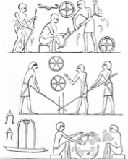
Figure 11. Section of tomb-drawing of Nebamen at Thebes showing various operations on different parts of a chariot. I n the upper picture, the carpenters are bending poles, and the drawing at the bottom to the left shows a wooden chariot-yoke that may have been THM-processed

The reliefs in the tomb of the scribe Hesire at Saqqara, dated ca. 2800 B.C., contain representations of furniture, including a chair whose seat has been described by Aldred in Singer as “strengthened by bent wood supports, in hard- and softwoods” and a stool “with bent wood reinforcements”. More immediate evidence that the process of bending wood was known to the Egyptians is provided by the paintings in the tomb of the nomarch Amenemhat at Beni Hasan, ca. 1971-1928 B.C. The bowmaker who holds a rod over a receptacle that possibly contains hot water, while straight rods and completed bows are displayed nearby was presented in the figure 2.3.

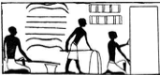
Figure 12 Bending of bows from a facsimile of a wall painting in the tomb of Amenemhat at Beni Hasan, ca.1971-1928 B.C.

Only green and unseasoned wood could be bent by this method; seasoned wood of large cross-sectional dimension can only be bent by softening with the use of a steam chest and there is no evidence that this apparatus was used in ancient Egypt. The Egyptian paintings showing bowmakers was interpratated as meaning that the heating and bending of the wood was carried out before debarking and that it may thus be understood that the wood was green. The technique of laminating thin sheets of wood, with the grain of one sheet perpendicular to that of the next, i.e., plywood, was known to Egyptian carpenters at least from the period of the Third Dynasty, 2686-2613 B.C.
Vessels of wood have been in use on the water for thousands of years. Before ships or even boats, there must have been a long succession of floats and rafts used as aids to swimming. However, details of drawings, carvings, and models of Egyptian, Greek, Assyrian, and Minoan times, and even the work of Scandinavian Neolithic artists, representing early vessels do not suffice to show how they were constructed. It is even less possible to determine whether any part of the vessel construction was the result of a thermo-hydro-mechanical (THM) process.
The fabrication of a canoe is carved out of a single log and then expanded over an open fire. Such a boat is light and has much more room than a regular logboat. Extra boards can be added to increase their size. This type of vessel belongs to the group of boats that are called primitive boat-types, i.e., boats built of skin, bark, reeds, or hollowed-out tree trunks, that have been used by man for thousands of years. Dug-out canoes have been found wherever there are suitable forests. The limiting factor is the tree diameter. The size of the hull was often increased during manufacture by filling the hull with wet and perhaps even heated sand, the weight of which forced the sides apart. Today such boats are used by different aboriginal groups, e.g., Greenlanders, Indians in Canada, and the Punan Bah people in Borneo.
The Punan Bah people use dugouts or longboats for transport on the many rivers that flow through the landscape of their great island. A special feature of these longboats is that the tree trunk, after being hollowed out with an axe, is widened over a fire. This technique is also known from prehistoric times with regard to longboats in northern Europe. After widening, a plank is sewn to each side of the boat and we thus have the first step towards the development of the clinker-built ships with which we are familiar from the Viking period. The technique for fabricating longboats in Borneo and summarize the main steps of the boat-building process as:selection and felling of the tree;
- preparation and cleaving of the trunk;
- preliminary shaping of the base;
- trimming of the base;
- expanding the hull by heat;
- sewing.

The Punan Bah build their longboats of the same kind of species. Ideally, they use meranti (Shorea gen.), but to save time during building softer species can also be employed. The Punan Bah select their wood on the basis of a variety of criteria, all associated with their beliefs in a shared destiny for the boat-builder and his boat, as well as taking into account the quality of the wood, its hardness, accessibility, and size. The boat-building process begins in the rain forest, where the tree has been felled. Here, the branches are cut off, and the bark removed. The length of the boat is then measured out on the bare trunk and the selected piece of the trunk is cut. Thereafter, a cleavage line is drawn lengthwise, exactly following the fiber direction of the trunk.
The trunk is cleaved into two halves with the help of wooden wedges. Both halves of the trunk can be used for longboats if small boats are to be built, whereas, for large boats, only one part of the trunk is utilized. The preliminary shaping of the base naturally involves the following sub-phases: removing the sapwood, hollowing out the trunk, and shaping the base. The preliminary boat is then transported to the place where it will be finished. After the preliminary shaping, the base has to be trimmed and smoothened, both externally and internally, to give the final shape and thickness. This is time-consuming precision work done by hand with the help of adzes and axes. The widening of the base takes place over a fire: the entire hull is placed over a large bonfire until the wood reaches a temperature at which it becomes flexible. The sides are then twisted outwards and downwards with the help of large forked branches so that the base is flattened and widened, while the ends lift themselves, and the sheer in the base increases.
The expanded boat is hardened so that it can better withstand the attacks of rot and insects. The hull is first placed over the fire with the underside downwards and, after about five minutes, it is turned over so that the charred underside is faced upwards. After about an hour, the hot wood is stretched outwards and downwards in the central region. When the wood is sufficiently stretched, the sides are fixed with the help of a wooden bar between them. The widening has not been completed at this position but, in order not to split the wood, it is necessary to stretch the boat over the whole of its length before returning to the center for the final widening. The total increase in width at the middle of the hull is about 14% based on the original width. Before expanding, the hull was thus about 0.7 m in width and 7 m in length. Figure 2.7 shows a drawing of such a hull before and after the expansion. It can be worthwhile to notice that the expansion process used by the Punan Bah people in Borneo differs from that used by the North American Indians, which is presented in the introduction.
The sewing involves a number of processes that gradually transform the expanded boat base into a proper boat with lashed-on strakes, stem, and stern. The sewing process involves the following phases: the preparation of the lashing material, the forming and fastening of the thwarts, the dressing and fastening of the strakes, and finally the dressing and fastening of the stem- and stern-transoms. The tradition of expanding the hull by heat from an open fire can also be found as far away from Asia as Northern Europe.
The Thermo-hydro-mechanical Processing of Wood find of a wooden plank ship in Scandinavia and its closest parallels are the thousands of petroglyph images of Nordic Bronze Age ships. Five large lime-wood planks made up most of the boat. According to the reconstruction, there was no keel, but a 15.3-m long – up to 50-cm wide – lime plank with carved out cleats for fastening the frames. At each end, it had a V-shaped section on which flanged stem and stern pieces were sewn. It continued some distance fore and aft of these to form the bases of the lower of the characteristic double protrusions. Whether the bottom plank has been expanded from a hollowed-out trunk or manufactured directly to shape cannot be established. Figure 2.8 depicts a reconstruction of the Hjortspring boat.
The reconstruction of the Hjortspring boat indicates a plausible line of development from the simple log boat to one with sides extended by planks. This evolved into boats of the Hjortspring type, which is essentially a log with two added strakes of planking. In time, the planks grew in number, and the log turned into a proper keel. This corresponds well with the shell-based way of designing boats according to Nordic tradition, where the frames are inserted after the planking. Expanded log boats were in use at the same time as clinker-built boats, right up to the Viking Age. The so-called Björke boat, cf. The natural shape of the wood. The bends, forks, and holes in the woodwork have been used in many ways. It was used on a large scale in the construction of wooden ships. Greater structural integrity and strength can be achieved by using a single piece of wood that has grown into shape, rather than joining several smaller pieces together. The natural bent wood for the building of ships. Drawing used for teaching purposes at the Maritime Academy in Stockholm was presented in figure 13.
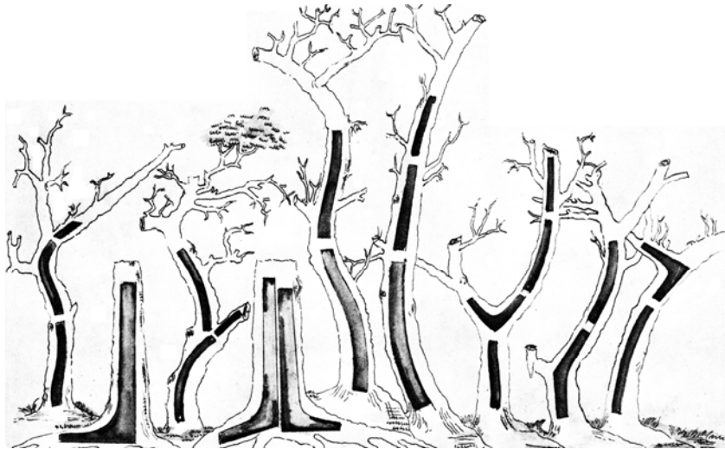
Figure 13. Natural bent wood for the building of ships. Drawing used for teaching purposes at the Maritime Academy in Stockholm

As in the Viking Age, timber was produced through the radial splitting of oak logs with the help of an axe and wedges, a technique that was used until the 16th century. From these wedge-shaped pieces of timber, the boards were axed. These were heated over an open fire and doused by water to make them pliable so that they could be given the appropriate shape for their place in the hull. Softening of boards over an open fire (top) and the installation of pliable boards on the hull was presented in figure 14.

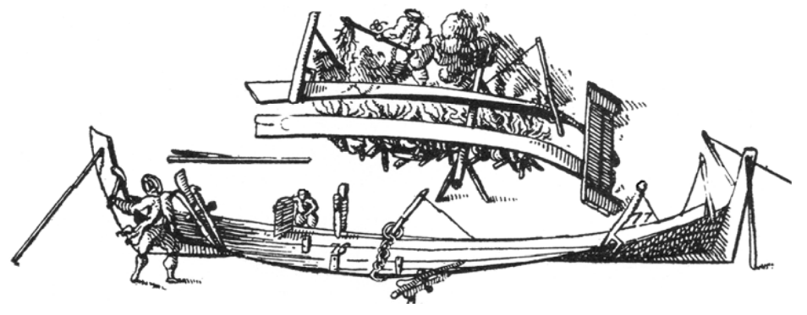
Figure 14. Softening of boards over an open fire (top) and the installation of pliable boards on the hull

The ancient method, when shipbuilders made the boards pliable by heating over an open fire, gave way only very slowly to the gentler treatment by boiling in water or steaming in a steaming vessel. For example, steaming vessels were not used in Swedish shipyards until the mid-eighteenth century. The Curved trees in Grifino Poland was presented in figure 15.

Figure 15. Curved trees in Grifino Poland

2.3 THM-processing in the construction of wooden vessels
Vessels of wood have been in use on water for thousands of years. Before ships or even boats, there must have been a long succession of floats and rafts used as aids to swimming. However, details of drawings, carvings, and models of Egyptian, Greek, Assyrian, and Minoan times, and even the work of Scandinavian Neolithic artists, representing early vessels do not suffice to show how they were constructed. It is even less possible to determine whether any part of the vessel construction was the result of a thermo-hydro-mechanical (THM) process.
For example canoe logboat is carved out of a single log and then expanded over an open fire. Such a boat is light and has much more room than a regular logboat. Extra boards can be added to increase its size. This type of vessel belongs to the group of boats that are called primitive boat-types, i.e., boats built of skin, bark, reeds or hollowed-out tree trunks, that have been used by man for thousands of years. Dug-out canoes have been found wherever there are suitable forests. They vary in shape depending on local requirements and on the available material. The limiting factor is the tree diameter. The size of the hull was often increased during manufacture by filling the hull with wet and perhaps even heated sand, the weight of which forced the sides apart. Today such boats are used by different aboriginal groups, e.g., Greenlanders, Indians in Canada and the Punan Bah people in Borneo. The Punan Bah people use dugouts or longboats for transport on the many rivers that flow through the landscape of their great island. A special feature of these longboats is that the tree-trunk, after being hollowed out with an axe, is widened over a fire. This technique is also known from prehistoric times with regard to longboats in northern Europe. After widening, a plank is sewn to each side of the boat and we thus have the first step towards the development of the clinker built ships with which we are familiar from the Viking period. The technique for fabricating longboats in Borneo was summarize by the main steps of the boat-building process as:
- selection and felling of the tree;
- preparation and cleaving of the trunk;
- preliminary shaping of the base;
- trimming of the base;
- expanding the hull by heat; and
- sewing.

The Punan Bah build their longboats of the same kind of species. Ideally they use meranti (Shorea gen.), but to save time during building softer species can also be employed. The Punan Bah select their wood on the basis of a variety of criteria, all associated with their beliefs in a shared destiny for the boat-builder and his boat, as well as taking into account the quality of the wood, its hardness, accessibility and size. The boat-building process begins in the rain forest, where the tree has been felled. Here, the branches are cut off, and the bark removed. The length of the boat is then measured out on the bare trunk and the selected piece of the trunk is cut. T hereafter, a cleavage-line is drawn lengthwise, exactly following the fiber direction of the trunk. The trunk is cleaved into two halves with the help of wooden wedges. Both halves of the trunk can be used for longboats if small boats are to be built, whereas for large boats, only one part of the trunk is utilized.
The preliminary shaping of the base naturally involves following sub-phases: removing the sapwood, hollowing out the trunk, and shaping the base. The preliminary boat is then transported to the place where it will be finished. After the preliminary shaping, the base has to be trimmed and smoothened, both externally and internally, to give the final shape and thickness. This is a time-consuming precision work done by hand with the help of adzes and axes. The widening of the base takes place over a fire: the entire hull is placed over a large bonfire until the wood reaches a temperature at which it becomes flexible. The sides are then twisted outwards and downwards with the help of large forked branches so that the base is flattened and widened, while the ends lift themselves, and the sheer in the base increases. T he widening is first and foremost designed to improve the stability of the boat by increasing the sheer in the sides. In addition, the expanded boat is hardened so that it can better withstand the attacks of rot and insects.
The hull is first placed over the fire with the underside downwards and, after about five minutes, it is turned over so that the charred underside is faced upwards. After about an hour, the hot wood is stretched outwards and downwards in the central region. When the wood is sufficiently stretched, the sides are fixed with the help of a wooden bar between them. The widening has not been completed at this position but, in order not to split the wood, it is necessary to stretch the boat over the whole of its length before returning to the center for the final widening. The total increase in width at the middle of the hull is about 14% based on the original width. Before expanding, the hull was thus about 0.7 m in width and 7 m in length. It can be worthwhile to notice that the expansion process used by the Punan Bah people in Borneo differs from that used by the North American Indians, and which is presented in the introduction. The hull before and after the expansion was presented in Figure 16.

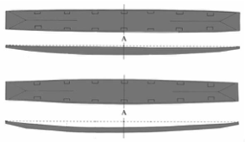
Figure 16. A longboat under construction (a) before and (b) after expansion of the hull.

The width at point A is 660 mm before and 750 mm after the widening. The distance between a line between the aft and fore end of the boat (the dotted line in the figure) and the rail at point A is 30 mm before and 150 mm after the widening. The length of the boat is 7 m. The sewing involves a number of processes that gradually transform the expanded boat-base into a proper boat with lashed-on strakes, stem and stern. The sewing process involves the following phases:
- the preparation of the lashing material,
- the forming and fastening of the thwarts,
- the dressing and fastening of the strakes,
- the dressing and fastening of the stem- and stern-transoms.

The tradition of expanding the hull by heat from an open fire can also be found as far away from Asia as Northern Europe. Five large lime-wood planks made up most of the boat. According to the reconstruction, there was no keel, but a 15.3-m long – up to 50-cm wide – lime plank with carved out cleats for fastening the frames. At each end, it had a V-shaped section on which flanged stem and stern pieces were sewn. I t continued some distance fore and aft of these to form the bases of the lower of the characteristic double protrusions. Whether the bottom plank has been expanded from a hollowed-out trunk or manufactured directly to shape cannot be established. The reconstruction of the Hjortspring boat was presented in figure 17.

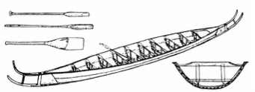
Figure 17. Reconstruction of the Hjortspring boat.

The reconstruction of the Hjortspring boat indicates a plausible line of development from the simple log boat to one with sides extended by planks. This evolved into boats of the Hjortspring type, which is essentially a log with two added strakes of planking. In time, the planks grew in number and the log turnes into a proper keel. This corresponds well with the shell-based way of designing boats according to Nordic tradition, where the frames are inserted after the planking.
Expanded log boats were in use at the same time as clinker-built boats, right up to the Viking Age. The Björke boat was found by the shore of a lake in Sweden and can be dated to about 450 A.D. Most of the wood was well preserved when it was found. The Björke boat was built with many different techniques. The bottom was an expanded lime tree with added boards of pine wood, the frame was made of spruce lashed to the hull with juniper withes, and the added boards were fastened with iron nails. The construction process for the expanding looks fairly like that still used by the Punan Bah people. It was practised in Finland until at least the 1930s for small boats of aspen. The Björke boat was presented in figure 18.

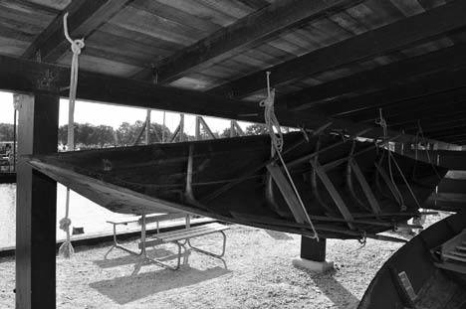
Figure 18. Reconstruction of the Björke boat from 450 A.D. at the Viking ship

In Egypt, where all habitable and cultivated land was irrigated by the Nile, we should expect a very early start in navigation and wooden shipbuilding. The first datable boat representations are models founded in graves. The very oldest appears to be from the Neolithic (ca. 6000 B.C.) site of Merimda Beni Salaam and it seems most likely that these boats were made of papyrus bundles, not wood. It is impossible to say when the first wooden ships were built in Egypt, but finds reveal wooden boats as old as 5000 years. However, the early Egyptian boats and ships were of quite a simple construction without any keel, and the boat-building technology evolved independently within Egypt in response to local conditions. The way in which the boats and ships are built reflects aspects both of the legitimization of power and of participation in a regional trade network at least occasionally accessing the Red Sea before the third millennium B.C. A contemporary and detailed description of Egyptian boats and boat-building techniques is given by the Greek historian Herodotus (ca. 484-425 B.C.) in his history of the Greco-Persian Wars. It is difficult to find evidence that their shipwrights used any THM processes.
An odd water vessel is the quffa that was probably invented in the regions of the Tigris and Euphrates and has been used in this region since at least the seventh century B.C. and probably goes back to the beginning of civilization. This vessel is a circular skin boat in which the flexible leather or hide cover is stretched over an internal frame of bent wood. Craft of this sort are not directly in the line of evolution, which developed into the later standard types of ships with keel and ribbed hull and which derived ultimately from the dug-out canoe. With regard to design, Scandinavian wood treatment perhaps reached its peak during the Viking Age. Both the Viking ships with their inventories and the early Norwegian stave churches are artistic masterpieces that are difficult to surpass even today. The ships are especially fascinating since they were built to a superb standard with a high prestige value and a refined technology from which we still have things to learn when designing modern yachts. A reconstruction of a small boat from the Viking Age at the Viking ship was presented in figure 19.

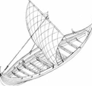
Figure 19. Reconstruction of a small boat from the Viking Age at the Viking ship

The term Viking ship does not describe a single type of ship but is a collective designation for the vessels built from the end of the 8th century to the beginning of the 12th century in accordance with common Nordic boat-building traditions. Viking ships were open, clinker-built vessels with a side rudder and a single mast. They were powered by oars or driven by the wind, using a square sail. Their hulls, which had a boards of pine wood expanded log of lime tree light and flexible design, were held in shape by lateral timbers (floor timbers, beams and knees) and by longitudinal reinforcements (stringers and keelson). The longships were primarily warships, manned with a maximum of warriors who also acted as oarsmen. After a defeat in battle, the ship might still be handled by a crew numbering only a third or a quarter of the original number. In the 17 m-long Skuldelev 5-replica Helge Ask, the full crew was 26 oarsmen. In longer ships, the number of men was increased by two for each additional meter, as the average spacing between the oars was one meter or slightly less. The largest Viking longships were probably manned by as many as 80 men. In broad ships like the Norwegian Gokstad ship, there would be room for several more men than the number of oarsmen. This was also the case in the broad and deep cargo ships. They could be sailed by a crew of only 4 to 5 men, but they could transport a much larger number of people if necessary, for instance for the transfer of settlers from Norway to Iceland.
The Vikings were skilled shipwrights who, on the basis of experience and tradition, could build ships that were adapted for particular purposes and specific seas. Their longships with an extensively curved stern and stem put great demands on the professional skills of shipbuilders as well as on the quality of the wood material. Viking shipbuilders preferred to build their ships from oak in southern Scandinavia and from pine in northern Scandinavia. Other species of wood were, however, also used for special purposes, such as ash for the upper planks in the longships. An interesting observation is that the Vikings probably did not use heat to render the wood pliable during the construction of the ships, and it is notable that they did not use heat even for the bending of the highly curved boards for the hull.
The building method is called “by eye”, i.e., without drawings and from the outside inwards: the keel was first laid out, usually in one piece, after which the stern and stem were raised. The planking was then assembled with iron rivets in clinker fashion, creating the lines of the hull by varying the shape of the planks and the angle from one plank to the next. After the bottom part had been built up with the planking, the bottom frames, usually of naturally bent wood, were cut to shape and inserted. The sequence could then be repeated with the sides of the ship. The same working process can also be seen in the Bayeux Tapestry from ca. 1070 A.D., which from a Norman perspective reflects the circumstances surrounding the invasion and battle of Hastings in 1066.
The secret enabling the Vikings to bend oak wood in the hull to a comparatively great extent is the technique of splitting the log radially with the help of axes and wedges and bending the wood in the green state. For detailed studies of the conversion method. In the manufacture of boards for the hull, the log was first split into two halves, then into 1/4 and 1/8-parts and sometimes down to 1/32-parts. The number of boards was largely dependent on the diameter of the log and 32 pieces were considered to be the upper practical limit from a single log. When a log is split into halves or more, the split follows the grain orientation in the longitudinal direction, so that fewer fibers are cut than in the sawing or shaping of a log with an axe. The sapwood was usually removed at this stage. The board width was, therefore, determined by the radius of the log minus sapwood and the inner part of the heartwood. For example, a log with a diameter of 1 m is required to obtain an approximately 30-cm wide board. The radial splitting of a log into sectors used for boards for the hull of a Viking ship was presented in figure 20.

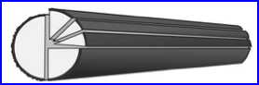

Figure 20. Radial splitting of a log into sectors used for boards for the hull of a Viking ship.

Some of the major advantages of radially split boards include the longitudinal fibers (grain) being parallel to the board sides contributing considerably to the mechanical strength and dimensional movements due to changing humidity being greatest in the smallest dimension of the board (i.e., its thickness). Radially split wood is “watertight” (the rays are parallel to the sides of the boards), resistant to cracking and generally more durable. Viking ships were built of fresh timber. Fresh or green wood is tougher than its dry counterpart and is also more pliable. By splitting the log into smaller and smaller pieces, boards that were light and thin but, at the same time, unprecedentedly tough were obtained. If we are careless and try to build a copy of a Viking ship today with sawn and less carefully selected wood, the boat will either break or be too heavy. The great advantage of green wood is that the ship retains its shape when launched. Since the boat is built in its wet form, no swelling or shrinkage and thereto-related problems occur. Experiments show that the radial splitting of large oak logs can be done without undue difficulty because the rays assist the cleaving.
With a combination of high knowledge of the wood material and skilled shipwrights, the Vikings used radially split green wood in their fabrication. Their ability to produce complicated bent wood constructions without the use of heat is unique in shipwrighting. The heating of wood either from an open fire, boiled water or steam has been used for at least a thousand years before and after the Viking Age. The medieval shipwrighting for cargo ships in the S candinavian countries was a direct continuation of the shipwrighting of the Viking Age when it comes both to the shape of the hull and the technology. It was based on the clinker- building technique with rather thin boards throughout the Middle Ages, and the carvel-building technique probably did not come into use until the late thirteenth century. It was vital that the timber used for building the different parts of the ships was selected according to its natural shape, e.g., natural bent wood to produce frames, knees, etc.,. The fiber structure of the wood is thereby maintained, which gives the ships strength and stability.

2.5 The industrialization of solid wood bending
Historically, the industrial bending process not only enhanced the structural stability of a design but also allowed for the most economic use of materials and manpower. Commercially, the new process lowered the cost of construction and gave bent wood furnishing a competitive edge over products made by more conventional laborious means with elements that had been cut or carved, and then joined. The ultimate success of the bending process occurred after the middle of the nineteenth century when, through mass production, bent-wood products flooded the market.
The development of the technology of wood bending began when the first patent was granted in England in the first quarter of the eighteenth century and continued until the time when, through the work of Michael Thonét 140 years later, it was prepared for introduction into industrial manufactur. The three oldest patents, granted between the years 1720 and 1794 to J. Cumberland, H. Jacksson and J. Vidler, used different approaches to the process of softening the wood, including boiling, steaming and heating by conductio. These operational procedures were intended for use primarily in the area of ship building. Dring the first decade of the nineteenth century, attempts to apply this process to the bending of laminated wood for the constructions of chairs by the Belgian Jean Joseph Chapuis (1755-1864) and the American cabinet-maker Samuel Gragg (1772-1855) met with considerable success. The remarkable feature of Gragg’s work was his confident use of bent laminated wood; a goal not attained by Thonét – despite repeated experiments – until nearly fifty years later.
Experiments with bent wood for purposes other than furniture making are also known from the early nineteenth century. In 1821, the Austrian wagon maker Melchior Fink was granted a patent for producing rims for bicycle wheels in one piece, although he never used this method on an industrial scale. The English craftsman I saac S argent became famous for his spiral staircases and Michael Thonét built cartwheels for the Prussian army in the 1840s.

Unit 4. Acquiring knowledge about cutting and gluing wood and wood-based materials to obtain curvilinear elements

Wood cutting
Dividing the wood into parts can be done with hands or power saws. The most universal handsaw that can be used in woodworking is the frame saw shown in figure 21.
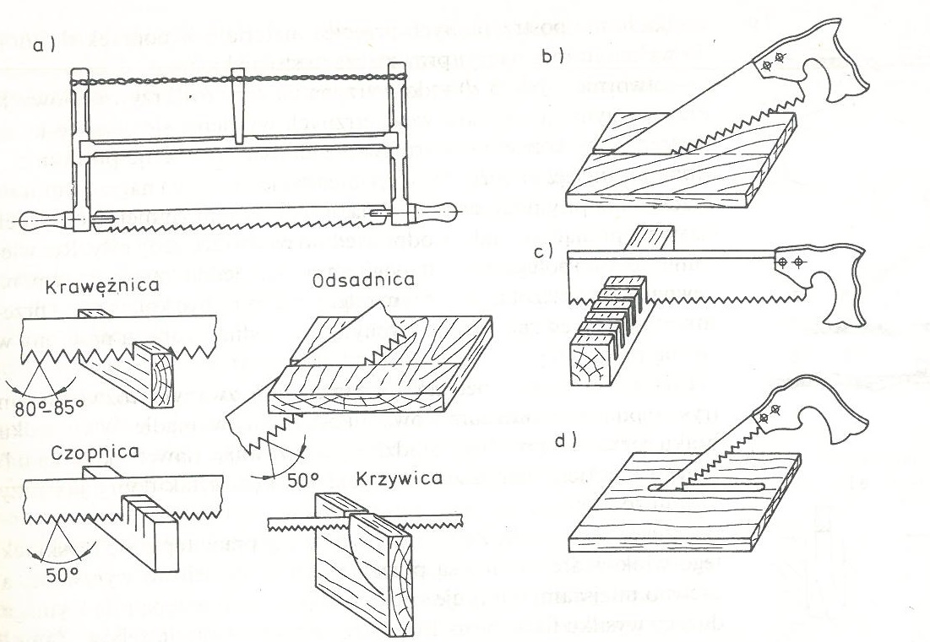
Figure. 21. Types of saws and their use: a) frame saw; b) payer; c) ridge; d) hole saw

The hacksaw blades have different toothing depending on whether they are for roughing or fine cutting. The most commonly used frame saws, depending on the saw blade attached, are:
- curb - for cutting along the fibers,
- tenon - designed to make joinery connections,
- guide bar - for making cuts with a smooth kerf across the grain,
- rickets - for cutting holes and curves

It is important to have prepared at least two blades for the same frame: one with coarser teeth for longitudinal sawing and the other with finer teeth for cross-cutting. In addition to the frame saw for boatbuilding, single-bar saws are also useful:
- panel - for cutting wide lumber,
- ridge - for accurate sawing in order to obtain smooth, fray-free cuts across the grain and for making cuts at carpentry joints,
- hole saw - for cutting out curved contours. When cutting the internal contours, a hole is drilled with a diameter that enables the sawing of the hole saw with the end of the hole saw.

4.1.1. Saw teeth opening
To prevent the saw blade from jamming and heating up during sawing, and thus to reduce the physical effort of the person cutting the saw, properly open the saw teeth. The teeth are bent at the same angle outside the saw blade, and the bending must be consecutive and alternating, i.e. one tooth is pivoted to one side, and the next one to the other side. The ways of setting the saw teeth are shown in figure 22.

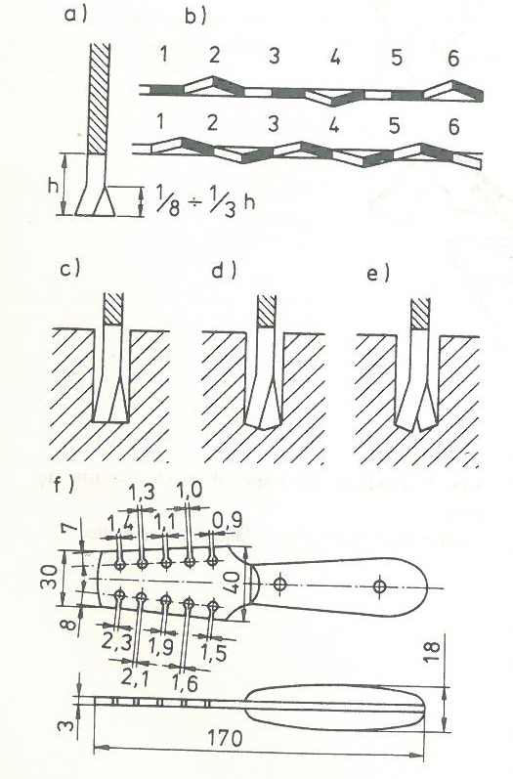
Figure. 22. Saw teeth setting: a) correct setting; b) methods of opening; c) correct setting - teeth first set and then sharpened; d) incorrect setting - teeth first sharpened and then set; e) too large an opening; f) single-arm retractor

The saw is opened with a special tool called a spreader, after fixing the saw blade in a vice. In the absence of a retractor, you can even cope with the use of a screwdriver or other flat tool, but the effect will not be as good as with the use of a retractor.

4.1.2. Sharpening the teeth of the saw.
After prolonged work, the saw teeth become blunt and as a result, the wood fibers are not cut, but partially torn out, and the wood peels in places. In addition, sawing with a blunt saw requires a lot of physical effort. The saw is sharpened after the teeth are opened. Clamping the saw blade in a vice should be such that the teeth inclination is directed to the right. The different kinds of sharpening the saw teeth was presented on the figure 23.

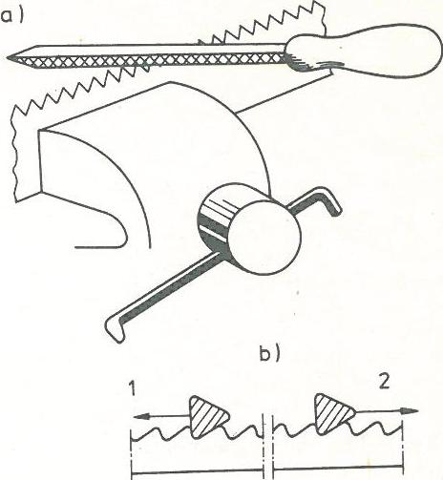
Figure 23. Sharpening the saw teeth: a) fixing the saw in a vice; b) sharpening schemes 1 - "under the tooth" - correct, 2 - with the direction of the tooth inclination - incorrect

The principle is to start sharpening from the right side, i.e. sharpening "under the tooth". Sharpen with a file with a triangular cross-section. The size of this cross-section should be such that it completely fills the space between the teeth. for each tooth the number of working movements guarantees uniform tooth heights The main cutting edges of blunt teeth always shine A fading flash when sharpening indicates that the teeth are sharpened.

4.1.3. Teeth alignment
Saw blades, after prolonged use, and especially with incorrect sharpening, can have uneven or even broken teeth. The teeth should then be aligned. For this purpose, a device is used, consisting of a wooden tray (1) in which a flat file (2) is placed. The tray with the file moves along the tips of the teeth until it reaches the level of the lowest tooth. This work is strenuous and profitable only with small differences in the height of the tines. The aligning saw teeth was presented in figure 24.

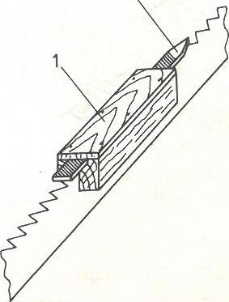
Figure 24. Aligning saw teeth: 1 - wooden trough, 2 - flat file

During sawing, use the entire length of the saw blade, while moving "away from you" (working movement), you should exert light pressure, and when moving "towards yourself" (idle movement), the saw blade should be slightly raised. When sawing, the inclination of the saw blade to the horizontal plane of the cut element is also important. When cutting the wood across the grain, a much greater saw slope is recommended - close to the level. The first strokes of the saw are made towards each other only to create a groove for the saw blade.
The plywood should be cut with a fine-toothed saw, e.g. with a spine. To do this, turn the plywood with the left side downwards so that the right side does not cause any cuts caused by the saw teeth tearing out the veneer pieces. In the absence of a fine-toothed saw, a piece of a board or plywood should be placed under the section to be cut and cut through both pieces.

4.1.4. Tools for finishing operations
A simple tool can be made to remove burrs created during plywood sawing (also textolite, plexiglass and other materials). hitting a hacksaw a piece of cloth in the shape of a triangle. The edges of this cutout should be sharpened with a file. As the cutout is triangular in shape, the tool is suitable for deburring the edges of workpieces with different thicknesses. By putting the plate with the cut out to the edge of the processed material and moving it "towards you", the edges of the material are aligned and deburred. The tool for deburring was presented in figure 25.

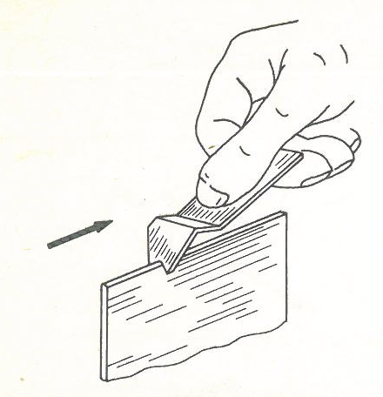
Figure 25. Tool for deburring

The exact cutting of wood at an angle of 90° and 45° is made easier by the miter box, which you can easily make by yourself. The box consists of three parts: the bottom and two side parts. The internal width of the box and its length can be any. After breaking the box, cuts are made in its side walls at an angle of 90° and 45° in two directions. When cutting, the element is inserted into the box, held with one hand, and with the other, using a ball, cuts exactly at the required angle. The cuts made in the side walls are a good guide for the saw blade, which does not bend and jump to the sides during cutting. Typical miter box was presented in figure 26.

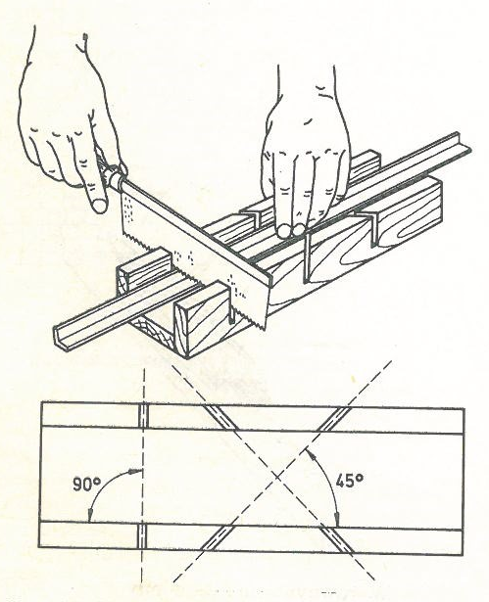
Figure 26. Miter box

Shipbuilding also requires cutting at angles other than 90 ° and 45 °. For marking such angles, an adjustable square, called a carpenter's miter saw, is used ( 11 a). Wood waste, preferably beech, is used to make it. First, a shaft with dimensions of 24x45x340 mm and an arm with dimensions of 9x45x290 mm are cut out. These elements are rough machined and then formed according to the construction dimensions (figure 11 b). After the two parts are carefully processed, they are put together, clamped in a planer or on a carpentry and cut out semicircular foreheads. The joiner's miter saw was presented in figure 27.

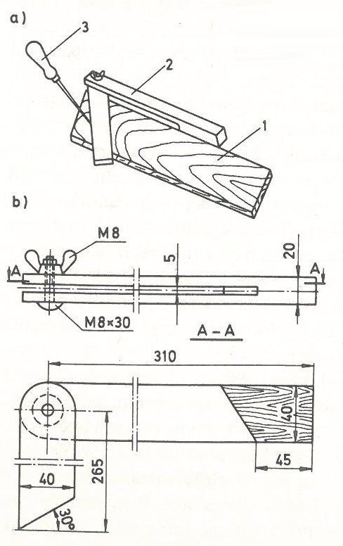
Figure 27. Joiner's miter saw: a) marking with a miter saw 1 - board marking, 2 - miter saw, 3 - stylus; b) working drawing

Mark the slot on the shaft, cut it out, then remove the waste with a chisel and file the inside of the slot with a file. All surfaces should be smoothed with sandpaper, put the whole thing together and drill a hole for the bolt. Preserve individual elements with varnish or clear varnish, and after drying, put them together and screw them together with a screw.

4.1.5. Mechanical tools
Having access to woodworking machines can save a lot of time and energy. A circular saw is used to divide the lumber and make raw elements. Longitudinal sawing is aimed at preparing raw elements with a width corresponding to the width of the element increased by some excess for further processing. For this type of sawing, a guide should be used set at the distance from the saw blade that is to be the width of the raw element. In the absence of a special saw for longitudinal cuts, the first precise cut in a straight line can be obtained by using a special pusher, which is made from a piece of a properly processed board. The Sawing wood with a guide was presented in figure 28.

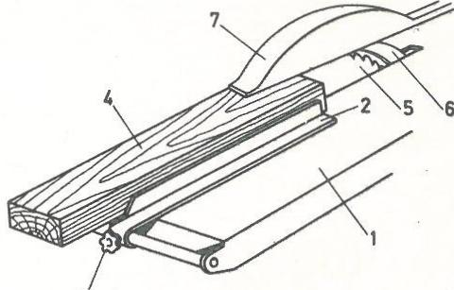
Figure 28. Sawing wood with a guide: 1 - machine table, 2 - guide, 3 - screw securing the guide, 4 - part to be sawed, 5 - saw blade, 6 - splitting wedge, 7 - saw guard

The appearance of the pusher and the way of using it is shown in fig. 13. The board (3) prepared for trimming should be placed on the machine table (1). Install the extended guide (2) along the guide of the machine in the form of a long, rigid, carefully machined strip. Apply the pusher (4) to the front part of the board and drive a nail into the hole (5) drilled in its side part so that the pusher's face touches the guide. By guiding the pusher's face along the guide, a straight cut is made of the board. The Figure 28. Performing the first cut on unedged sawn timber was presented in figure 28.

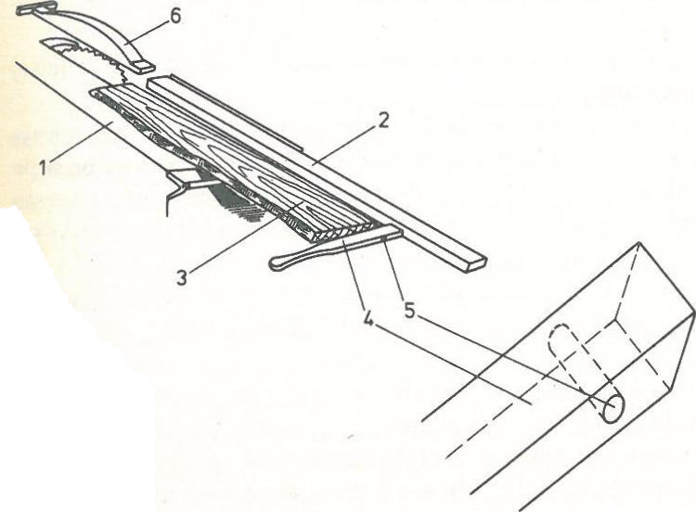
Figure 28. Performing the first cut on unedged sawn timber: 1 - machine table, 2 - extended guide, 3 - edged board, 4 - pusher, 5 - nail hole, 6 - saw guard

Since sawing with a circular saw is dangerous, basic rules must be followed. To avoid injuring your fingers, be sure to use the saw guard and the special material pusher. Align the guide bar parallel to the saw blade to prevent it from jamming. The use of glasses is required to protect the eyes from dust. The riving knife is used to prevent the material from being thrown away by the saw, which is caused by the material clamping on the saw due to stresses in the wood. When sawing across the cut, it is essential to stand on the left side of the material to be cut. The pusher for moving boards on a circular saw was presented in figure 29.

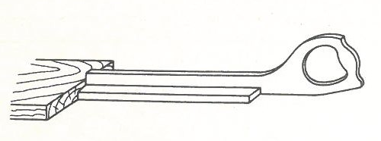
Figure 29. The pusher for moving boards on a circular saw

Oblique sawing is performed with the use of special equipment, which, together with the sawed board, moves along the machine table. The auxiliary device for oblique sawing is often equipped with a special protractor on which the angle at which the material should be cut is precisely set. Band saws are used for curvilinear sawing. Curves are cut out after drawing them on the surface of the material. The diagonal sawing device is shown in the figure 30.

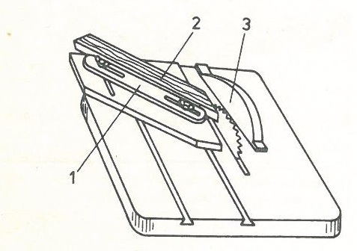
Figure 30. Miter sawing; 1 - auxiliary device, 2 - part being cut, 3 - saw guard

If you do not have a machine band saw, you can make a saw similar to a band saw. For this device, you need to make a solid table (1) and attach the square beam (2) to it at right angles. Attach a strong, flexible bar (3), e.g. made of juniper or ash, to the beam, which acts as a spring pulling the saw upwards. To the end of the bar, attach (e.g. with a metal clamp) the end of the saw blade to an ordinary frame saw, lead the saw blade through the hole cut in the table and fix the other end to the bar (4) pivoted to the other end of the beam. The end of this bar is a pedal that is pressed with the foot during sawing. Install a roller under the table that serves as a saw blade guide, against which its rear edge should rest. The home-made band saw was presented in figure 31.

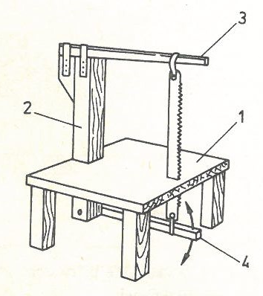
Figure 31. Home-made band saw; 1 - table, 2 - beam, 3 - flexible bar, 4 - oscillating bar

A sharp saw blade should be used for sawing. To prevent it from deviating from the correct direction, the saw should be kept exactly perpendicular to the sawing surface and guide it slowly and carefully. If the saw blade becomes excessively hot during sawing, open the teeth and sharpen them. In the event of the saw blade jamming, also open the teeth and sharpen them, and for a longer cut, press a narrow wooden wedge into the cut. The wrong angle of the saw blade can also cause jamming. When the cut plywood breaks loose, the cause lies in the saw teeth being too thick. The saw should then be guided at an angle to the sheet, not perpendicular.

Gluing wood
Joining wood with adhesives allows for obtaining elements of large thickness (posts, stems), large lengths (stringers) and surfaces (sides). Gluing combined with bending makes it possible to obtain curved elements without subjecting the wood to hydrothermal treatment. Gluing stiffens the joints, and therefore allows for a wide use of various types of carpentry joints. Only waterproof adhesives should be used for gluing wooden parts of boats and yachts. The most popular glue that is readily and generally available is casein glue. It is not completely waterproof, but it is suitable for gluing water equipment, provided that the glued places are isolated from direct exposure to water by painting several times.
The sale includes glues such as "Kazeinowy 416" for hard wood, "Kazeinowy 516" and "Kazeinowy 616" for soft wood and plywood. This glue should be stored in a cool place, preferably in tightly closed glass vessels. You mix it up in such a way that you add one part of the glue to two parts of water, mix it thoroughly for a few minutes, and then let it stand for about half an hour. If the glue thickens too much, prepare a new batch, do not dilute it with water.
AG glue is much better, but less accessible. It is a completely waterproof adhesive, insensitive to shocks, vibrations or weather conditions. Its only disadvantage is its short shelf life, which is about a month and a half. Before use, the adhesive is mixed in the ratio of 100 parts of the adhesive and 18 parts of the special AG hardener. The life of such prepared glue at 20 ° C is about one hour and it decreases with increasing temperature.
During places for gluing preparation, i.e. joints, it is first of all necessary to check whether the joined elements are accurately machined and matched to each other. Then, the glued joints should be thoroughly cleaned of dust, grease (e.g. by washing with denatured alcohol), possibly varnish and other residues. Of course, only dry wood can be glued. The temperature of the room where bonding takes place is also important and it should not be lower than 10 ° C.
It is best to apply the glue to both glued surfaces with a brush and leave them for a few minutes. Then put the lubricated parts together and press them together with the help of wooden clamps. When gluing long pieces of wood, e.g. masts or booms, the clamps placed along their entire length should be tightened gradually and successively in such a way that the pressing force along the entire length is approximately the same. The stronger the pressure, the better the bonding will be. The different types of gluing were presented in figure 35.

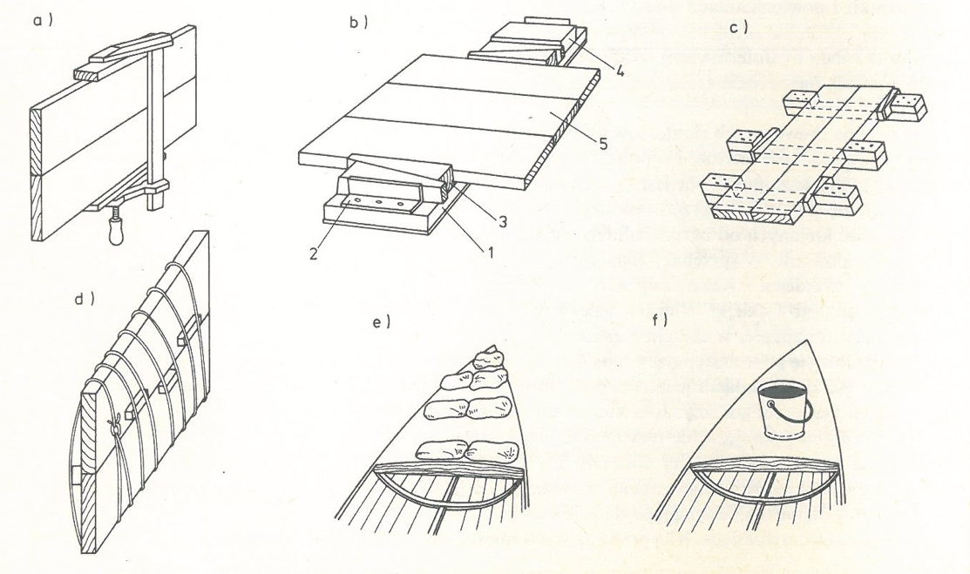
Figure 35. Gluing a) with a carpentry clamp; b) using a supporting board: 1 - board, 2 steel angles, 3 - wooden wedges, 4 - blocks, 5 - glued elements; c) with the help of wooden wedges and blocks; d) applying pressure with string and wedges; e) sandbag load; f) load with a bucket of water

In the absence of carpentry clamps, simple structures can be glued with a supporting board (figure 35 b). It consists of a base board (1) and steel angles (2) fixed at both ends. The pressing force of the glued element (5) placed on the board is regulated by means of wedges (3) and additional blocks (4). If the glued constructions are quite long, then simple devices (figure 35 c) made of strong pieces of wood and wooden blocks attached to its ends can be used for gluing them. The glued parts are pressed down with wooden wedges.
The easiest way to exert pressure during gluing is to wrap the glued elements with string or wire (figure 35 d), and then increase the pressure by inserting the wedges between the glued element and the string or wire. When gluing a plywood deck, the appropriate pressure can be exerted by placing bags filled with sand (figure 35 e) on it or, for example, placing buckets of water (figure 35 f) or even pressing bricks.

4.3. Wood bending
In amateur conditions, wood bending is performed by "dry" gluing on templates or by "hot" bending. For "dry" gluing, appropriate templates should be made. The template for gluing frames and stems was presented in figure 36.

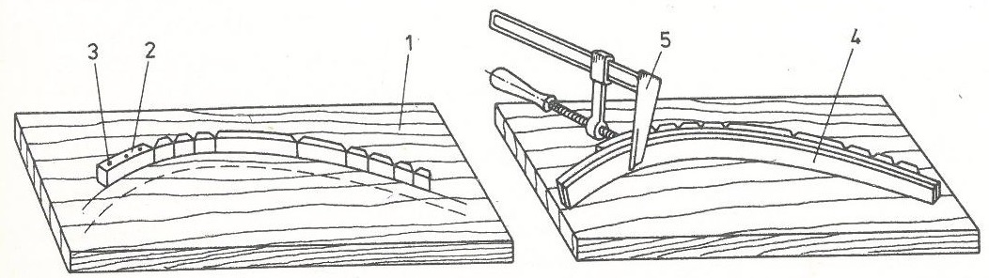
Figure 36. Template for gluing frames and stems - gluing elements on the template 1 - thick board or plywood, 2 - blocks, 3 - screws, 4 - strips, 5 - carpentry clamp
Source:

To make them, you need thick plywood (1) or another board with a thickness of more than 20 mm. On this board, mark out the shape of the glued element, and then, along the drawn line, fix hardwood blocks with screws (3) and nuts in such a way that their front walls give the total outline of the glued element. Longer blocks (2) are mounted on straight sections, and short ones on rounder ones. These blocks do not have to touch each other, because the covered strip will follow the drawn line anyway. Then a few strips (4) coated with glue are folded together and screwed together with carpentry clamps (5). Clamps should be fastened every 15-20 cm. After the glue dries, the moldings will retain the required shape.
The same is done when gluing the stem, but if it is a stem of quite large dimensions, instead of blocks, special holders should be made from an angle bar (6) with dimensions of 30x30x5 mm. The height of the handle depends on the width of the stem. The angle section - after a suitable incision - is bent at an angle of 90 °, and a rod (7) with a diameter of 10 mm should be welded as the hypotenuse. In the lower part of the angle bar, two holes are drilled through which the holder is attached to the board with screws. The handles are attached every 20 cm in such a way that their foreheads are always tangent to the drawn line. The Template for rebate and stem gluing - stem gluing holder was presented in figure 37.

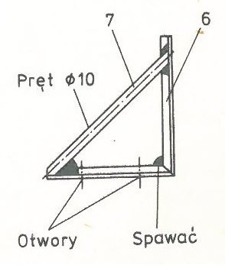
Figure 37. Template for rebate and stem gluing - stem gluing holder 6 - angle section, 7 - rod
Source:

Hot bending is less labor-intensive than gluing, because the tedious process of cutting and processing the strips and gluing is eliminated. On the other hand, bent elements are weaker and it is difficult to predict whether the material has hidden defects inside. For bent elements, the same templates are prepared as for gluing, but the steps are slightly different. The material to be bent can be plasticized by evaporation or by boiling. An amateur way of pairing elements in a work box is presented in figure 38.

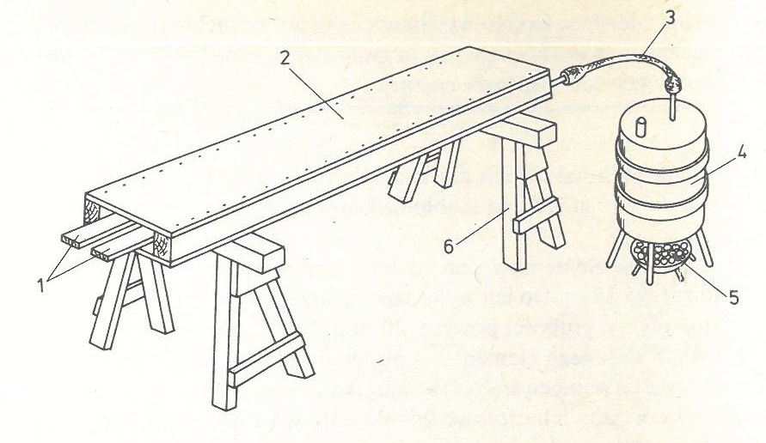
Figure 38. Steaming the strips in the steam box 1 - pairing elements, 2 - steam box, 3 - rubber, 4 - metal barrel, 5 - hearth, 6 - goats
Source:

The material (1) prepared for bending is placed on the pads in the steam box (2) made of e.g. plywood or boards and open on one side. The box is placed on an elevation (6). A rubber hose (3) connected to a metal barrel (4) is connected to the evaporation box. The barrel is 3/4 filled with water so that steam can collect in the remaining volume. A fire starts under the barrel in the furnace (5). From the moment of boiling the water, the elements are kept in the box for about 20 minutes, then they are taken out and bent on a template or bent into the hull. After drying, the elements retain their shape.
The cooking process is similar, for which a metal pipe with a larger diameter (about 100 mm) and a length depending on the length of the bent elements is used. The pipe must be "sealed" on one side by welding the metal bottom. Water is poured into the pipe and inserted diagonally into the furnace or coke oven furnace. He puts the elements (2) prepared for bending into the pipe (1) and also boils it for about 20-30 minutes, and then after taking it out, it bends on a template, remembering to hold them quite densely with clamps. The coking slats in a pipe was presented in figure 39

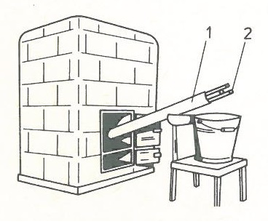
Figure 39. Cooking slats in a pipe; 1 - metal pipe,
2 - elements prepared for bending.
Source:

Unit 5. Acquiring knowledge about bending of wood by steaming in order to obtain curvilinear elements of the skeleton and planking of ships and boats,

5.3. Wood Modification
Wood is the ultimate renewable material. It possesses qualities that have made it a material of choice for millennia and these qualities are further enhanced by its recognized carbon sequestration. Moreover, the polymeric components of wood and its porous structure confer on it a noble, versatile, and general-purpose character and a faculty for transformation exceeding that of all other materials. The unique advantages of this material, its widespread availability, sustainable renewal, favorable ecological assessment, and its flexibility of implementation, give this worthy material its letters patent of nobility in the eyes of scientists and engineers. Nevertheless, the fact that wood is a natural product originating from different individual trees imposes limits on its use. This natural material may need to be transformed in order to acquire the desired functionality.
There are ways in which the properties of wood can be enhanced by modification through eco-friendly methods. One emerging eco-friendly method is the combined use of temperature, moisture, and mechanical action, the so-called thermo-hydromechanical treatment. There are numerous thermo-hydro-mechanical processing techniques and the number of these processes is growing continuously. Termo-hydro-mechanical processing is implemented to improve the intrinsic properties of wood, to produce new materials, and to acquire a form and functionality desired by engineers without changing the eco-friendly characteristics of the material. These processes can be divided into two major categories; Thermo-Hydro treatments (TH) and T Thermo-Hydro-Mechanical (THM) treatments.
Craftsmen have modified wood for centuries by TH/THM treatments, but it was in the 19th century, with the construction of the Vienna Chair by Michael Thonét (1796-1871), that the industrialized process of wood molding technology was born, allowing its products to be commercialized all over the world. Besides greatly improving the understanding of basic material properties, chemistry, and physics as well as giving rise to advances in materials and wood science, modeling techniques provided the means for engineers and researchers to engineer wood as a material and produce new materials under controlled processing conditions.
Hydrothermal treatment involves the action of heat and water or steam on wood. Wood, softened in this way, is more susceptible to bending. For the so-called For the evaporation of wood, you need a device in which it can be folded. Usually they are autoclaves, cylindrical tubes with hermetic closure, to which steam pipes are brought. Of course, in artisanal conditions, it is impossible to have the above-mentioned ones, but you can make a home-made steamer or a bathtub in a quite accessible way. Evaporators can be of different sizes, it depends mainly on the demand. The easiest way to make an evaporator is to build a chamber to which we will lead the steam pipes. You will also need a steam source. A properly prepared furnace will be irreplaceable. The wood should be steamed until it reaches 30-35% humidity. For small plants, it is a good idea to soak the wood in vats or other containers with warm water. Timber that is assembled for several days, depending on the species, should absorb enough water to become plastic. In order to bend the wood, we also need a suitable device, called a hoof or a yoke.

5.1.1 Reasons for thermo-hydro-mechanical processing
Never before have the forestry and forestry-related industries been so sharply in the focus of discussions concerning the major challenges for the future. The challenges being discussed are of great significance: instead of consuming the Earth’s nonrenewable resources, the use of renewable materials is being encouraged in all quarters; fossil fuels must be phased out and human consumption must increasingly reflect a concern for the climate and the environment. Whilst in service, the carbon having been fixed in wood by photosynthesis can act as a long-term carbon store. Wood-based products such as solid wood can also act as short-term carbon stores. Carbon accounts for about half of the mass of a wood product. For example, with a wood product stock of about 60 million tonnes in Europe alone, the carbon storage effect of wood products plays a significant role in mitigating ecological and societal effects. The forest industry uses renewable raw materials and manufactures eco-friendly products. Carbon is stored in the forests and in their products. This means that both forests and forest products are part of the answer to the climate challenge.
Concern for the environment and the climate has put pressure on wood researchers and the wood industry. The demand for investigations and the development of new treatments for eco-friendly products, for improving wood properties and finding alternatives to tropical hardwoods as well as to energy-consuming material processes and fossil-fuel-based materials is greater than ever before, and this is the reason why some new modification technologies are being commercialized.
The TH process is based on wood, water, and heat, and the T HM treatment incorporates an additional mechanical force. This is an environment-friendly process that uses a recyclable and renewable natural resource that decreases the CO2 in the atmosphere. At the same time, T H/THM processes consume relatively little energy. The result of studies in different fields of T H/THM processing also indicates that the properties of wood such as its dimensional stability, strength, surface hardness, and durability are improved.
Enhancing the competitiveness of timber by using an innovative upgrading method with a low environmental impact can increase the use of local materials instead of imported rare tropical hardwoods, creating added value for local timber resources, increasing profitability, providing regional income, and providing employment in regional/convergence areas. People are also starting to recognize the advantages of combining renewable sources such as wood with an environmentally acceptable processing technique in order to achieve new high-quality materials. Thermo-hydro-mechanical processing as a base for product improvement and the development of new product-market combinations is now of significant interest in the industry. Potential areas of application for thermo-hydro-mechanical processing include the building industry, furniture manufacture, improving service lives of wood products through increased durability and stability, wood-finish compatibility, and new market areas now being identified.

5.1.2 Modification of wood
The purpose of any technological development involving wood is to standardize, homogenize and produce new wood-based materials with dimensions that are independent of those of the tree, to decrease anisotropy, overcome the problems of dimensional instability and improve the material’s durability and resistance to fire. In order to obtain semi-finished and finished products with or without added value, wood can be transformed
- by transformation, i.e., sawing, chipping, pulping;
- by reconstitution, i.e., in the manufacture of engineered wood products from wood, wood chips, and particles; and
- by modification.

For TH/THM wood modification the specially adapted tools and instruments are used. They were created in a long period of time, by riching the experience gained during several millennia of wood TH/THM treatment, and especially the role of wood science, chemistry, mechanics, and physics on the recent techniques of wood thermo-hydro-mechanical processing. To modify wood, two treatment types are implemented: chemical treatments and TH/THM treatments. The former are much more numerous and the range of chemical agents is very broad, whereas, for the TH/THM treatments, only heat, water, and mechanical forces are employed. Displays a simplified synoptic diagram of the current chemical and THM treatments were presented in figure 40.

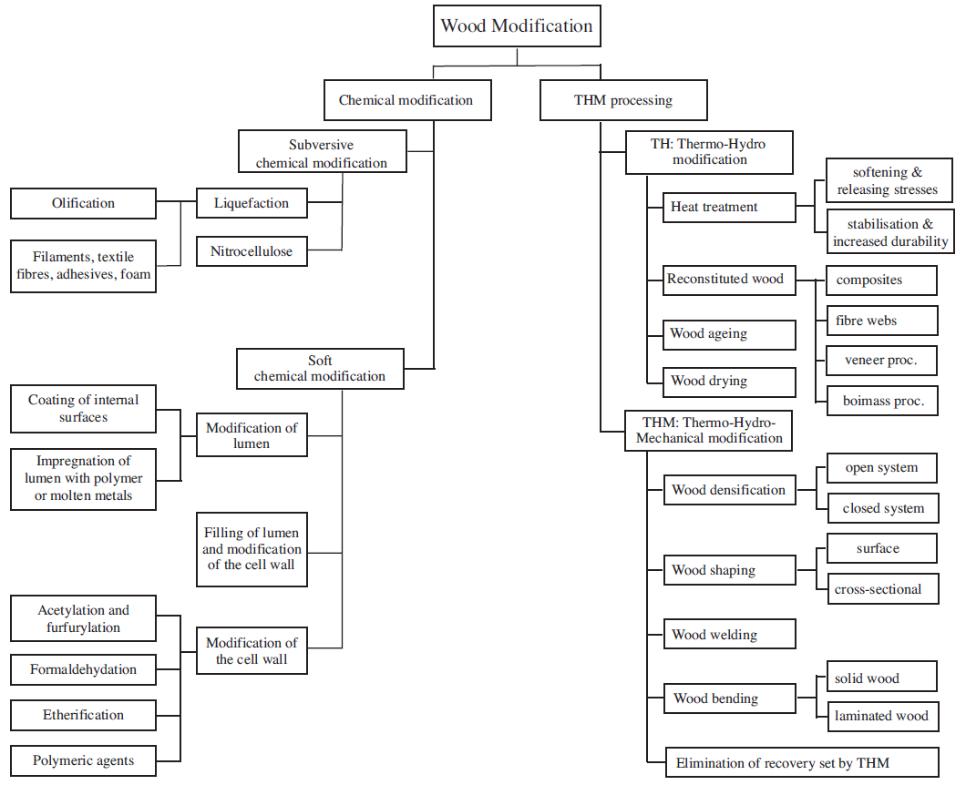
Figure 40. Diagram of the various processes of chemical modification and thermo-hydro-mechanical processing of wood.

5.3.3 Chemical modification
Chemical modification of wood is defined as any chemical reaction between a reactive wood cell component and a chemical reagent, with or without a catalyst, giving rise to a covalent bond between the two components. The most promising application of this technology is developed in the area of reconstituted wood products, e.g., particle boards, plywood, and veneer-based products and in the enhancement of the dimensional instability, resistance to biological degradation (durability) and resistance to fire of the wood.
Generally, two classes of chemical treatments can be distinguished: subversive and soft. The subversive treatments are those that enter into the core of the cellulose fibrils. They break down the crystalline structure of cellulose and eliminate the multilevel and hierarchical structure of wood. These treatments radically modify the chemical components of the wood, and consequently, the material produced lacks practically all the intrinsic characteristics of untreated natural wood. Examples of subversive treatments are liquefaction and olification of lignocelluloses, where liquefaction is adopted mainly to produce oil from biomass under very severe conditions. Converted celluloses to oil using reactive chemicals, under high temperature and high pressure. T his type of liquefaction is called olification of lignocelluloses. Other recent types of liquefaction involve the dissolution of chemically modified wood or even untreated wood in a solvent. Applications of these types of liquefaction have been developed in the preparation of adhesives, moldings, foams etc. Nitrocellulose (cellulose nitrate) is prepared by treating cellulose with a mixture of nitric acid and sulfuric acid. It is employed as a propellant or low-order explosive (guncotton) and as a film-forming resin in the inks and coatings market.
The soft chemical treatments, on the other hand, leave the crystalline structure of wood intact and touch only the amorphous part and the side groups (functional groups) of the wood components at the molecular level. These treatments allow the microstructure of the modified wood to remain more or less unchanged. In this category, some typical treatments include formal dehydration, acetylation, etherification, impregnation by carbinol and maleic acid, impregnation by vinyl resins, impregnation by polyethylene glycol (PEG ), impregnation by phenol-formaldehyde resin, filling by metal alloys of low melting point, etc. These treatments can lead to improvements in certain physical and mechanical properties of wood, such as hygroscopicity, resistance to micro-organisms, and fire resistance, as well as in its mechanical behavior with respect to the moisture variations. There was also investigated the influence of various soft chemical treatments on the mechanical and physical characteristics of wood, and they have shown that some treatments improve certain properties of wood but are likely to lead to deterioration in others. For example, the impregnation of wood with a polyethylene glycol (PEG) resin reduces the hygroscopicity of wood but at the same time increases the mechano-sorptive creep deformation. In contrast, acetylation can simultaneously reduce both the hygroscopicity and the mechano-sorptive creep behavior of wood.
The chemical treatments that involve a radical modification of the wood structure, i.e., subversive chemical wood treatment, constitute a delicate field, which requires a detailed study of the organic chemistry. The soft chemical treatments of wood are mainly implemented to reduce the hygroscopicity and mechano-sorptive creep and increase the resistance to micro-organisms.

5.3.4 Thermo-hydro and thermo-hydro-mechanical modification of wood
The TH/THM treatments have an important advantage over the chemical treatments since the products of the TH/THM wood are particularly environment-friendly. During thermo-hydro-mechanical processing, no chemical agents are introduced into the wood and no subversive chemical degradation affects any of its components. Under TH/THM treatments, many types of processes are developed to produce different products as a result of the laboratory level or in industrialized commercialized processes. The TH treatments include many types of processes, such as those to:
- improve dimensional stability and reduce the wood hygroscopicity;
- enhance the resistance to micro-organisms;
- achieve accelerated aging of the wood;
- release internal stresses (reduce the recovery set) and soften the wood through wet heating.

One can also perform a TH treatment of reconstituted wood products, e.g., wooden composites, paper, fiber-boards, plywood and wood plastic composites. The THM treatments include
- densification, i.e., T HM densification in a closed or open system;
- wood shaping by surface densification and embossing;
- wood shaping by wood cross-sectional transformation;
- wood welding;
- wood bending, i.e., solid wood bending and laminated bending; and
- THM treatments to eliminate the shape memory of densified wood.

The fact that wet wood can be shaped under the action of mechanical and thermal loads has been known for a very long time. The various stages of the construction include the preparation of the hull starting from a trunk, heating of the hull of humidified wood, giving the desired shape to the canoe, and mechanical fixing to maintain the given shape. Mallets and wedges are used to hollow out the interior of the trunk. The trunk is then scraped to give it the desired thickness; one finger thickness for the upper part and two fingers for the bottom. In order to widen the canoe and give it the final shape, it is filled with water to humidify the wood. The water is then heated to boiling by heated stones. The fire lit at the side also heats the outside of the canoe. Once the wood has been softened by the hot water and fire, the wooden beams are set up to widen the hull, fixing and maintaining the desired shape. The principles used in the construction of a canoe by an elementary and ancient THM process were presented in figure 41.

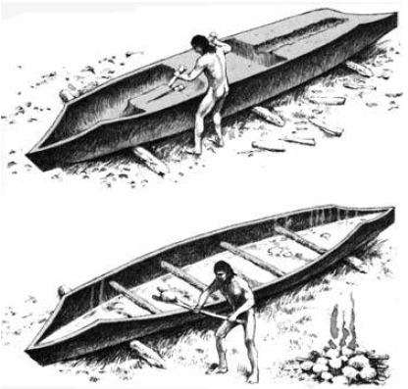
Fig. 41. The construction of a canoe (Freed & Baby, 1983).

The shaping of steamed wood has been employed since antiquity and has been carried out in numerous ways. Plasticization of the solid wood in order to make it possible to bend the piece without fracture is the most common way of shaping, e.g., for ship construction. The bending can be achieved in one or in two planes as well as in different directions in the same plane. Wood is normally bent after pre-steaming in various types of strapping devices that minimize the effect of tension on the convex surface and maximize the compressive yield on the concave surface, thus limiting the risk of breakage.
Another process involving the shaping of wood is the technique of laminated bending that is primarily directed towards the bending of veneers for other than structural purposes, such as in sports goods, furnishing details, etc. The need to increase the efficiency of the process of manufacturing wood veneer products and the increasing importance of laminated bends in structural applications has led to an increasing interest in a basic understanding of the wood material and the process. The fundamental mechanisms that must be understood and developed for bending laminated wood for structural purposes and for non-structural members are however similar, especially when the radius of curvature is small. The examples of products made by solid wood bending and laminated bending was presented in figure 42.

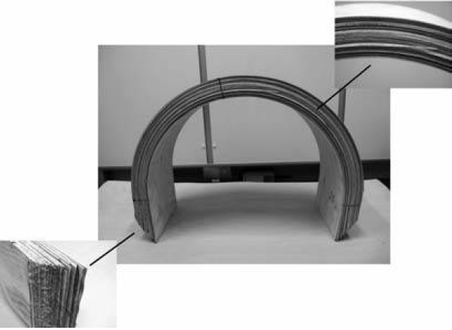
Figure 42. Examples of products made by (a) solid wood bending (chair) and (b) laminated bending (window frame).

Wood can be densified and its properties modified not only by filling its void volume with polymers, molten natural resins, waxes, sulfur, and even low fusion metals but also by compressing it under conditions such that the structure does not become fractured. Densification is the process whereby the wood density is increased by reducing the void volume of the lumens in the wood material.
In Inwood shaping, the wood can be processed either at the surface or in the cross-section of the wood. Embossment is a process where the surface of the wood is partially densified, normally by a steel tool, to create a decorative pattern on the surface. This process is comparable with the methods of densification of wood, but its main purpose is not to increase the density of the wood, but only to shape the wood surface. Embossment has a long tradition. For example, the art of pressing, engraving, and fretting patterns into wood has been a part of I ran’s ancient history and goes as far back as 5000 years when it comes to the interior design of palaces, boxes laid over tombstones, pulpits, and book-racks. The advances achieved during the 20th century in wood material science and engineering provided the means for engineers and researchers to develop new eco-friendly materials from the wood.

5.4. Thermo-hydro wood processing
The thermo-hydro treatment of wood constitutes a modification technique since the wood constituents undergo chemical changes during the treatment. The reasons for heat-treating the wood is to improve some of its intrinsic properties such as dimensional stability, resistance to micro-organisms, stress relaxation during the forming of wood-based composites, veneer production, woodcutting, and wood fracture resistance. Currently, this technique is implemented to make artificially aged wood, so-called accelerated wood aging.
Over the 40th investigated the effect of heat and processing time on the dimensional stability of wood. Wood was immersed in baths of molten metal at temperatures between 140 and 320 °C, and it was reported that heating for seven hours at 260 °C reduced the swelling of Sitka spruce by 60%. In the middle of the 60th was reported that, although the dimensional stability and set recovery of compressed wood were improved by heating, certain parameters related to strength were reduced to an unacceptable level, particularly the surface strength. Hence, it was predicted that the dimensional stabilization of wood by heat had no future.
In 70th the effects of temperature, pressure, and moisture content were studied to find the optimum conditions for the heat-stabilization of different species of wood, and a heat-treatment method called FWD (Feuchte-Wärme-Druck) was launched. The optimum conditions for pinewood for instance were stated to be a moisture content of 20-30%, a temperature of 160 °C, and a pressure of 0.7 MPa. A considerable resistance towards brown rot fungus was reported, and the strength reduction was stated to be insignificant.
During the 1980s, French and Japanese industries began to study the heat treatment of wood in a closed system in order to increase microbial durability. Since then, the interest in heat treatment has increased all over the world. The process essentially involves a controlled degradation of wood, primarily resulting in the destruction of hemicelluloses. Several different methods are included. The basic diversity of the different processes is indicated by their oxygen-excluding and heat transporting media. Substantial similarity is that these processes run in a temperature range between 180 and 240°C to change the chemical composition of the cell wall. Due to a severe loss of strength, TH treatments of wood at elevated temperatures above 300°C are limited. The temperature is achieved with superheated steam in a vacuum, or with an inert gas such as nitrogen. Pre-heated oil can also be used in the process. A simplified picture of the results obtained from the heat-treatment methods indicates that heat treatment increases the stability and durability but also the brittleness of wood and leads to a loss of certain strength properties including impact toughness, modulus of rupture, and the work to failure.
The commercializing of industrial heat-treated wood products is a recent advance. This type of industry aims at improving the biological durability of less durable wood species and enhancing the dimensional stability of wood or wood-based products, e.g., particle boards. The properties of industrially produced heat-treated wood, in general, have been intensively investigated in recent years. On the European market, several industrial heat-treatment processes have during the last few years been introduced using closed systems.
The most widespread industrial heat-treatment process of wood is the seasoning sawn wood in kilns. This process is performed at temperatures below 100 °C, i.e., low-temperature convective drying, or above 100 °C, i.e., high-temperature drying. Thermal modification of wood may be viewed as an extended seasoning process, which ends with an increased temperature period when all the water in the wood has vaporized. One heat-treatment chamber for controlling the temperature and humidity of a two-stage treatment plant was presented in figure 43.

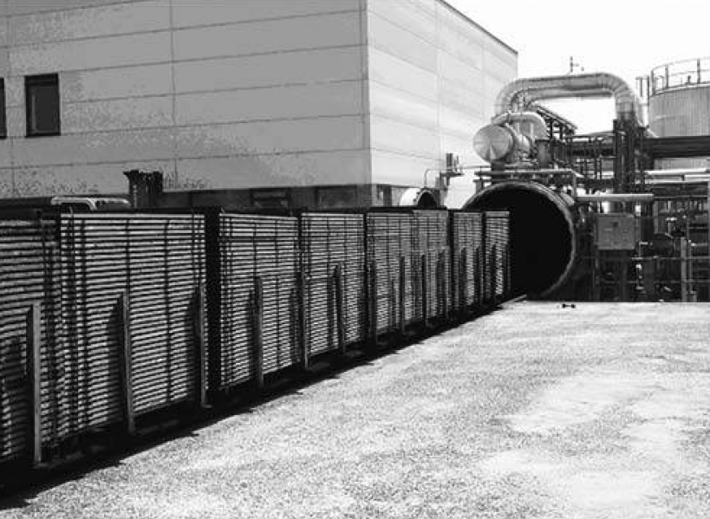
Figure 43. Heat treatment according to the Plato process in a thermo-hydro vessel, 20 m long and 2.4 m in diameter, with a controlled temperature and humidity (by courtesy of the Plato International BV, the Netherlands).

In a TH process, wood is heated in water to soften it and to release its internal stresses. A common industrial TH process is steaming and boiling logs before slicing or rotary peeling them to veener. Actually, the boiling temperature of the water is seldom reached. Almost always, the temperature is lower than 100°C. TH processes have also been extensively studied as a technology for the processing of biomass for the production of sugars. That's why for several decades, friction welding has found broad applications in many metal and plastic industries.
In 90th the studies of joining wood pieces by means of pressure and frictional movement were attempted. It was noticed, that two pieces of wood can be welded by means of an oscillating or linear frictional movement. Early work in joining pieces of wood by friction welding, was noticed that demonstrated that during the welding process the contact zones between two wooden pieces were joined together by “molten wood” through the heat produced during the frictional movement. The movement causes a thermal alteration of the wood cells, which leads to the formation of a viscous layer or “molten wood”. After stopping the friction movement and cooling, the material in the contact zone forms the connection between the pieces, as displayed in Figure 44.

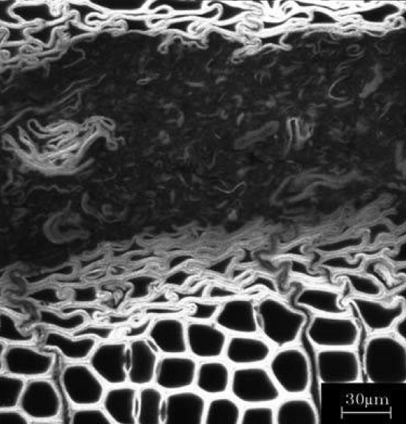
Figure 44. Cross-sectional view of a confocal laser-scanning micrograph picture of the heat-affected zone and the adjacent regions of friction-welded Norway spruce (Stamm et al., 2005).

Investigations of the welded wood show that the strength achieved by this method is close to that obtained using conventional glues, but that the strength of friction welded joints decreases at high humidity. The development of a relatively high initial resistance also permits for instance the continuous welding of multilayered laminates. In this technique, the temperature of the wood between the welded surfaces may rise to more than 400 °C during welding. Moreover, the total welding processing time is short, about 10-20 seconds. These techniques have attracted industrial interest.
Mechanically induced vibration wood-welding techniques can also be utilized to obtain wood surface finishes with a greater surface hardness and performance in the presence of polymerizing unsaturated oils, such as sunflower oil or other polymerizing finishes.

5.5. Thermo-hydro-mechanical wood processing
Compressing wood in the transverse direction reduces the void volume of the lumens in the wood material and increases its density. This process is commonly called densification. The idea of wood densification by compressing the wood in its radial direction existed begin in 1886. Next on 22th, the method for densifying wood by impregnation with rubber was developed. Until the year 1945, this type of wood was used in the aviation industry when it was replaced by aluminum. Compressed solid wood has also been made in Germany since the early 1930s and commercialized under the trade name of Lignostone, a corresponding laminated compressed wood under the trade name of Lignofol, and a resin-treated laminated compressed wood under the name of Kunstharzschichtholz.
The first aim of the densification was to improve the mechanical behavior and moisture sorption of wood. At present, the objective of wood densification is manifold and includes numerous processes, such as wood shaping, enhancing the intrinsic mechanical, physical properties of the wood, producing high-quality wood, wood surface densification. One of the reasons for densifying wood in the transverse direction is to produce high-quality timber from timbers of low quality. A process developed in Japan called “Compressed Lumber Processing System” transfers a local timber with a low density of about 300 kg/m3 to timber with a density greater than 900 kg/m3. The elements fabricated by this THM process at a temperature of 180 °C were presented in figure 45.

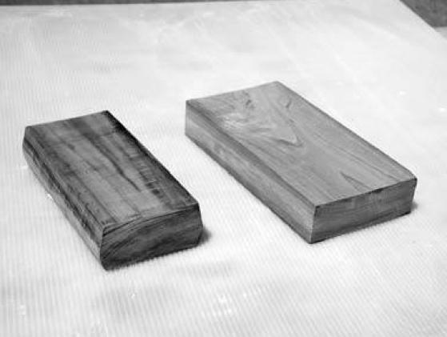
Figure 45 Photograph of two elements of densified wood fabricated by the “Compressed L umber Processing System” from low-density wood.

However, densified wood shows an undesired behavior, i.e., a tendency to recover all or part of its compression-set and return to its initial dimensions when subjected to heat and humidity. This phenomenon is called “shape memory” or “compression-set recovery”. Various wood products (bentwood, densified wood, wood surface densified wood, molded wood, and compressed wood fibers) suffer from shape memory. To overcome this issue, impregnated the wood after compression with a phenol formaldehyde resin. The wood was then heated for 10 to 20 minutes to polymerize the resin. This type of compressed and impregnated wood was called “Compreg”. Had thus succeeded in partially eliminating the shape memory of densified wood by a TH treatment. During advanced investigations of the densified wood treatment in THM processing has been noticed that the THM post-treatment of densified thin wood specimens at 200°C for only 4 minutes was sufficient to eliminate almost totally the shape memory of densified wood. On the other hand, the thermal treatment of wood was limited to 300°C, due to severe degradation of the strength of the material.
The purpose of recent research into molding and wood densification is techniques development for THM post-treatment involving the elimination of set recovery to implement wooden elements with large dimensions. Currently, this field is still developed especially into the THM densification of wood are being carried out. These processes are based on two-directional transverse densification of wood elements and involve four stages:
- wood plasticization by high-temperature steam,
- compressive molding,
- THM post-treatment, and cooling.

Two techniques are being developed, in which small trunks of wood with circular sections are transformed into trunks with square sections; and one is known as the “Compressed Lumber Processing System”. The differences between the two techniques lie in the stage of post-treatment. In the first technique, the molding and post-treatment form a continuous process, whereas in the second technique these two stages are separated. The problems related to the dimension of the wood elements (side effects), such as the development of cracks and exfoliation during shaping, cooling, and drying have yet to be completely solved. However the problems of “compressive molding of wood under a high-pressure steam technique” require much fundamental knowledge on wood THM behavior is required.
The researches of molding and wood densification were also developed in the field of molding, densification of wood, and THM post-treatments as well. An example can be the developed machine for pre-compression of wood in the longitudinal direction. After that, this type of densified wood element can be bent without steaming and jigs. The procedure involves:
- compressing the steamed softened wood element longitudinally in about 20%,
- releasing the applied compression, after which the wood partially recovers,
- the compressed set, so that the residual deformation is about 4-5%,
- allowing the wood to cool at room temperature and dry to a moisture content of 12%.

The deformation of wood cells during densification was also studied. After the investigation was discovered, that the hydrolysis of wood hemicelluloses from origin set recovery is sufficient to almost totally eliminate the shape memory through relaxation of the stored strain energy. A system for wood heat treatment based on oil at a high temperature (OHT), was also developed in this pass of time. In this open system, rape-seed oil is used as a medium as it can be heated above 200 °C. A similar system was investigated for eliminating the set-recovery of large industrial densified wood elements. The results have shown that oil-heating at a temperature above 200 °C can completely eliminate the compression-set recovery of large densified spruce panels. Such a product has shown improved resistance against micro-organisms. Because of its improved durability and the impregnation of densified wood by oil during the post-treatment, this type of product can be used for outdoor purposes.
According to the harvesting of rapidly grown wood, with low density, the densified wood in the production usage possibility ​of composite layered materials was also investigated. To densify small low-density hybrid poplar specimens the semi-closed THM reactor was developed. This system might have had some advantages in the field of all closed systems, but unfortunately, the dimensions of specimens used for densification are small and it would be difficult to evaluate the interest of this system when employed for large sized wood elements for building and construction purposes.
At present, the technology of TH wood treatments has been industrialized and their products are being commercialized. The research in the field of wood THM molding and wood densification as well as the post-treatment of compressed wood by THM actions aims to widen this field to large-sized wood elements for applications in the building industry. Moreover, many other THM treatments are advancing at the laboratory level. However, the main characteristics of all recent TH/THM treatments are based on scientific knowledge, wood physics, chemistry, mechanics, material, and wood sciences. Understanding these treatments requires the appropriate scientific knowledge related to wood. It is essential to know the structure and composition of wood, the elasto-viscoplastic behavior of the wood according to the temperature and the wood moisture content, the effects of TH/THM processing parameters (heat, humidity, and processing time) on the mechanical properties, the chemical kinetics of reaction and degradation of wood, heat and mass transfer in wood during TH/THM processing and the mechanisms of eliminating recovery-set in THM woods.

5.6. Bending of solid wood in woodland craft
Techniques for bending wood are existing since long period of time, although early man used heat to help straighten rather than bend his arrows. Rigid pieces of wood may be rendered pliant by heating, steaming, or boiling, and these methods are used in such varied crafts as basketry, chair-making, and the shaping of tool handles and wooden hoops. Thin rods will often bend satisfactorily without treatment, if the wood is handled whilst it is still green and unseasoned, and in other instances water alone may suffice to restore its pliancy. For walking sticks, craftsmen have often bent and bound wood while it is still alive and green, so that it will grow into the desired shape without being weakened by the stress of stretching and compression. Sometimes the material is warmed over a naked fire or in damp sand. The softening treatment may be used for straightening curved rods as well as for bending straight ones. In either case, the wood retains the shape in which it is dried and “set”, as shown in figure 46.

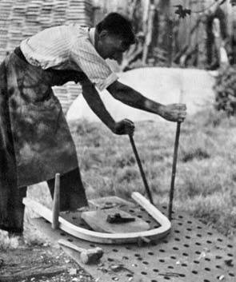
Figure 46 Bending a length of steamed ash to form the back frame of a Windsor chair

Ash wood is a strong, tough and pliant material that is also light in weight, readily cloven and easily bent either in the green state or after steaming. Consequently, ash is a common material in woodland crafts in regions where this species is commonly grown. This craft was widespread in the countryside of Great Britain until about the 1950’s, and it has also been practised in many other parts of the world.
When making a hoop, a straight ash pole is first split into three or four segments with a froe (sort of knife), while being held in the angle of a stout three-legged break. The hoop-shaver then trims each piece to shape with his draw-knife, sitting astride his wooden shaving horse, which holds the wood in its vice-like grip. Each thin band is then warmed over a fire to render it pliable and then bent between two rollers or over a wooden frame. A more “modern”, and simpler method is to steam the band in a steam chest over a water boiler. This renders the band so pliant that it can be coiled without further treatment. The final coiling is done on a rigid wooden frame with four, six, or eight spokes. The hoop is formed and held in its circular shape by being forced against adjustable pegs set on the spokes, until its two ends can be nailed together. Hoops are made in sets of six, known as coils, and each is coiled in turn within the pegs or within the stronger shive or “master hoop” that forms the pattern. The strongest and largest ash hoops are those used by coopers to set up their barrels, but ash hoops have been used in a wide range of applications, such as runners holding the sails to the mast, sieve rims, rims of military drums, bushel measures for grain, seed-lips for sowing grain in open fields, and old-fashioned spinning-wheels. Bent ash wood has also traditionally been used for the handles of various tools employed by farmers, foresters, craftsman, carpenters etc.
Before the modern composite materials were developed, ash was the sportsman’s wood. Ash was found in the ordinary tennis racket, the frame of which may consist of a single piece of wood bent, after steaming, into a circular form with it ends extending down into the handle. Cleft ash is used, because its grain is unbroken throughout, which is not always the case with sawn material. L ater, tennis rackets were made of laminated frames.

Unit 6. Theoretical knowledge about changes occurring in wood during the steaming and control of steaming process
Wood evaporation is a process of heating wet wood in an atmosphere of saturated wet water vapor. It is a water vapor that moisturizes the wood and heats it, but does not dry it. If the saturated and wet steam is overheated, saturated and dry steam will be created, which dries the wood, which would have a very negative effect on the prepared element. The process must be carefully controlled in terms of drying temperature and air humidity. The main purposes of steaming are to reduce stresses in the wood, sterilize, plasticize, discolor, etc. The steaming process is applied to the round wood prior to cutting into veneer, veneer or veneer. This ensures a reduction in the cutting force and in some cases the lack of prior machining prevents cutting. A masterful use of this process is the Toneta chair, which was made of a single rail, presented at the Paris Expo in 1800. Tonet was the first to patent the process of bending plasticized wood, which started the boom on bent furniture and the famous chair No. 14 that everyone knows. Over 20 million of them were produced. Production lasted until the mid-90s, but in Poland it is still being built in the vicinity of Bielsko-Biała.
The steam that we steam the material most often has a temperature of 1130C under approx. 0.06 MPa. The process takes place in the so-called steaming pits. The preparation of the old-style steaming house consisted of digging a pit, which then had to be covered with concrete on each side, and covered with a concrete cover on the top. The cover is equipped with a water seal and the entire bottom is well insulated from the ground. The construction of the new type of brewing houses resembles a convection chamber dryer. Perforated tubes through which steam flows out are arranged at the bottom. Sometimes there is a water bath at the bottom with an oil-heated heater. The steam produced in this way is very wet and is perfect for steaming the wood. If the plant has a high-pressure steam boiler, the steam from the boiler is dry. In the case that the wood, under the influence of dry steam, warps and cracks, then it is necessary to place the perforated tubes in the tub with water at the bottom of the pit so that the steam becomes wet (water cushion). The brewing process is very energy-intensive.
The steaming process takes place in the brewing chamber. There must be a condensate drain on the floor. Condensate contains a large amount of harmful compounds that are released from the wood, therefore it is not possible to discharge the condensate directly into the environment. The pairing process is controlled semi-automatically by sensors placed in the chamber and a computer. The process is controlled similarly to dryers by means of framework steaming programs.

6.1. Common techniques of bending wood
There is a lot of different methods of bending wood. Ultimately, they all follow the same principles, but they all vary in levels of difficulty and how much time is required. First method concerns the water bending. Perhaps the most common method, water bending has been used for many years. You’ll need a leak-proof tank large enough to fully submerge the wood. Heat the water in the tank up, put in the wood, and wait for the wood to get soaked and heated. Remove the wood, put it on your form, and start the bending process. This is an iterative process, so it’ll take a few tries before the curve is held. Use adhesives and let the wood fully dry when you like the curvature. Method two concerns Kerf-Cut Bending, and it using a table saw, cut parallel slots along a piece of wood. You want to make sure they’re not too deep, so the wood doesn’t crack or break. Space the slots equally and when you have enough kerfs, start bending. When the desired bend is achieved, fill the slots with adhesive and let it set.
The third one calls Steam Bending concerns this process is similar to water bending. Start with a stovepipe inside of a large, insulated box. The stovepipe needs to be large enough for your wood. One end of the pipe is open, and the other end has a feed port for your steam source. Hook up your steam source, insert the wood, and wait for the steam to start making the wood malleable. When the wood is ready, take it to the form, use c-clamps and hold-downs on either end of the wood. Press the wood firmly against the guides on the form, secure it, and leave it there overnight. When the wood is unfastened, it will have the curve of the guides on the form. Method 4: Lamination Bending is need to have start with thin pieces of wood. You’ll glue those thin laminates together. Before the lamination adhesive is cured, take the wood to your form and tightly secure it with driven screws and C-clamps. Last one, method 5, calls Heat Bending using a hot pipe or bending iron to bend your wood. Soak the wood in water, then take it to your hot pipe, pressing it hard against the heated surface. This will take multiple iterations to get the desired bend. After you’re close to the bend you need, take the wood to your mold and securely fasten it. This method is similar to steam bending or water bending, but it doesn’t require you to heat the wood while it’s submerged.
For water bending it’s very important that you pick a piece of air-dried wood with the right species. Hardwoods are always the preferred type of stock for bending because they’re more accepting to be bent. You would like a plank of wood with moisture content over 25%. Use woods like maple, ash, beech, spruce, mahogany, oaks, or hickory. You definitely want hardwood for kerf-cut bending. You want grain consistency in the wood you pick. Popular types of wood would be poplar, maple, ash, European beech, spruce, or mahogany. This method requires strength in the wood, and softwoods would splinter and fail. Steam bending usually works better with hardwoods as well. Ash, oaks, hickory, and beech are the best for this method. Additionally, a really green kiln-dried softwood might also work to be steam bent. It’s just too easy for softwoods to snap and refuse to bend. For lamination bending, you want to make sure you use a thin piece of wood. You can work with similar species like in the previous methods. Finally, heat bending follows the same principles as steam bending. As such, you should pick hardwoods like hickory, ash, beech, and oaks for this method whenever possible. You can either heat a wooden board up to an extent where it becomes bendable, you can cut kerfs into a piece of wood to provide space into which the board can collapse, or you can use thin pieces of wood that are easy to bend on their own and stick a few of those together to form a board of your required width.

Unit 7. Knowledge about tools and equipment using in bending process,

7.1. Machining bending stock
The basic principle governing the machining of stock is that as much of the sawing, surfacing, and shaping as possible should be done on the straight piece before it is bent. In all such machining, however, several important points need to be remembered. These are:
- cutting stock to the minimum thickness with due allowance for deformation and shrinkage after bending,
- accurately cut the stock to a length that will fit tightly in the bending apparatus,
- surface to assure uniform thickness and remove saw marks that may induce bending failures,
- select rough stock with the objective of shaping the stock for bending. Due consideration should be given to direction of growth rings with respect to the plane of the bend and the ratio of width of the stock to thickness.

Since thin stock is more easily bent than thick stock, it is good practice to reduce the thickness of the bending stock as much as possible within certain limits. Stock cannot be dressed down to the thickness of the final part because it is compressed during the bending operation and shrinks during the drying and fixing process. Even air-dried stock at 20 percent will shrink appreciably after bending if used in indoor woodwork that reaches a moisture content of 6 to 8 percent in use. Boat frames, if well air-seasoned, can be cut to the approximate final thickness before bending. However, allowance should be made for final dressing to remove slight bending irregularities.
It is important to cut stock long enough to assure a tight fit in the bending apparatus so that steady and evenly distributed end pressure is exerted during the bending operation. The stock and apparatus should be long enough to allow for end trimming after bending. Stock with a long, straight leg beyond the bending zone facilitates both the designing of the straps and end blocks and the application of bending force. When several pieces are bent together to a single form, as is done with many wooden parts in hot-plate presses, all pieces should be cut to the same length. Such cutting can be conveniently and accurately done with an equalizing saw.
The careful surfacing of stock before bending has several advantages. It is easier to run straight stock than bent pieces through a planer or jointer. Removal of rough saw marks prevents many minor bending failures. Planning the stock before bending assures uniform thickness, which is especially important when stock is bent in groups. Even if the surfacing is unnecessary to the final use, as in large ship frames hidden by planking and ceiling, it is advisable to surface the face that is to be next to the form. Boat and ship frames are often roughly molded before bending. Such parts as rounds and dowels are turned before being bent. It is inadvisable, however, to drill holes or cut mortises in a piece before bending.
Bending can be facilitated and breakage is often reduced if the rough cutting of stock from lumber is judiciously done. Although the direction of annual growth rings with respect to the plane of bend is not of primary importance in relatively mild bends, it is of practical significance in severe bends, Stock for parts requiring severe bends should be cut so that the annual rings are flatwise, or perpendicular to the plane of the bend. Such stock bends with less breakage than stock with the grain edgewise to the bending form.
In bending stock with the grain flatwise to the form, it is advantageous to place the side of the piece that was closest to the center of the tree against the form, because this face is less likely to have severe surface checks.
If possible, the stock should be ripped from lumber so that it is wider than it is thick. Stock that is thicker than it wide tends to buckle laterally unless the sides are restrained during bending. When a finished part has a greater thickness than width, it is frequently possible to bend wide stock and then rip it into several pieces of the proper width. Chair-back posts and rockers, which are greater in bending thickness than in width, are frequently bent in groups in hot-plate presses. The pieces support each other laterally, except for the two outside ones, which often buckle laterally unless supported.

7.2. Plasticizing the stock
The purpose of all plasticizing treatments is to soften wood sufficiently to enable it to take the compressive deformation necessary to make the curve. Hot wood is more plastic than cold wood, and wet wood is more plastic than dry wood. A combination of heat and moisture is therefore most effective in softening wood. Treat with hot water or steam are used commonly to prepare wood for bending. Some chemicals soften the wood. However, research has not produced a satisfactory explanation of the phenomenon of plasticization, and softening methods are still based largely upon trial-and-error experience.
Despite considerable experimentation with various chemical treatments, plasticization with steam or hot water remains the most practical and satisfactory method of softening wood for bending purposes. Water alone softens wood somewhat, as evidenced by the fact that greenwood bends more readily than dry wood. Likewise, heated wood is more readily bent than cold wood. Together, heat and moisture can produce a degree of plasticity roughly 10 times that of dry wood at normal temperatures.
In general, hardwoods are more readily softened than softwoods, and certain hardwoods are more so than others. The degree of softening is one index of bending quality.
It is rarely, if ever, necessary to soften wood to its maximum degree of plasticity for bending purposes. Indeed, excessively soft - ended wood may fail sooner than wood that is not so soft; presumably, softening weakens the wood. Evidence of the effects of over-plasticization is found in the results of Forest Products Laboratory tests on the steaming of white oak was presented in the table 2.

Table 2. Bending results for 1- by 2-inch specimens of Wisconsin grown white oak, steamed at different steam gage pressures for various lengths of time and bent to 2 ¼-inch radius where the moisture content of wood before treatment was 25 percent.
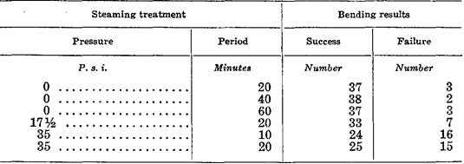

The results in table indicate that steaming at 35 pounds gage pressure for as short a period as 10 minutes is detrimental. Although steaming at 17½ pounds gage pressure caused more bending failures than steaming at 0 gage pressure, the number was not significantly greater from a statistical standpoint. The increase in the number of failures, however, indicates that steaming at 17½ pounds gauge pressure may be disadvantageous. All the specimens steamed at 0 gage pressure bent equally well, indicating that steaming at this pressure for as long as 1 hour had no harmful effect.
In other experiments, the effect of steam pressure on bending was measured by the total endwise compression steamed wood will assume before failing. Steaming at 0, 35, and 70 pounds gage pressure had an increasingly adverse effect on the amount of endwise compression that the wood could take before failing. Longer steaming periods at 35 and 70 pounds gage pressure also lowered the amount of compression the wood could take. The Effect of steaming pressure and time on endwise compression values of 1 ½- by 1 ½ by 3-inch specimens of Wisconsin- grown red oak was presented in table 3.

Table 3. Effect of steaming pressure and time on endwise compression values of 1 ½- by 1 ½ by 3-inch specimens of Wisconsin- grown red oak
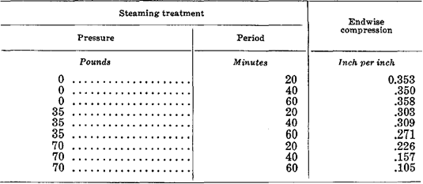

The moisture content of wood before treatment was 26 percent. The temperature of saturated steam at atmospheric pressure, about 212° F., is generally sufficient to plasticize wood for bending. This is an advantage in several respects. The use of steam at atmospheric pressure eliminates the need for expensive high-pressure retorts. It is easier to obtain saturated steam within a closed retort or steam box when the steam is injected at low pressure.
High-pressure steam becomes superheated and “dry” when released from pressure because the pressure is lost more rapidly than temperature. The operation of a retort or steam box is simpler with steam at zero or low-gage pressure. With high-pressure steam, the steam valve must be closed and sometime allowed to elapse before the door of the retort can be opened, thus delaying operations. One type of low-pressure retort is designed so that opening the door closes the steam valve and closing the door opens the valve. This arrangement speeds operations and reduces the possibility of a loss of moisture from the surface of the steamed stock while the steam is off.
Steam should be injected into a retort through water standing in the bottom so that the steam within the retort will be saturated or wet. If the steam is not injected through water, the retort should be designed so that a certain amount of condensate accumulates on the bottom before running into the drain. The line leading from the boiler to the retort should contain wet or saturated steam, and a run of uninsulated pipe near the retort will also help maintain wet steam in the retort.
Treatment of wood with boiling or nearly boiling water is approximately equivalent to saturated steaming at atmospheric pressure. Boiling water is more convenient when only a portion of a stick needs to be plasticized. It is often necessary to add moisture to wood, particularly to the surfaces, during the plasticizing process. If the stock has a moisture content of 20 to 25 percent, no additional moisture is needed, even for severe bends. At 15 -percent moisture content, it is probable that no additional moisture is needed for making moderate bends. However, additional moisture is needed in the surface zones for severe bends.
To make relatively dry stock (12 percent or less) plastic enough for moderate or severe bends requires that moisture be added during the heating process. Most of the added moisture is absorbed by the surface zones. Since the concave surface must assume the maximum compressive strain, it needs optimum plasticity induced by sufficient heat and moisture. Dry wood should be both heated and moistened, but wet wood need merely be heated.
Bending stock selected from general-use lumber is probably too dry for satisfactory bending. To increase its moisture content and avoid long steaming periods, the dry stock should be soaked in water for several days. The pieces should be end coated to prevent excessive absorption by exposed end grain.
The required steaming or boiling period varies. Wet stock can be steamed for a shorter period than dry stock. Stock to be bent to a mild curvature can be steamed for a shorter period than stock to be bent to a severe curvature. Different species probably become plastic at different rates, and therefore some species may need longer steaming periods than others. As a general rule, the wet stock should be steamed or boiled for ½ hour per inch of thickness and dry stock 1 hour per inch of thickness.
There is some danger of over steaming or overboiling stock, but when the steaming is done at atmospheric pressure, the danger is not great. According to table 1, stock steamed at 0 gage pressure for 20, 40, and 60 minutes produced about the same number of successful bends, 37 out of 40. Similar stock with a moisture content of 15 instead of 25 percent produced 29, 35, and 37 successful bends out of 40 after steaming at 0 gage pressure for 20, 40, and 60 minutes, respectively. For similar bending results, stock at a moisture content of 15 percent needed a steaming period of 60 minutes, while stock at 25 -percent moisture content needed only 20 minutes.
In commercial bending, the plasticizing treatments should be coordinated with other bending operations. The retorts or steam boxes should have sufficient capacity to keep the bending apparatus in continuous operation. Individual retorts should be small enough to allow rapid unloading so that the surfaces of the steamed stock do not dry before it can be placed in the bending machine. Numerous small retorts also allow more flexibility in adjusting steaming periods to the thickness and character of the stock. For efficient
operation, the capacities of the retorts and machines should be SO balanced that the time required to load, steam, and unload the stock from the retorts is correlated with the time required to load, bend, and unload it from the bending machines. Under such conditions, the steamed stock can be placed in the machine and bent with minimum delay.
Since moisture diffuses more rapidly along than across the grain of the wood, the ends of the bending stock absorb more moisture during the steaming or boiling treatment. Such pieces may end check during the drying and fixing process. Overly wet ends are also easily mutilated by the devices applying end pressure. A moisture-resistant coating applied prior to the plasticizing treatment will reduce the absorption of moisture at the ends and minimize the hazard of checking and mutilation.

7.3. Plasticizing With Chemicals
Certain chemicals, such as urea, urea -aldehyde, tannic acid, and glycerin, have been tried as wood plasticizers. It has been found that soaking wood in tannic acid solution has no important effect on plasticity. Experiments at the Forest Products Laboratory using glycerin as a plasticizer failed to yield favorable results. Treatments with urea alone or together with formaldehyde or dimethyl urea cause wood to become highly plastic. The effect pro- reduced by urea alone is the most marked. Urea causes wood to become thermoplastic, in which state it can be bent when hot even though the moisture content is low. Urea-treated stock does not bend so well and is weaker than, stock plasticized by steam.
In limited tests at the Forest Products Laboratory, urea-treated wood was bent less successfully than steamed wood, and it developed more tensile failures during drying and fixing than steamed wood. Urea may also discolor wood and make it more hygroscopic than untreated wood. It is not definitely known how chemicals accomplish plasticization, but evidence supports the hypothesis that lignin and the less stable forms of cellulose are chemically attacked. The fact that wood can be pulped by the use of urea supports this hypothesis. The number of successful bends and failures in bending, and tensile failures in drying to fix the bend, in 1 - by 2-inch specimens of Wisconsin-grown white oak where the moisture content of wood before treatment was 25 percent was presented in table 4.

Table 4. The number of successful bends and failures in bending, and tensile failures in drying to fix the bend, in 1 - by 2-inch specimens of Wisconsin-grown white oak where the moisture content of wood before treatment was 25 percent.
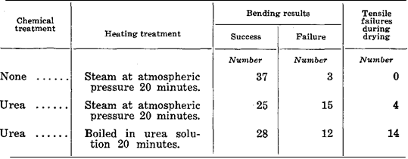

7.4. Bending With End Pressure
For most bending, end pressure is necessary to obtain the required compression and prevent tensile failures. End pressure can be applied in several ways, but the most common is by means of a metal strap with end fittings, such as end blocks or clamps. The metal strap is placed against the convex side of the stick to absorb tensile stress that would normally be absorbed by the wood. If the strap can be made to operate with 100 -percent efficiency, no tensile stress is present in the wood, and the whole stick is subjected to compressive stress.
In actual practice, it is improbable that the metal strap often absorbs all the tensile stress. The convex face of the stick is therefore subject to slight tensile stress and is stretched slightly in the lengthwise direction. Unless a tensile failure develops, this stretching is advantageous because it reduces slightly the amount of compressive deformation required on the concave side. To make a successful bend, the wood must be distorted without developing visible failures either in tension or in compression. Moderate to severe bends, which require end pressure, can be divided into three general classes:
- a simple bend in a single plane,
- a re-entrant or S type of bend in a single plane,
- a compound bend in more than one plane.

The different classes of bends require different methods of strapping and bending and of restraining while drying and fixing. A simple bend in a single plane may be made by hand, in a hot-plate press, or in any type of bending machine. The pieces may be bent singly, in groups, or in multiple widths to be sawed later. The strapping of a simple bend in a single plane is relatively easy. The strap is continuous from end to end and is in contact with the convex side of the stock. The strap is either equipped with end blocks to apply pressure to the ends of the stick or clamped to the piece at the ends or at points beyond the curve. Provision may be made for adjusting the distance between the end blocks or for regulating the amount of end pressure applied. When slender pieces are bent, a means of reducing the amount of end pressure applied is necessary to avoid buckling of the unbent part during bending.
The re-entrant and S types of bends consist of several simple bends reversing in direction. Since the convex and concave sides of the stick are interchanged as the bend reverses, multiple straps are needed. For only one reversal of curvature, the straps are fastened to the form or table at the inner portions of the form and are equipped with end blocks at the outer extremities. Such bends are generally made by hand, one at a time, with the straps, arranged so that they function on the convex side of the section being bent. The best pieces are then clamped to the forms and dried and fixed. A diagrammatic sketch of the bending apparatus for making was presented in figure 47.

a)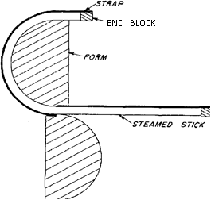b)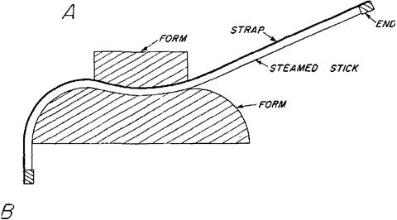
Figure 47. Diagrammatic sketch of bending apparatus for making: a) an S; b) a re-entrant bend in wood.

Compound bends, which are in two or more planes, are made with a complicated system of devices for applying end pressure. Bends of this nature are made by hand by highly skilled workmen. The general scheme is to complete one part of the bend, clamp it to the form, and proceed to the next part, constantly manipulating straps and end blocks to maintain the required end pressure at all times. The piece is bent to a metal form and must be dried and fixed while fastened to the form.
The actual bending technique, although subject to minor variations with the different classes of bends, has more or less general established features. After the plasticizing treatment, the stock should be placed in a position for bending with as little delay as possible. In some types of equipment, the strap and end-block assembly automatically locate the piece with respect to the form. Some bending apparatus is designed so that the strap and end -block as- simply hold the stock in position, preventing it from shifting on the form. In other machines, the fixed end of the stock must be clamped to the form or some device employed to hold the stock near the midpoint of the form.
The stock should fit snugly against the end blocks before bending is started. This can be accomplished by equipping the end block with a screw and bearing plate that is screwed tight or by inserting wood or metal shims between the stock and the end block. Some clearance between the end of the stock and the end block may be permissible in the early stages of bending. After bending starts, this clearance will soon disappear, and the end blocks will come into play. Generally, however, some end pressure should be applied at the very start of bending. When a number of pieces are bent together in a common strap and end-block assembly, they must be cut to a uniform length so that each will bear its share of the end pressure. Shimming individual ends is time-consuming.
The bending load should be applied slowly so that the plasticized wood will be distorted more or less uniformly along its length. In some apparatus, such as hot-plate presses, the stock is prevented from backing away from the form during bending by the machine itself and the character of the imposed forces. In other types, it is necessary to hold the bent portion of the piece in contact with the form. In bending such heavy pieces as boat parts, for example, it is generally necessary to apply force to the portion already bent to keep it in contact with the form. The bending slab or table is equipped with holes for pins or dogs that are used along with wedges or screws to force the piece against the form and prevent it from backing away. The bending of a boat rib by pulling one end around the form and holding the bent part against the form by means of dogs and wedges was presented in figure 48.

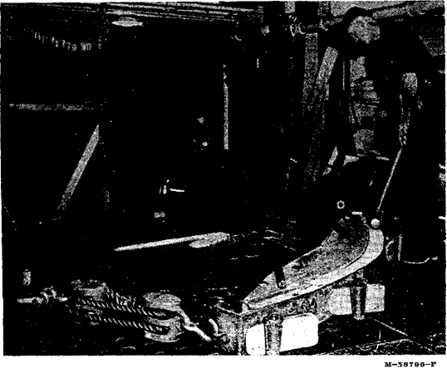
Figure 48. Bending a boat rib by pulling one end around the form and holding the bent part against the form by means of dogs and wedges.
If end blocks are equipped with a screw and a bearing plate, it is customary to release the end pressure to some extent as bending progresses. This operation is particularly necessary when a reverse bend or buckle starts to form in the still unbent portion of the piece. The reverse bend is more likely to occur in slender pieces. Reverse bends can be eliminated by equipping the end blocks with reversed levers that extend back as far as the last point of contact between the wood and the form. Although releasing the end pressure during bending may reduce slightly the chance of compressive failure, it invites tensile failure. Even though it has been widely recommended in the past, there is some question concerning the need for releasing end pressure as the bending progresses, except to relieve the tendency to buckle or form reverse bends. Measurements of end pressure during bending tests show that this pressure increases up to a certain point and then remains practically constant throughout the rest of the bending process. From a theoretical point of view, the end pressure could remain constant, diminish, or increase during a bending operation, depending on the stress-strain relations developed in the wood. The pan is equipped with reverse levers and devices for applying pressure to prevent lateral buckling. A hot-plate press for bending parts was presented in figure 49.

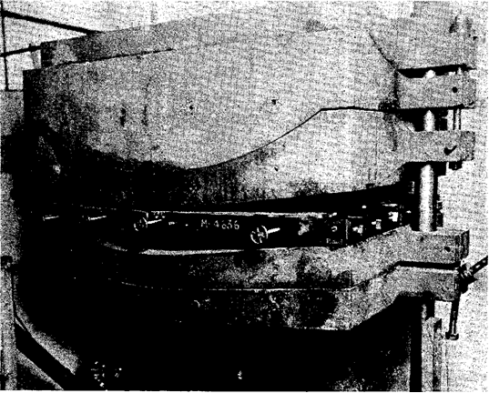
Figure 49. A hot-plate press for bending parts.

Many devices and machines have been made for bending wood. In some cases, the piece can be bent by hand around a form by means of a strap and a device for applying end pressure. Some machines consist of rollers between which the strips of wood are passed. The diameter and position of the rollers determine the shape of the bend. One hand-powered machine for bending several pieces at once consists of a battery of straps and end blocks fastened to a central steam-heated form. Each piece is placed in its strap and bent to the form until a complete load is obtained. The pieces are left on the form until dried and fixed. For bending, heavy members, such as ship and boat parts, a bending slab or table with the form attached is used. One end of the piece is generally fastened, and the free end is pulled around the form by means of tackle and a power unit.
Hot-plate presses, which are widely used to bend furniture parts, consist of hollow metal male and female forms or platens heated by steam. The bending stock is placed between the forms, either with or without a pan for applying end pressure, and the forms are brought against the stock by hydraulic pressure. A mechanical fastening is used to keep the plates in position after closing. The bending pieces are held to shape and dried between the heated plates. Another type of hot-plate press for bending chair parts was presented in figure 50.

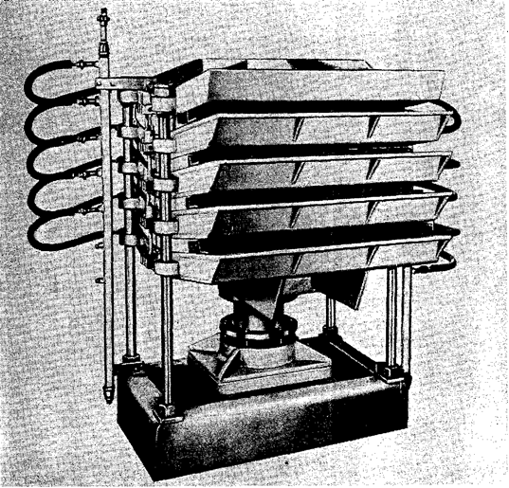
Figure 50. Hot-plate press for bending chair parts.

A machine commonly used to bend several heavy pieces or a larger number of small parts at the same time consists of two heavy arms connected to a heavy strap. As the arms move upward, the heavy steel strap pulls the stock around the form. A minor strap is generally used with this type of machine. When the bend is completed, tie rods are fastened across the ends of the minor strap to permit the removal of the stock from the machine.
A machine for bending rims or rails consists of a horizontal table with a form attached. In some machines, the form and table rotate, winding up the stock. In others, the form and table are stationary, and the stock is bent by fastening one end of the piece and carrying the other end around the form. With both types of machines, a strap and end block are used. Because the stick is slender, the end pressure is released as the bending progresses. If the stock is wound in a single plane, the ends are scarfed beforehand. The Rim type of bending machine with a chair part bent through an arc of 180° was presented in figure 51.

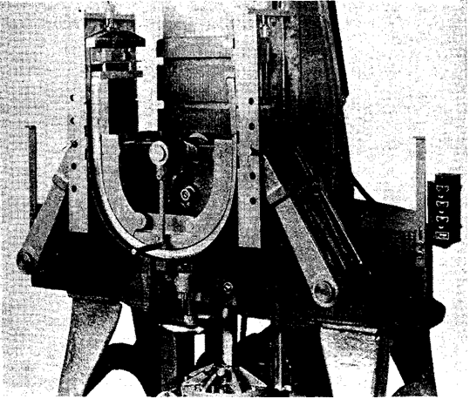
Figure 51. Rim type of bending machine with a chair part bent through an arc of 180°.

7.5. Bending Laminated Members
The laminating form to produce curved members is analogous to the production of solid curved members. A straight piece of considerable thickness is built up by gluing together a number of thinner pieces, such as one-inch boards. The laminated member is then bent like a solid piece. The advantages of this method are the easier and faster drying of the thin boards and the opportunity to select the best boards for the faces, particularly the concave ones. However, the glue joints must be good, and the glue must be able to withstand the steaming treatment. Applying Veneer To Improve Bending Quality Wood of poor bending quality can be improved by gluing veneer of good bending quality to the surface that is to be concave. The veneer assumes the maximum amount of compressive deformation and supports the inner surface of the wood.
This method was tested at the Forest Products Laboratory with 1/8-inch birch and Douglas-fir veneer glued to ½-inch sweetgum heartwood of poor bending quality. The specimens of solid sweetgum and sweetgum and veneer, all 5/8 inch thick, were at 20 -percent moisture content when steamed. After steaming at atmospheric pressure for 20 minutes, they were bent under end pressure to a radius of 3½ inches. The bending results was presented in table 5.

Table 5. The bending results
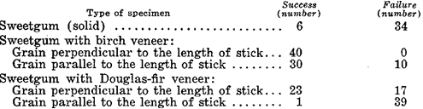

The poor bending quality of the sweetgum (6 successful bends out of 40) was vastly improved when the birch veneer was glued to the compression. face. The Douglas -fir veneer, however, could not assume the required deformation when the grain of the veneer was parallel to the length of the stick. Only one specimen of this group was bent successfully. Douglas -fir veneer glued with the grain perpendicular to the length of the stick improved the bending quality of the sweetgum.

7.6. Types of Bending Failures
In a successfully bent piece, the deformation, chiefly compression, is distributed nearly uniformly over the curved portion and consists of myriad minute failures. For the most part, the failures consist of folds or wrinkles in the fiber walls, with perhaps some slippage of the wood elements past each other. The wrinkling is greatest on the concave surface of the piece, and it decreases as the convex surface is approached. If the strap and end blocks have functioned perfectly, the point of zero deformation is at the convex surface. If they have not functioned perfectly, the zero point is slightly below the convex surface, which has assumed some tensile strain.
Failures occur if the plasticized wood is stressed beyond its tensile or compressive limit. In free bending, failures are nearly always in tension, because plasticized wood cannot be stretched more than 1 or 2 percent of its length. If tensile failures occur when end pressure is applied, it is because the strap and end blocks are not exerting sufficient pressure to keep the stretch of the convex side below the limit of 1 to 2 percent. This is the most common type of failure in commercial bending operations, and, as a rule, it is due to poorly designed or worn apparatus or to poor bending technique. Such irregularities as distorted grain, cross-grain, and seasoning checks may contribute to tensile failure. Tensile failures in a slat bent with insufficient end pressure were presented in figure 52.

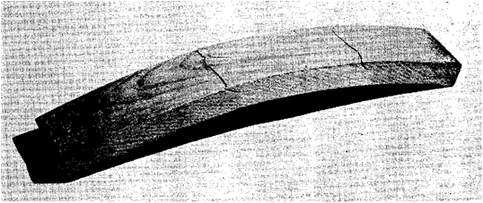
Figure 52. Tensile failures in a chair -back slat bent with insufficient end pressure.

Tensile failures also take the form of small slivers that break away from the convex face during bending. These are generally associated with slight cross grain. If the metal strap is a wide as the stock it helps to prevent slivers from breaking up if it is narrower, slivers may break o upon the edges. A device for exerting pressure against the face of the stock at the point of tangency to the form is helpful in reducing living. Compressive failures occur:
- when the plasticized wood is compressed excessively,
- when stresses are concentrated because of some defect,
- when lines of weakness encourage shear failure.

The compressibility of the stock depends on the species of wood used and the plasticizing treatment. A species of poor bending quality is severely limited in the number of compressive distortions that it can take without failing. Improper plasticizing treatments also reduce compressibility. Failure in a bent boat frame was presented in figure 53.

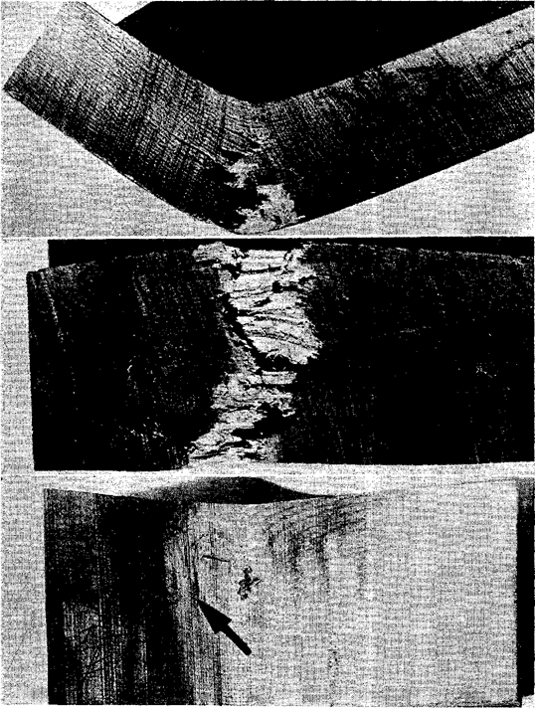
Figure 53. Failure in a bent boat frame.
The knot could not be compressed, and the stick developed a sharp kink that caused the outer face to fail in tension. Failure in compression may take the form of a crosswise fold or wrinkle, a longitudinal separation of fibers followed by lateral buckling, or a shear failure roughly along the longitudinal axis of the piece followed by separation of the fibers and buckling. The mildest form of visible compressive failure is a bulge or wrinkle extending from edge to edge on the concave side. Compressive failure may also occur in green stock. The space occupied by the excess water reduces the available void volume and causes hydro-static pressure to develop when the wood is compressed beyond a certain point. The two types of compressive failure was presented in the figure 54.

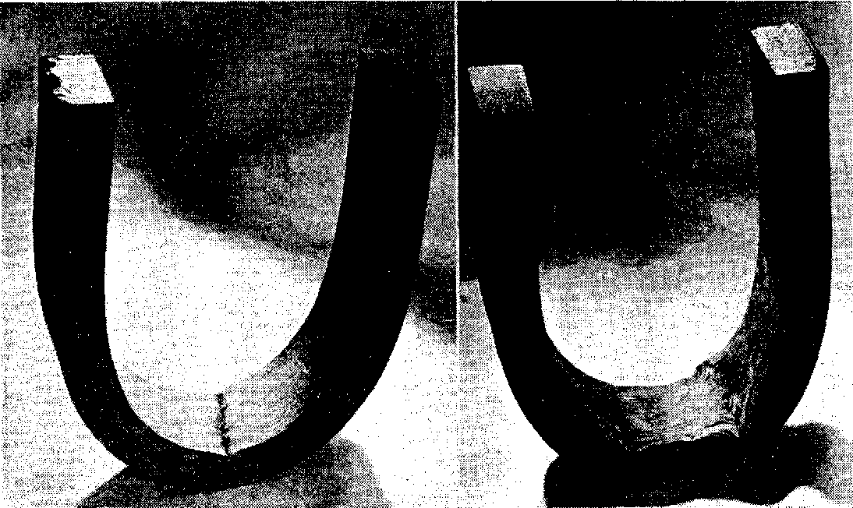
Figure 54. Two types of compressive failure. Cross fold or wrinkle (left) typical of wood of poor bending quality or improperly plasticized wood; lateral buckling (right) preceded by shear failure.

Compressive failures by lateral buckling in a plane perpendicular to the bend are common in pieces bent edgewise without lateral support. Such pieces are too thin or narrow to act as columns under the compressive stress, and they bend like beams. A similar effect is produced in pieces containing surface checks on the con - cave side. Compressive failures brought about by the presence of surface checks on concave face of stock was presented in the figure 55.

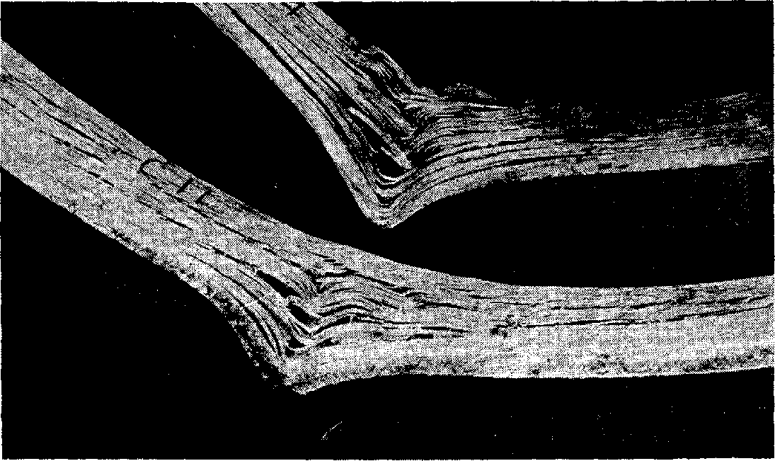
Figure 55. Compressive failures brought about by the presence of surface checks on concave face of stock.
The surface checks set up lines of shear that, in effect, reduce the wide piece to a series of narrow strips that tend to buckle laterally, as does a single strip bent edgewise. Sur - face checks in combination with either spiral or diagonal grain may cause a sliver -shaped portion to shear from a corner of the piece, particularly if the checks are located near an edge or corner. In making compound curvatures, the twisting of stock at the points where the plane of the bend changes may cause shear failure.
Some distortion of cross section during bending is inevitable. As the piece is compressed between the strap, form, and end blocks, it tends to become thinner and wider. Unless restrained, the piece widens most on the concave side, which is in contact with the form. The increase in width is due to the fact that the plasticized wood tends to flow in the direction perpendicular to the lines of force. This increase in width probably provides some of the space needed by the compressed and folded fibers. In cutting or machining stock before bending, allowance should be made for the distortion of cross section during bending. Mutilation of stock during bending occurs principally at the ends. Crushing or splitting of the ends is common, because pressure is not applied uniformly to the entire end surface. Unless end coated, the ends of a steamed piece are often plasticized more than the rest of the piece because of greater absorption and penetration of moisture during the plasticizing treatment. The Crushing of the end of a bent chair -back post, caused by improper bearing of the end block was presented in the figure 56.

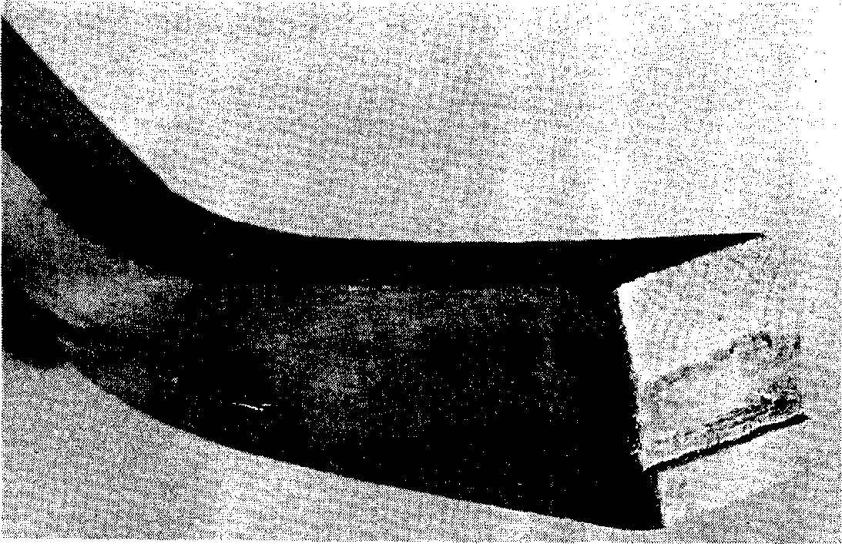
Figure 56. Crushing of the end of a bent chair -back post, caused by improper bearing of the end block.

7.7. Removal of Discolorations Caused in Bending
Steaming or boiling causes wood to change in color and take on a lifeless appearance. This effect is restricted to the surfaces. A more serious source of discoloration is the reaction of extractives in the wood with metal. The reaction of tannic acid and iron gives the most serious discoloration. When hot, wet oak comes in contact with iron, it becomes a dark purplish -black color. This may occur in the steaming retort or boiling tank or in the bending apparatus.
If stain is detrimental to the final product, various protective measures can be taken. The stock should be protected from drip or kept from contact with iron shelves in a retort. Although it is difficult to avoid stain while wood is soaking or boiling in steel or iron tanks, coating the inside of the tank will help. The water in the tank should be replaced at intervals to reduce the amount of iron in it. Paper or cellophane can be placed between the stock and the iron parts of bending apparatus to prevent stain. Iron or steel parts can be galvanized to eliminate most of the staining, although galvanizing is not permanent and will need to be renewed. Straps of spring brass will not stain most woods other than oak, and it only slightly. Stain resulting from the action of tannic acid and iron can be removed by bleaching after the bent piece is dried and fixed. A hot 3% solution of oxalic acid applied to the stained piece will remove the stain. Afterward, the acid solution should be sponged from the piece with clear water. The process may be re - peated several times if necessary.

7.8. Repair of Pieces Damaged in Bending
Failures may impair or completely destroy the utility of a bent piece. They weaken it, break the continuity of the surfaces, and impair its appearance. Tensile failures are generally more detrimental than compressive failures. Sometimes, the damage can be repaired.
If the tensile failure is in the form of a large sliver, it is occasionally feasible to force and fasten the sliver back into place, permitting the member to be used where appearance is not important. Boat parts are sometimes repaired in this way. Tensile failures in chair parts are generally cause for rejection of the piece.
Compressive failures accompanied by buckling and separation of the fibers generally make the piece useless. In chair parts with a hidden concave side, it may be possible to use a member with a rather severe compressive failure. The member can be reinforced with corner blocks. Parts with moderate compressive failures consisting of wrinkling and bulging of the fibers without much separation can often be used after the bulges are dressed off. When maxi - mum strength is needed, defective members should not be used.

7.8. DRYING AND FIXING (SETTING) THE BEND
If a piece of wood is removed from the bending apparatus while still hot and plastic, it tends to straighten or spring back. This is a natural reaction of the wood to the release of the compressive stress imposed during the bending operation. This stress is greatest along the concave face of the piece, where some wood has failed and de - formed; along the convex face it actually ceases, and a slight tensile stress may exist even during bending. As soon as the piece is out of the bending apparatus, the tensile stress intensifies, tending to pull it straight. Some compressive stress remaining in the wood along the concave face also tends to straighten the piece. However, the permanently deformed wood along the concave face prevents the piece from straightening out completely.
To counteract this tendency to spring back, the piece must be held in its bent shape until it has cooled and dried or “set.” This is sometimes done by leaving it in the bending apparatus. More often, tie rods or stays are fastened to both ends, and the piece is removed from the apparatus and stored while setting. Or it is clamped to the form and removed from the bending machine. The piece may also tend to elongate slightly with release of end pressure when removed from the bending apparatus. To counter - act this tendency, a minor strap that provides some end pressure is sometimes kept on the piece until it sets, and tie rods are hooked to the ends of this strap.
With mild bends, the tendency to spring back is not entirely overcome by cooling and drying. With such bends, it is customary to overbend somewhat to compensate for the partial spring back. Although cooling and drying both contribute to the restoration of stiffness and the fixing of the bent shape, drying is apparently more important. A piece bent to varying curvature is more difficult to hold in shape. If restrained merely at the ends, it will attempt to assume a uniform curvature. It will therefore require more restraining members. The safest way to dry and fix such a piece is to keep it in the form.
A scheme that has proved helpful in retaining the curvature of bent members during drying and fixing consists of permitting the inner or concave face to dry more rapidly than the outer. This is accomplished by removing the form and retaining the metal strap or by using perforated forms. When the inner face dries first, it sets in an expanded condition along the length of the member. This set will help counteract the tendency of the bent members to close up when the entire piece reaches a low moisture content.
Bent parts are dried in various ways, depending largely on the intended use. Bent parts for boats or ships are sometimes permitted to dry on the framework of the vessel. Ship and boat builders seldom provide special drying rooms, because ship or boat framing members do not require such thorough seasoning as do many other bent parts. Pieces that are bent in hot -plate presses are dried while in the press between the steam -heated plates. The steam pressure may be 20 pounds per square inch or more, which gives a plate temperature of 260° F. or higher. In other types of bending ma - chines, including the steam -heated form, the bent pieces are also dried in the machine.
Chair manufacturers dry bent parts in heated rooms. These rooms may be equipped with thermostats and occasionally with some means of controlling relative humidity. The temperature within these drying rooms may range from 140° to 190° F. Occasionally, bent pieces are dried in ovens at excessively high temperatures. Some bent pieces are dried in the shop by applying concentrated heat in one form or another. Many bent members are permitted to stand in the shop while drying and fixing.

7.9. Effects of Drying and Fixing
Several things happen to bent, plastic pieces as they dry. Plasticity is reduced and stiffness increases as moisture are lost, The properties of the wood become more like those of untreated wood, although its original strength is never completely recovered. As the wood loses moisture and plasticity and shrinks, new stresses are set up within the bent piece. The shrinkage in length and thickness causes the bent piece to attempt to take on a shorter radius of curvature. As the thickness decreases, the difference between the length of the convex side and that of the concave side calls for a general curve of a shorter radius. The wrinkled and folded wood on the concave side of the bent piece develops lengthwise shrinkage in drying. This shrinkage exerts tensile stress on the concave side that tends to increase the curvature. If no compression member is placed between the ends or legs of the piece, the tensile stress is transmitted to the convex side and sometimes causes failures. The tensile failures that occurred in a bent boat frame during drying and fixing were presented in figure 57.

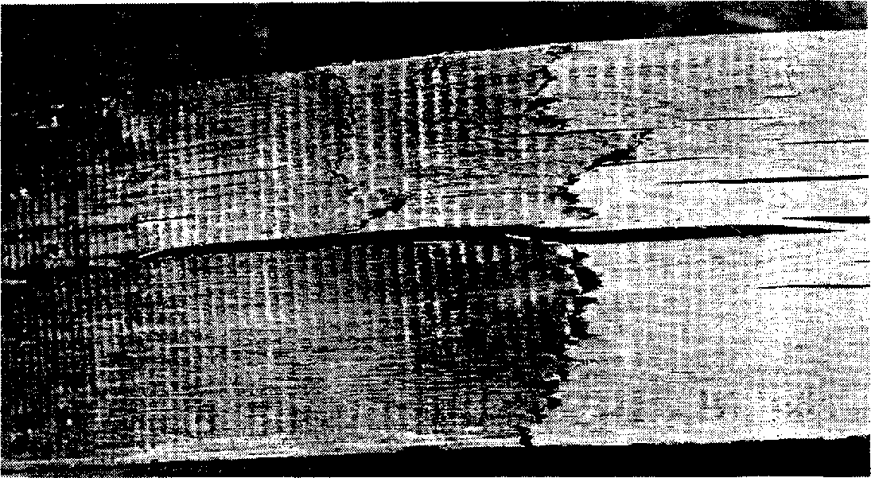
Figure 57. Tensile failures that occurred in a bent boat frame during drying and fixing.

Such failures can be prevented by applying some end pressure to the bent piece. The bent boat member prepared for drying and fixing, showing minor strap, tie rods, and wood stays were presented in figure 58.
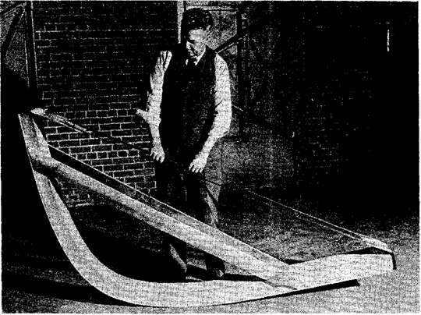
Figure 58. Bent boat member prepared for drying and fixing, showing minor strap, tie rods, and wood stays.

The strap will absorb some of the tensile stress during bending and during the drying and fixing process. If a minor strap or the main strap with end fittings is left on the piece during drying, any tensile stress in the convex side is taken up by the strap. A minor strap being fastened on the side that is to be convex was presented in figure 59.

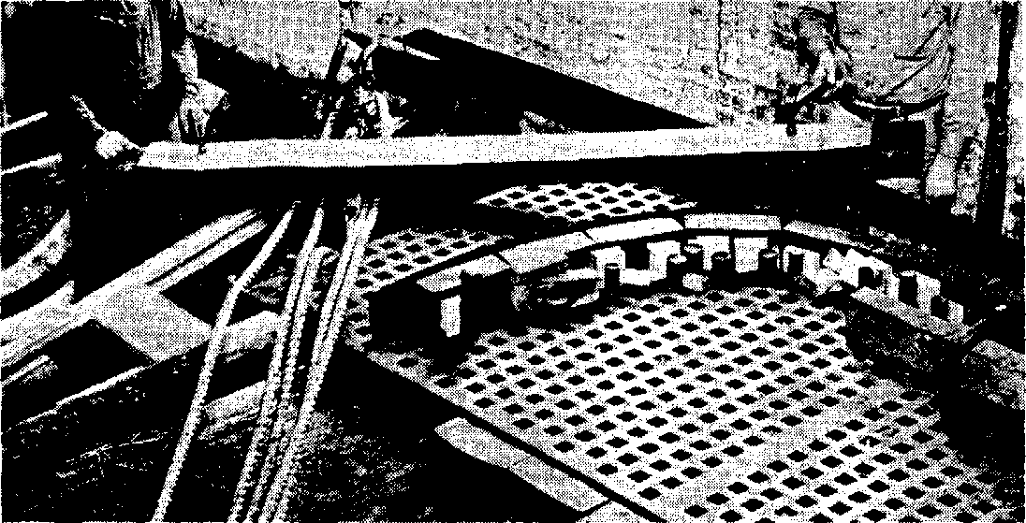
Figure 59. Spikinag minor strap to the outer face of a piece that is to be bent to form a boat rib.

Pieces dried in a hot-plate press with good bending pans are under end pressure. When no compression member is provided between the ends of the bent pieces, their curvature may be increased so that they are no longer suitable for the intended use. Over drying increases the hazards of tensile failure and distortion of curvature. A drying room with controlled temperature and relative humidity reduce this hazard. Likewise, if the bent pieces are suitably restrained by devices that act both in tension and compression, distortions of curvature are not likely to occur. Drying also causes shrinkage in the width of the piece, which sets up stresses similar to ordinary drying stresses. The greater the loss of moisture during the drying and fixing processes, the greater is the drying stress. The hazards of surface and end checking that were present in the original seasoning are present to a lesser degree in the drying of bent stock. The surface of wood seasoned to a moisture content of 15 to 20 percent is generally set in compression. In such a state, the wood is able to withstand exposure to severe drying conditions without developing fresh checks. The steaming or boiling treatment given wood before it is bent may, however, relieve this surface set and enable the surface to go into tension in the lateral direction when the bent piece is dried. Under such conditions, surface checks may develop in the drying and fixing process.
Stock steamed and bent at a high moisture content is more likely to develop surface and end checks during the drying process than stock steamed and bent at lower moisture content. In a furniture factory, oak and beech parts steamed and bent at a relatively high moisture content surface checked during drying. The drying room was maintained at a temperature of 170° F., with no control of relative humidity. In the case of oak chair-back posts bent in a hot-plate press and dried between plates heated by steam at 20 pounds gage pressure, the percentage of pieces rejected because of checks increased rapidly with an increase in the moisture content of the bending stock. Pieces dried in hot-plate presses are highly susceptible to end checking, particularly when the ends have absorbed considerable moisture during steaming or boiling. End coatings reduce end checking.

7.10. Conditions for Drying Bent Stock
In a commercial bending operation, a variety of bent members of different species and thicknesses may be produced, perhaps with variations in moisture content. Since it is impractical to have numerous drying rooms in order to obtain optimum drying and setting conditions, all of the best pieces are placed in 1 or 2 rooms. The temperature and relative humidity of the drying room should therefore be suitable for all of the best stock. Temperatures of 140° to 160° F., with no moisture added to the air, are generally satisfactory unless the members happen to be particularly large, of a species difficult to season, or at a high moisture content.
The length of time that bent members need to remain in the drying room depends on the adequacy of air circulation, the thickness and moisture content of the stock, and the desired final moisture content. Bent pieces in furniture and chair factories generally are left in the drying rooms for 24 to 72 hours. A common practice is to leave them until the restraining device across the ends becomes slack. The pieces will no longer spring back when the restraining device is removed.
The time required to reach the moisture content needed to fix the bend is usually much shorter than that required to reach a moisture content suitable for service. The amount of time or drying necessary to fix a bend varies with the species of wood and the type of bend. Oak steamed and bent in the green condition becomes set even before it dries to the fiber saturation point (about 30% moisture content). If a bent member is dried to a moisture content suitable for service, the bend is certain to be fixed.

7.11. Behavior of Bent Members
It is generally considered that the curvature of a bent member is permanent after it has been dried and fixed. Such is not the case, because changes in moisture content set up stresses that change the curvature. The various zones through the thickness of the piece differ in the extent of deformation and in the amount of longitudinal shrinkage and swelling they will undergo with a change in moisture content. In addition, shrinking and swelling in thickness tend to alter the curvature of the piece. The wrinkled and folded fibers on the concave side, which have been considerably compressed in bending, shrink and swell appreciably in the lengthwise direction. At the same time, the convex side undergoes negligible lengthwise shrinking and swelling.
The effect of the shrinking or swelling in length and thickness is cumulative. With shrinkage, the curvature is increased. With swelling, the curvature is reduced as the piece tends to straighten. Red oak specimens, 1 inch thick, steamed at a moisture content of 25% and bent to a radius of 2 5/8 inches were dried to a moisture content of 8 percent. After the distance between the legs was measured, the bent specimens were brought to a moisture content of 21 percent. At this moisture content, the legs were more than twice as far apart as at 8 percent. When redried to 8%, the legs were still 60 percent farther apart than originally.
Specimens of the same material steamed at 15 % of moisture content and bent to a radius of 2 3/8 inches behaved in the same manner but with even greater changes in curvature. When the moisture content of these specimens was raised from 8 to 12 per - cent, the distance between the legs was increased by 20 percent. When the moisture content was increased to 22 percent, the distance between the legs was 2½ times that at 8 percent. When redried to 8% of moisture content, the legs were more than twice as far apart as they were originally when at the same moisture content.
Although neither set of these specimens maintained its curvature under changes in moisture content, the stock steamed and bent at the higher moisture content changed less in curvature with later fluctuations in moisture content. It is evident that a bent piece of wood cannot be expected to retain its curvature unless it is held at a constant moisture content or is firmly fastened to other members of the structure.

Unit 8. Bending of steamed wood on moulds (frames) and on hull (planks),

8.1. Types of planking
In building a simple pulling boat, the keel, hog, stem, apron, deadwoods, sternpost and perhaps transom are assembled and securely set up. In normal practice, this will be the same way up as they will be in use. From the hog, the garboard, bottom, bilge, topside and sheer strakes are planked up, held together along their ‘lands’ as the areas of overlap between neighbouring strakes, by copper rivets. At the stem and, in a double-ended boat, the sternpost, geralds are formed. That is, in each case, the land of the lower strake is tapered to a feather edge at the end of the strake where it meets the stem or stern-post. This allows the end of the strake to be screwed to the apron with the outside of the planking mutually flush at that point and flush with the stem. This means that the boat's passage through the water will not tend to lift the ends of the planking away from the stem. Before the next plank is laid up, the face of the land on the lower strake is bevelled to suit the angle at which the next strake will lie in relation with it. This varies all along the land. Gripes are used to hold the new strake in position on the preceding one before the fastening is done.

8.1.1. Clinker-built planking
Clinker-built or lapstrake, the overlapping joint is called a laps. Clinker planks are individually shaped, fitted around temporary moulds and fastened to each other and to a permanent keel, stem and transom, each plank overlapping that previously fitted. Good wood-to-wood fits plus a little bedding compound of some sort are all that keeps the hull watertight. The planks are fastened to each other with copper nails and roves, and steam-bent ribs are added after completion of planking, and are also fastened with copper nails and roves or sometimes but simply copper nails clenched or bent over. All the smallest dinghies are more often built right way up. Also referred to as lapstrake planking, clinker planking has its origins in a northern European tradition which also goes back to the Bronze Age. The Viking ships for example were clinker planked. Its more recent evolution resulted in lighter boats. The small dinghies we most often associate with clinker planking only really developed with the growth of yachting in the last 170 years.
The Clinker-built method of constructing a watertight boat shell is thought to have originated somewhere in central Asia and travelled with its original inventors as the ice retreated and they migrated to the shores of the Baltic via the great rivers of Russia that feed into it. The early settlers in the recently ice-free countries of Scandinavia had a great need for boats. The nature of the country, mountainous, and cut by fjords and narrow arms of the sea made water the most practical form of transport. Marine Archaeologists have found very few remains of this very early craft, the perishable nature of their materials has meant that only in very unusual circumstances has anything survived to the present day. What has survived shows that the fundamental principles have changed little in two thousand years.
The clencher method of construction makes a hull very stiff for its weight and requiring only the simplest tools to build it. An Axe, wedges for splitting logs, a hammer for clenching nails and a primitive bow drill are all that are necessary to construct even the most advanced of the type, the Viking Longship. We are fortunate in having several well preserved examples of this final perfection of technique so that we can see how little it changed over the centuries. These craft were specially built to act as enormous coffins for Nordic Royalty and since they were carefully buried they survived more or less intact.
Clencher built boats of which there where several types dominated the Northern seas from Iceland and Greenland to the English Channel some travelled even further afield in the hands of the Viking corsairs who used them for their grander raids, doing the whole circuit of Europe. First south via the Bay of Biscay, through the Straits of Gibraltar and then along the coasts of the Mediterranean, raiding as they went. Through the Dardanelles and the Black Sea and finally home via the Russian river system. The light weight of the boats making the portages necessary at the heads of the rivers practicable. The Norsk lapstrake was presented in figure 60.

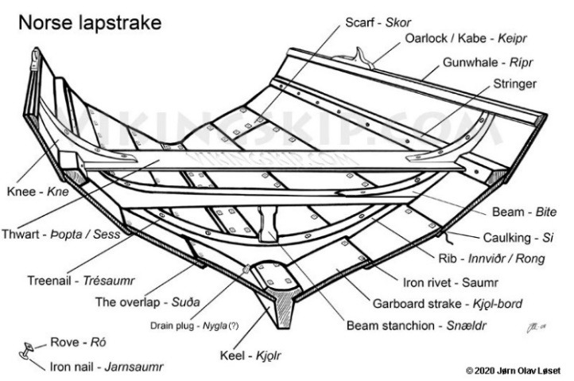
Figure 60. Norsk lapstrake

The method lived on well after the Viking era and clenched planking has been found on larger vessels used for trading in Northern waters. The Bremen Cog is an intermediate type with clinker side planking and a caravel bottom. Some northern Carracks where also built in this manner, and their images, the plank edges clearly visible, are preserved on the seals of many ancient ports. With the eventual adoption of the frame first method of construction for larger wooden hulls clenched planking survived as the preferred method for making smaller boats and inshore fishing craft. Its ability to be prefabricated from ready cut parts made it the ideal system for the shallops carried by the larger ships of the Age of Exploration. Carried in the hold as a Do-It-Yourself kit they could be rapidly assembled by the ships carpenter to augment or replace the ships complement of small boats. The description of clinker planking was presented in figure 61.
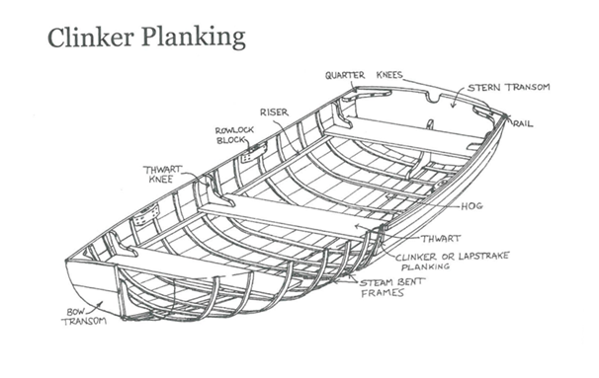
Figure 61. The Description of clinker planking

The relatively thin planking of this type of hull means that only the most stable timbers can be used. In Europe, Northern Larch is preferred for the larger working boats where the plank thickness exceeds half an inch. For lightweight sailing dinghies with plank thickness of only five sixteenths of an inch or so only South American mahogany is stable enough to be truly satisfactory. Worries over the destruction of the Amazon forests in recent years has lead us to take great care that we only obtain our timber from legal sources and that all its documentation, certified by the Brazilian Government, is in order before it is delivered.
The ribs, or more correctly the timbering, in these boats is local English oak, only partially air dried and then steamed into shape. The further curing of this timber in the boat tensions the structure adding to its stiffness. The gunwales and rubbing strakes are made from a tropical hardwood called Iroko. This timber comes to us in logs sawn into planks two inches thick the full width of the tree and this we convert to sided timber making the best use of each piece. This timber is widely distributed in both Africa and the Far East, we normally get ours from The Cameroon in East Africa. The joints application of clinker construction was presented in figure 62.

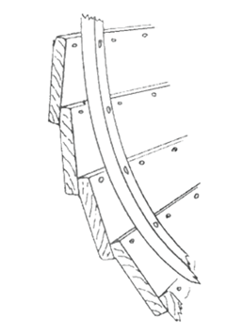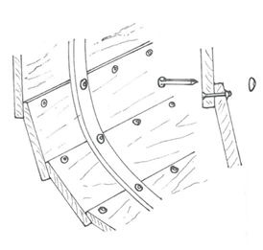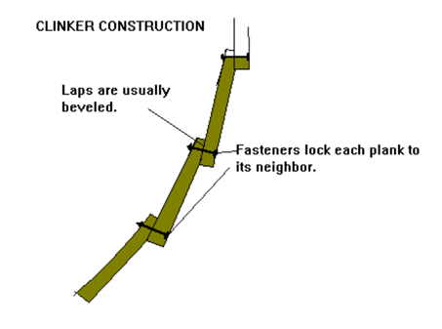
Figure 62. The joints application of clinker construction
Source: http://www.clinkerboat.com/about clinker boats.html

The hull is fastened with copper boat nails, square in section "clenched" i.e. riveted, over roves, the conical washers, and this system gives the method its name. Originally the Scandinavians used soft iron nails with diamond shaped flat roves, however the use of copper has been universal for a very long time since it does not rust or react chemically with the oak timbers. Finally the plank "lands" are sealed with a small amount of a synthetic rubber compound. This replaces the horse hair and "Stockholm Tar", a resinous pitch distilled from pine wood and much used by the old The relatively thin planking of this type of hull means that only the most stable timbers can be used. In Europe, Northern Larch is preferred for the larger working boats where the plank thickness exceeds half an inch. For lightweight sailing dinghies with plank thickness of only five sixteenths of an inch or so only South American mahogany is stable enough to be truly satisfactory. Worries over the destruction of the Amazon forests in recent years has lead us to take great care that we only obtain our timber from legal sources and that all its documentation, certified by the Brazilian Government, is in order before it is delivered. The example of boat clinker built made in Shipyard - Jacek Struck was presented on the figure 63.

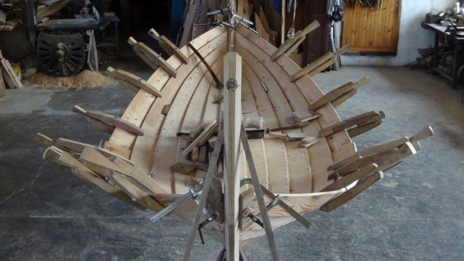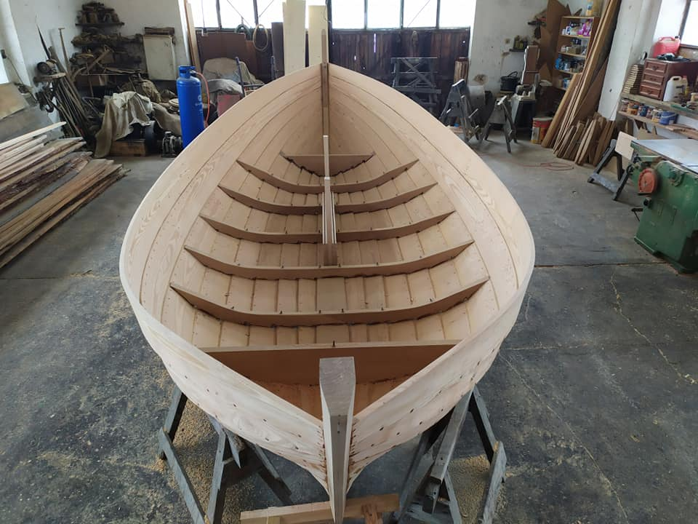
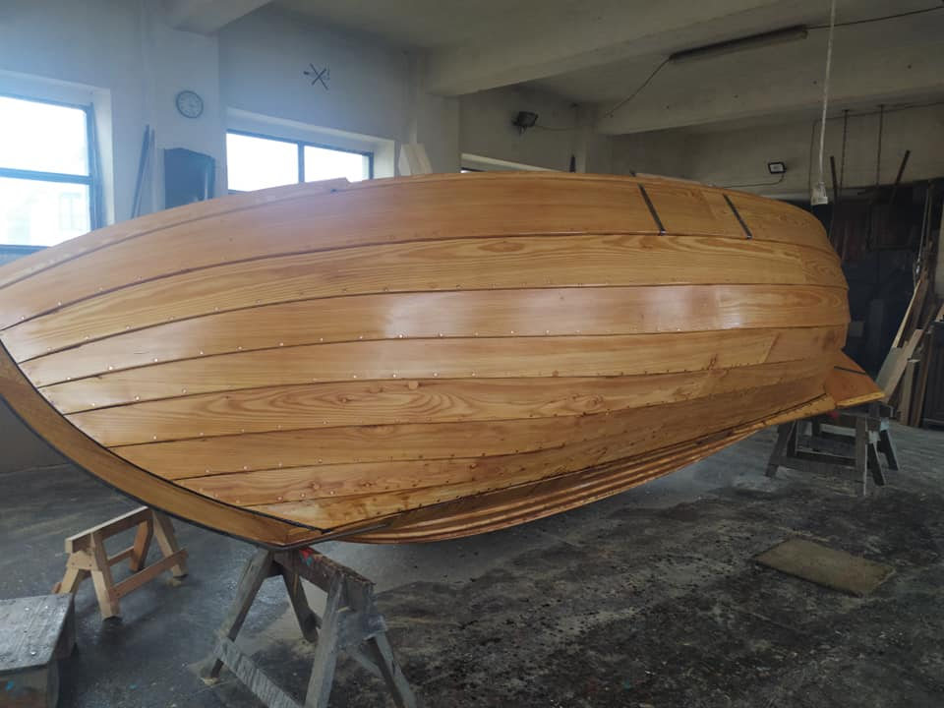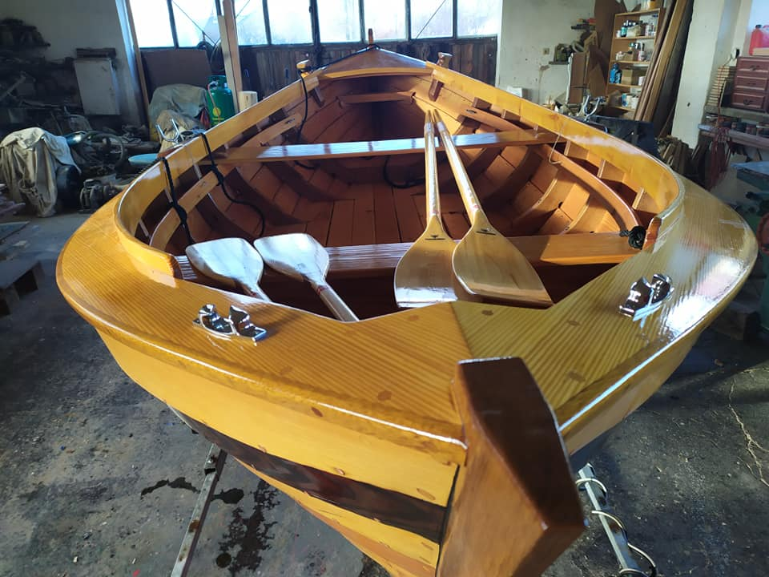
Figure 63. The example of boat clinker built made in Shipyard - Jacek Struck Jastarnia Poland

The ribs, or more correctly the timbering, in these boats is local English oak, only partially air dried and then steamed into shape. The further curing of this timber in the boat tensions the structure adding to its stiffness. The gunwales and rubbing strakes are made from a tropical hardwood called Iroko. This timber comes to us in logs sawn into planks two inches thick the full width of the tree and this we convert to sided timber making the best use of each piece. This timber is widely distributed in both Africa and the Far East, we normally get ours from The Cameroon in East Africa.
The hull is fastened with copper boat nails, square in section "clenched" i.e. riveted, over roves, the conical washers, and this system gives the method its name. Originally the Scandinavians used soft iron nails with diamond shaped flat roves, however the use of copper has been universal for a very long time since it does not rust or react chemically with the oak timbers. Finally the plank "lands" are sealed with a small amount of a synthetic rubber compound. This replaces the horse hair and "Stockholm Tar", a resinous pitch distilled from pine wood and much used by the old boatbuilders.

8.1.2. Carvel planking
Carvel-built, the planks are mounted against the ribs. Carvel-planked boats are built by erecting permanent frames or temporary moulds on the keel structure, and if steam-bent frames are to be used they are bent to fit battens or ribbands wrapped around the moulds. The planks are individually shaped to fit and are fastened with copper nails and roves and/or screws to the frames. The planks are fitted with a small V-joint outboard, into which caulking cotton or oakum is hammered and payed or puttied over. Carvel-planked boats are generally built right way up. Variations include batten-seam Variations include batten-seam carvel construction, used where the thickness of the planking is too light to hold caulking cotton (usually 1/2 inch or 12mm). Each seam has a batten behind it, and each plank is fastened to the batten as well as to the frame. The description of carvel planking was presented in figure 64.

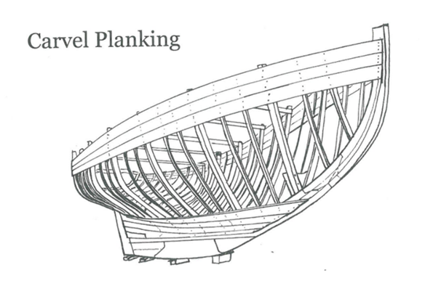
Figure 64. The Description of carvel planking

Carvel planking evolved from a Mediterranean tradition with roots back in the Bronze Age. The last big change was when the Industrial Revolution allowed cheaper production of stronger metal fastenings and carvel-planked boats began to get vessel, lighter. Except for some classes of fishing built very few carvel-planked vessels have been built since the 1960's. In spite of rumours to the contrary, materials to build carvel-planked boats are still available, and there are still professionals available who can do it but it is also possible for a determined amateur. The joints application of carvel construction was presented in figure 65.

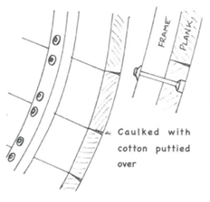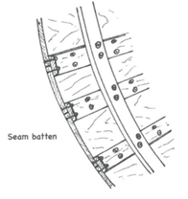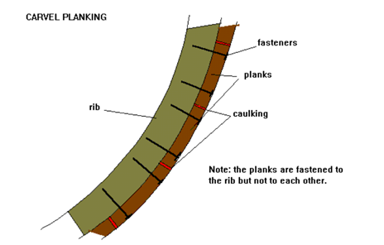
Figure 65. The joints application of carvel construction
Source: http://www.clinkerboat.com/about clinker boats.html

Types of Boats like Yachts, fishing and commercial vessels and launches over around 20 feet long were almost exclusively carvel-planked until the 1950's. It is still more suitable for yachts and launches of more traditional style. Because the timber will expand and contract when wet and dry it is most suitable for boats that are moored in the water. Boats that have been designed for more recently developed constructions systems will often not adapt because of the greater weight of carvel construction. Batten-seam carvel boats have been built down to around 6 foot in length. Sydney's racing skiffs from 6-footers to 18-footers and even larger 22 and 24-footers were generally batten-seam Cedar-planked, as were many launches of 16-20 feet. The construction of carvel boat was presented in figure 66.

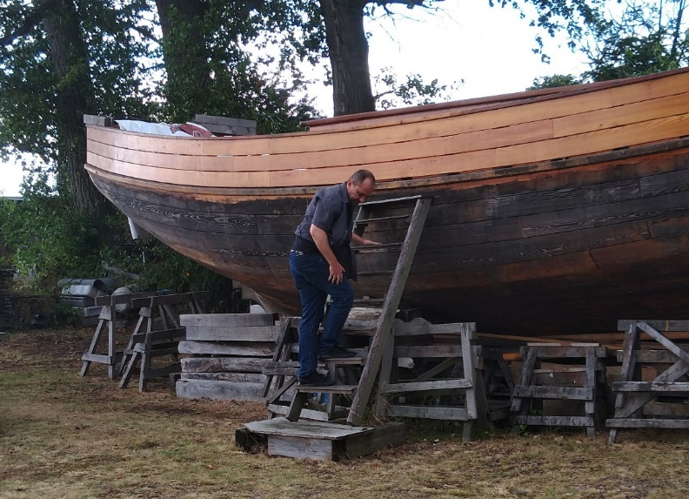
Figure 66. The construction of carvel boat.

8.1.3. Strip planking
The strips are gently rounded and are nailed to the strip underneath. Strip planking is a form of carvel planking. The hull is built over forms using strips of wood, edge-glued, and edge fastened together. The strips are kept narrow so that there is very little shaping required. Strips are usually a minimum of 1/2" thick, with a maximum width of 1 1/2 times the thickness. With modern epoxy adhesives, it is the glue and not the fasteners that holds the hull together. A related method (our Stripper) uses strips of wood, edge-glued, faired, then coated inside and out with epoxy and fiberglass cloth. In this method the glue joints are less critical as the hull ends as a composite; the wood serving as a core. The glue joints only need to be rigid enough so that the hull can be faired and glass cloth applied without the hull deflecting from shape. This method is used on canoes and other small boats and planking thicknesses may be as thin as ¼ ". The joints application of strip planking construction was presented in figure 67.

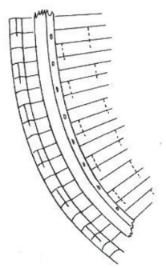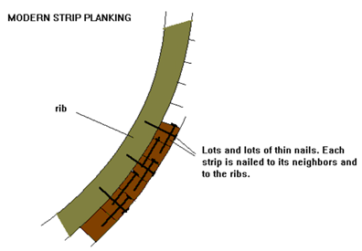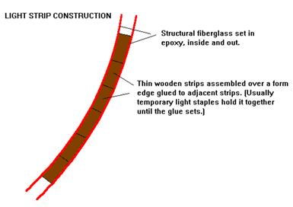
Figure 67. The joints of strip planking
Source: http://www.clinkerboat.com/about clinker boats.html

Strips can be cut from wider lumber and fitted to the previous plank as required by the curvature of the hull, or they can be "bead and cove". Bead and cove is somewhat like a ball and socket. One edge of the wood is concave, the other convex. This method eliminates having to fit each plank to the previous plank. With epoxy, nails are redundant. If you are building a boat with ¾" thick or thicker planks, nails can be a great help in construction, allowing you to hold the planks in place without a lot of clamps. For thinner planks, you may find yourself abandoning fasteners as they are difficult to drive straight in the time allowed by the glue, and many of the nails will come out one side or the other. Galvanized finish nails are frequently used but may not hold if the wood is soft and there is a lot of twist in the plank. In such a case it is best to use ring shank boat nails or clamps. If using thickened epoxy, the purpose of the fastener is to hold the plank in place until glue sets.

8.1.4. Cold-moulded planking
The first layer of cold forming is applied diagonally. The angle is found thanks to several bending attempts on different parts of the hull. This allows the easiest arrangement in the largest number of places. This layer is glued with epoxy to the stringers and the edges of the bulkhead, but be careful not to stick the edges of adjacent boards together. At a layer thickness of only 1/4 ”, they may bend slightly differently and will not fit exactly together. The second layer is applied to the first one, and the edges are glued to the adjacent ones. The layers are pulled together with sheet metal screws and stick to each other, the excess glue fills the joints (spaces) between the boards in the first and second layer. The sheet metal screws are removed and re-screwed in in other places. The holes left are filled while gluing the third layer. In the first and second layers, this is not necessary because the glue will be pressed into them when the next layer is pressed against them. The sample of covering first layer was presented in figure 68.

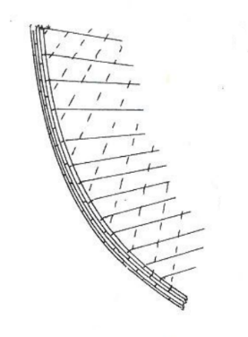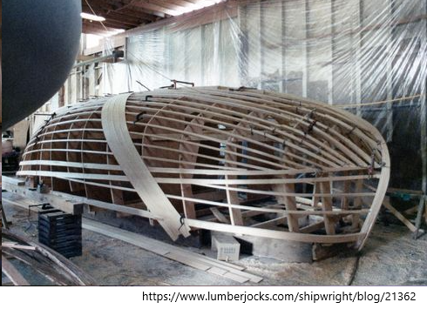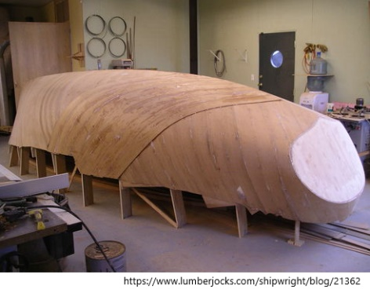
Figure 68. The sample of covering first layer

8.1.5. Double planking
Double planking, the planks are often riveted to each other. Plywood panels are cut to pre-determined shapes and stitched together, usually with wire ties or plastic cable ties spaced as necessary, and the joints filled with thickened epoxy glue. Both sides are smoothed and taped with fibreglass tape in epoxy resin. The pre-determined panel shapes and careful setting up result in the hull shape coming together very quickly. The application of double planking was presented in figure 69.

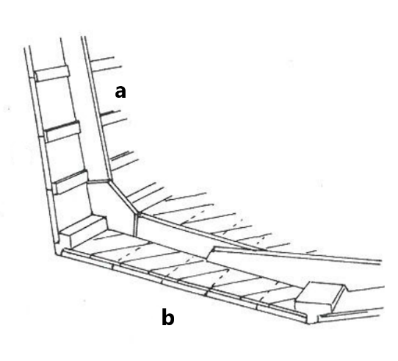
Figure 69. The application of double planking

The method was first used in the 1950's with polyester resin and glass tape for a number of small classes of boat including the Mirror dinghy. The greater strength and ease of use of epoxy resins meant that they took over in the 1970s. There is a wide variety of designs available for stitch-and-tape construction for canoes, kayaks, dinghies, day sailers, trailer sailers, multihulls, launches, power boats and small yachts. The sample of stitch and tape was presented in figure 70.

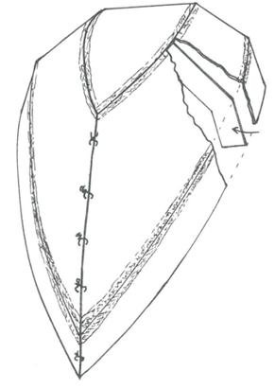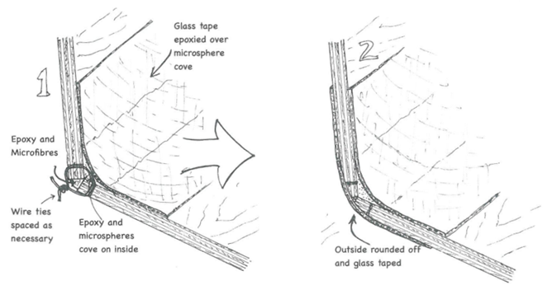
Figure 70. Stitch and tape

8.1.6. Epoxy Strip Planking
Thin strips of wood are edge-glued to each other over temporary moulds, then sheathed with glass cloth in epoxy resin, then turned over, cleaned up and sheathed inside also. This results in a sandwich construction that has immense strength and stiffness for its weight. The core timber can be solid timber such as Western Red Cedar or a manufactured product such as Durakore, which is end-grain balsa sandwiched between veneers and cut into strips which are joined end-to-end to make up planks which are then fitted to the moulds just like solid timber planks. Durakore allows the construction of extremely lightweight vessels. The boats are always built upside down.
Strip planking was used earlier this century even before the invention of waterproof glues, but the planks were nailed both to frames and the rest of a backbone similar to a carvel-planked hull, and a variety of bedding compounds were used to keep the water out. Each plank had to be bevelled to fit against the previous one, and the whole process was extremely slow. The same system remained essentially unchanged even when waterproof glues came into use. Small canoes were built with narrow edge-glued strips in the USA from the 1960's, sheathed both sides with fibreglass cloth in polyester resin, and therefore needing no internal framing, but the Yanks never made the connection to using the system with larger craft. In the late 1970's Arnie Duckworth of ATL Composites, the WEST System agents in Australia and New Zealand began building larger boats this way using WEST epoxy resins for both gluing and sheathing and within a few years the method came to dominate one-off wooden boat construction in this part of the world. Arnie's invention of Durakore in the early 1980's meant that ultra-lightweight boats could be built that rivalled those built from foam cores, but much cheaper for one-off construction. The sample of epoxy strip planking was presented in figure 71.

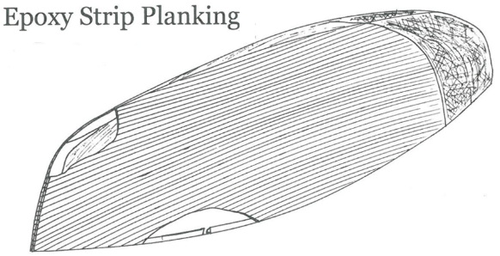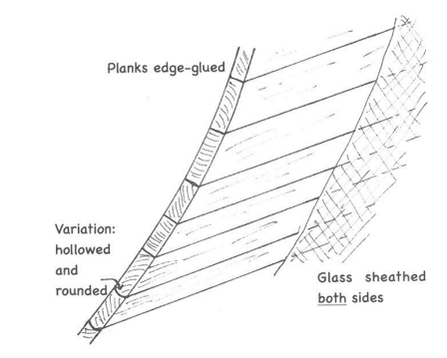
Figure 71. The sample of epoxy strip planking

The types of boats hull of any shape can be built using epoxy strip planking. There are ways around even the most difficult of hull shapes. Dinghies and canoes, yachts, launches and powerboats, ultra-light racers and heavy displacement traditional designs can all be built. Boats with large flat panels can more easily be planked with sheet plywood, but any one-off round-bilged hull can be built quicker strip-planked than with any other method. In European tradition carvel-planked or clinker-planked building methods had not changed substantially for hundreds of years. There had been a slow evolution and the basics of both go back thousands of years. Variations did exist, including diagonal planking. It's all changed since the advent of waterproof glues in the last decades. First came plywood, then moulded boats (diagonally planked and glued), then strip planking. All of these methods had their roots even before the development of waterproof glues, but the glues improved them and they would have become far more popular if fibreglass reinforced plastic boats hadn't started their quick rise to market dominance in the 1960's. The types of stealers connection was presented in the figure 72.

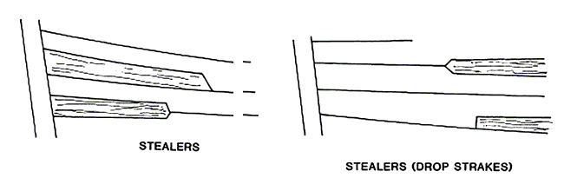
Figure 72. The types of stealers connection

While there are now many different methods, there are only two main divisions which are of vital importance: the traditional versus the modern. All traditional systems are based on the concept of a group of individual pieces of wood held together with metal fastenings, while all modern systems are based on the concept of a continuously laminated vessel of monocoque construction. The both concept of building are just as good, when done properly. When the two methods become mixed, it usually spells trouble. For example, gluing traditional planking together will usually end badly; and puncturing the surface of a laminated boat with metal fastenings will generally allow water in and cause problems.
On the basis of experience and knowledge was created by Jan Hugh Smith a table, where the types of planking methods are assigned to the appropriate types of boats. The ratings are based on assessments of the suitability of certain construction methods for particular hull shapes, weight requirements of certain types of boats built in traditional methods with their disadvantages as dry out and leak. The modern methods is preferable I nowadays due to the labour intensity, but traditional methods also have to be cherished as one of the European heritage traditions. The description of building method of boat types was presented in the table 6.

Table 6. The description of building method of boat types
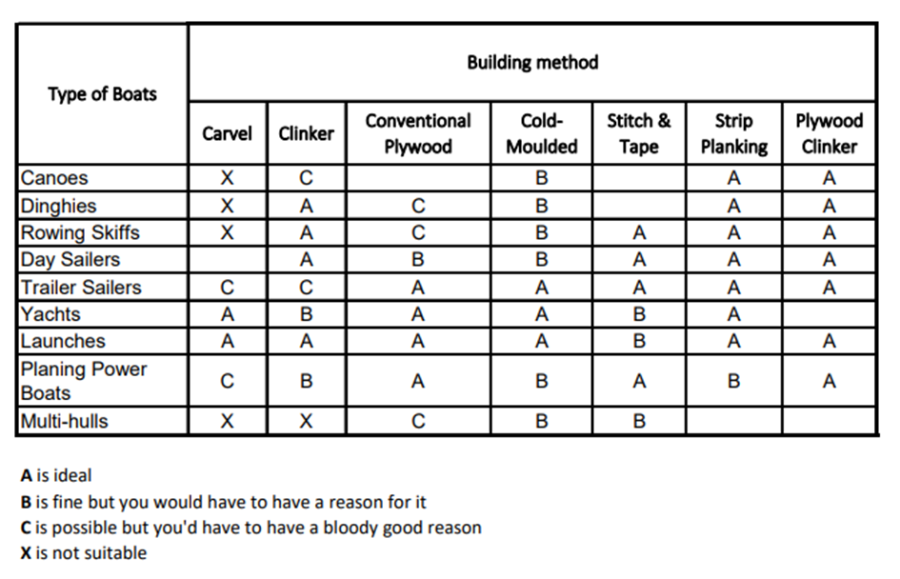

A form of planking in which the longitudinal shapes of the planks resembled anchor stocks. It was similar to the top and butt method of planking and was intended to prevent shifting and increase the longitudinal strength of wales and other stress-bearing planks. A method of planking of hull whereby one edge of the plank was straight while its opposite side had sloping edges locked by a hook. Top and butt planking. A method of planking whereby one edge of the planks were straight while their opposite sides had two sloping edges of unequal length, reducing the plank widths to half. It was used to increase longitudinal strength and to prevent shifting of wales and other stress-bearing planks. The connection of anchor stock planking, hook and butt planking, top and butt planking, joggled seam, and gravity piece was presented in the figure 73.

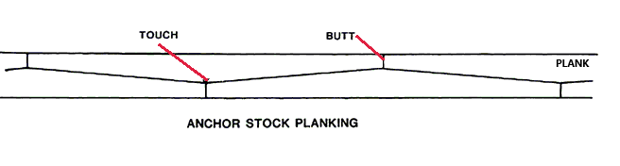
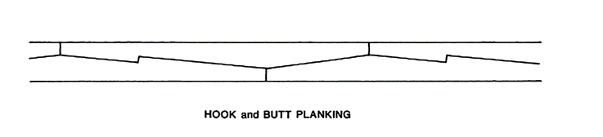
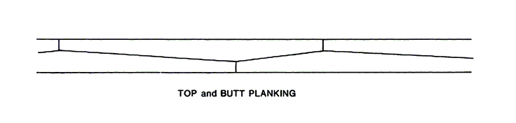
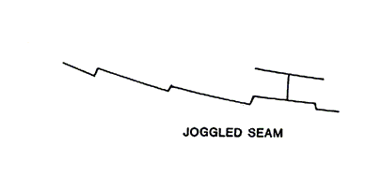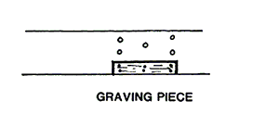
Figure 73. The four types of connection
(based on https://www.oxfordhandbooks.com Author: J. Richard Steffy, 2013

8.2 The Planking Process
To the after timbered out, rabbet faired, is planking. This is the biggest single job, and probably the most difficult for the beginner—not because there's anything very, complicated about it, but because much of it depends on judgment, eye, and the unconscious skill of hand that you gradually acquire without knowing it. The old pro loves to fit planks because he can do it without thinking, and it's his great talent, with a sort of timeless rhythm to it, which clothes and defines a thing of beauty. What we're talking about here is, of course, real planking in the ancient, classical manner: fair-seamed, tapered, fitted and through-fastened to the timbers, smoothed fair, and caulked. Learn this, and you are welcome to try edge-nailed strips, battened seams, cold-moulded laminates, or chicken-wire-and-fiberglass. (I hope you will sometime try a lapstrake job, because that is beautiful indeed.) But for now let's get on with the problems of smooth planking, which keeps the water out, and the people in, better than anything else I know of, and delineates (at least for you, the builder) the most beautiful shape that man has managed to create.
So, first, you need to know what shape the individual planks will be, before you worry about how to mark, cut, bevel, hang, and fasten them off. This boat we are dealing with is in some ways the most difficult and complicated shape one is likely to encounter, with wineglass sections throughout, great area below the tuck, extreme vanatlons in girth, long counter, and plank ends mitered to the cylindrical-section transom, but that is all to the good. I'm sure that if I can explain it, you can understand it, and you may as well know the worst at the beginning. It's like swinging two bats when you come up to the plate.

8.2.1. Lining out the sheer planking
The view of the hull of 39-foot sloop in two distinct parts, separated for our purposes approximately along diagonal D2 (and if we're lucky, also along what has been referred to elsewhere as the tuck ribband), you will dimly discern that I have distinct approaches in mind for these areas. The areas, one above and the other below this ribband, are for our purposes completely independent of each other. Kindly ignore the lower one, and bear with me as I attempt to line out the planks that will clothe the area between this special ribband and the sheer. The simplest way to do this (and entirely satisfactory, if you have skill and time enough) is to line out with a batten, by eye, the lower edge of the proposed sheerstrake, cut a plank to that shape, fasten it in place, and repeat the whole process over and over till you get there— in this case, to the flat of the bilge, where I hope you're planning to put in the shutter. This method is slow, laborious, and lends to irregularities, but it works. The lines plan was presented in the figure 74.

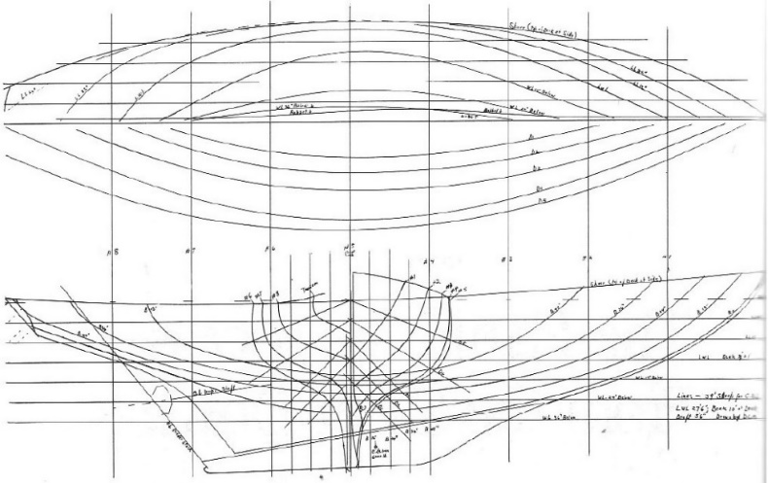
Figure 74. The lines plan

The more precise system, which is based on the following assumptions: Ideally, all seams are to be fair curves from bow to stern; all planks are to taper exactly the same amounts from the widest point in the middle to their narrowest points forward and aft. With 17 planks at exactly the same width on station 5 number, we should have 17 planks exactly the same width at station number 3, at station number 7, and anywhere else in the length of the boat. Finding the girths at each section, varying girths equally dividing into the same number of parts, which repetition of a proper number of times the area will be covered. The proper way to do this, is the measurement the distances between stations along with a sort of Great Circle course from stem to the transom-say, along the ribband that lies between diagonals D4 and on the body plan of the lines drawing. These dimensions will increase as you go away from the middle of the boat. The proper measurements the distances between stations along with a sort of Great Circle course from stem to the transom-say was presented in table 7.

Table 7. The proper measurements the distances between stations along with a sort of Great Circle course from stem to the transom-say
Stem to | 46" | #5 to #6 | 48"
#1 to #2 | 50" | #6 to #7 | 49 ½"
#2 to #3 | 49 ½ " | #7 to #8 | 50"
#3 to #4 | 48½ " | #8 to transom | 53"
#4 to #5 | 48"

Using a clean board about 6 inches wide and 6 feet long, the joint of one edge straight can be conducted. Starting a few inches from one end to the distances to a scale of 1 ½ inches equals 1 foot (1/8 inch equals 1 inch), and label each mark. So the end with a mark labelled "transom" exactly 4 feet 7 ¼ inches from your starting point labelled "stem”. The example of counting was performed on the equation below.

Example:$\frac{75{\frac{1}{2}}^{''} \left(girth at station number 5\right)}{17 \left(planks wanted\right)}=4{\frac{7}{16}}^{''}plank width at station number 5$

Lifting the board down and finding a limber lath, about 1/8 inch thick, 3/4 inch wide, and 8 feet long. The marking stick should be used to get the girths. The bend inside the ribbands, with its lower end resting on the top edge of the special tuck ribband, close alongside the number 5 mold and snug against the insides of the ribbands. The marked lath is exactly at the height of the sheer mark on the mold. In the other six-station girths the same way, the ​measurement should be carried, exactly from the top of that critical ribband to the sheer mark. The labels can't be mixed. Unfortunately, the rabbit before reaching the station mark and the girths at the points called "stem" and "transom" can't be measured. The plank layout by use of a diminish board was presented in the figure 75.

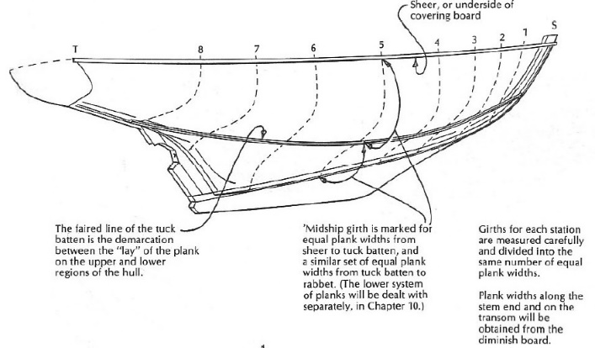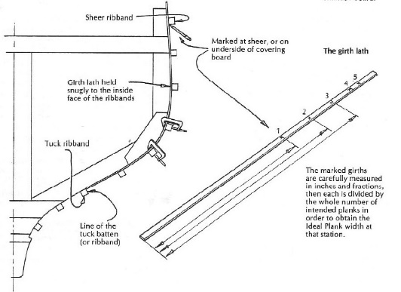
Figure 75. Plank layout by use of a diminish board

The measurement of the girths should be performed, subtracting from each the thickness of the deck (l inch in this example) written down the results in inches and quarters. In these boat examples, only the girth at station number 5 was used, which measures 75 2/4 inches. The number of planks counting the maximum width of each one instead is to be used to cover this space. The workable rule of thumb on widths should be performed in the proper way. In the first place, the maximum width of a plank should not be less than four or more than five times the thickness of that plank. Based on 1 5/16 inches thickness of stock, no less than 4-inch width at station number 5, where the girth is greatest. The dividing each of the six other girths by 17, to get the width of each plank at each station. The 17 planks, each 4 7/16 inches wide should be adequate to fill the gap. The plank layout by use of a dismish board was presented in figure 76.

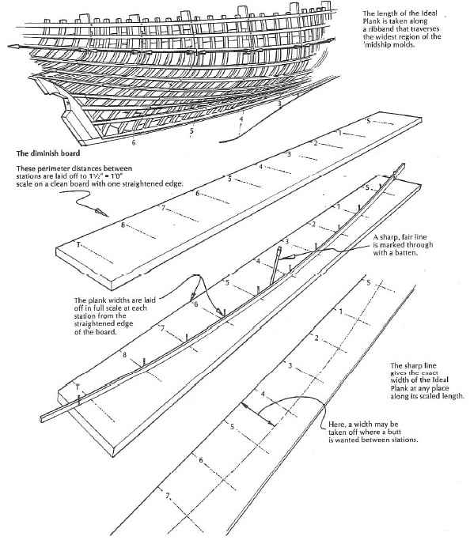
Figure 76. Plank layout by use of a dismish board

Going back to the board with the intervals marked on it in 1 ½ inches-to-the-foot scale. The line square across the board at each station, stem, and transom mark should be drawn. Along each of these cross lines, from the straight edge of the board, the width of the plank is obtained in the process of dividing each corresponding girth by 17 should be measured. Having a series of marks arcing from station number I upward to greatest height at number 5 and back down to a mark on the ordinate labelled number 8. The small nail should be driven firmly at each of these points. Flawless pine or spruce batten about ½ inch square and 7 feet long, should be bent around inside, and touching, the vertical nails, and hold it against them with three or four nails driven snugly against the inside face of your batten. The result should be a fair convex curve, requiring no local forcing of the batten to make it touch all of the marks. In case of any great discrepancies show up (a point more than ¼ inch away from the line the batten wants to follow), you'd better check your arithmetic. The ends of the batten beyond the number I and number 8, should be pulled down the ordinates until it exerts no pressure at these two points, and accept its decision as to the correct widths at the end ordinates—stem and transom. The curve needs to be correct and fair, marking a sharp line on the board the full length of the outside of the batten. The nails should be pulled. The true width of the plank that, repeated 17 times between sheer and tuck, should fill the space watertight.

8.2.2. Fitting the forward port sheer strake
To fitting the forward port sheer strake the five penny box nails, scribers, a light hammer, a crosscut saw, a bevel gauge, a half-dozen C-clamps, and a spilling staff, which is a thin board, 4 to 8 inches wide and as long as the longest piece of planking stock you propose to use. If this spilling board has a gentle S-curve in its length, it will do fine for the forward planks on the topsides. The staging planks on high horses so that the shoreline is waist- to shoulder-high should be set up. The long batten should be stemmed, that its lower edge delineates the exact line of the sheer. The spilling board needs to be placed into the forwarding end that rabbet and down 2 or 3 inches from the middle of the shoreline right up to the batten. Adjust should be performed without springing it edgewise, with the dividers locked at one setting, run the whole length of it with a pencil line that will be equidistant at all points from the edge of the batten. The scribing the sheerline was presented in figure 77.

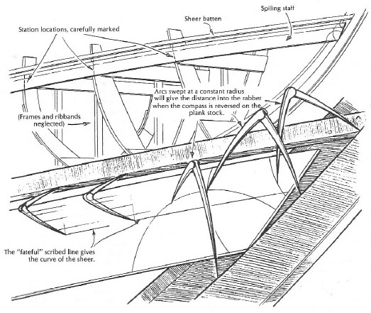
Figure 77. Scribing the sheerline

The sheer strake needs to be cut to fit, not edge-bent to fit. The drawn line that's represented the top edge of the sheer strake, keeping the legs of your scribers at right angles to the line of the batten. With high precision on the spilling board, the extra distance should be added to the plank to reach the rabbet line. The location of all stations (molds) for the purpose of marking widths to the lower edge. On the spilling board the exact curvature of the top edge of the sheer strake, from the stem rabbet to the butt, carefully marked in the middle of a bay some 20 feet aft of the stem. The notations of the locations of all the molds were covered. The diminished board provides all the necessary information. After taking off the clamps, and spilling the board tenderly to the three lies the raw plank l inch by 10 inches by 21 feet, the shape of the forward half of the sheer strake should be marked. The dividers are about 14 inches, should be a greater span than was used to mark the line on the spilling board. Using the span as a guide in placing the spilling board on the stock with the sharp leg of the dividers on the line of the end on the stock should be marked. It should be provided at 12-inch to 18-inch intervals along the entire length of the line you're transferring. Laying out spilling on plank stock was presented in figure 78.

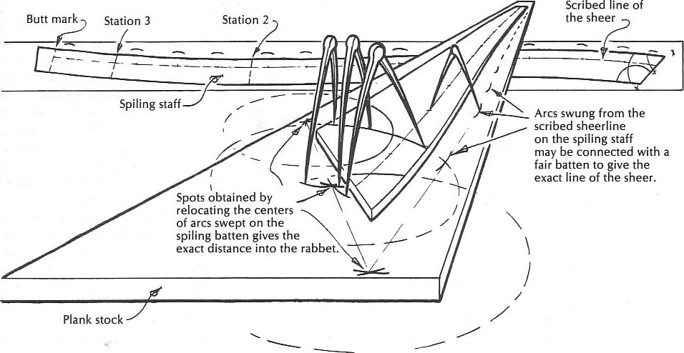
Figure 78. Laying out spilling on plank stock

The exact spot where the top edge of the plank will hit the rabbet line at the stem should be marked, and the location of each station where the plank will cross it and the location of the butt-cut as well. Next step needs to put the spilling board aside, and drive a nail, at the top of each of the short arcs you marked. Bending the batten against these should help to draw a line along it exactly parallel to the one on the spilling board, and representing the top edge of the sheer strake. The diminish board should help to exact widths indicated at each of the stations marked on the plank, obtained by scaling to the right spot on the diminish board, and measuring directly from it. The nail at each mark should be used, and draw a line should accord to the lay the batten, which will be the bottom edge of the sheer strake. In the next steep the plank should be cut. It can be used with a hand ripsaw. Some moderns use a big bandsaw with a wide blade or electric-powered circular handsaw. With practice, the cut will be done quickly and with great precision. The plank can't be fastened on the boat if it has humps and hollows on its exposed edge. The Sheer strake ready to cut was presented in figure 79.

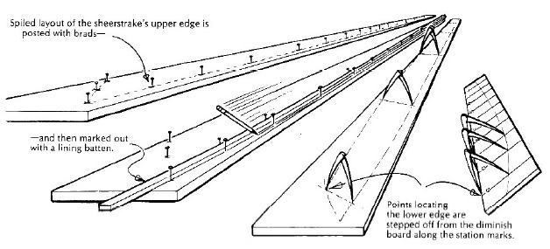
Figure 79. Sheer strake ready to cut

With bevel gauge, the angle between the sheer batten and the rabbet at the stem should be marked and cut at the forward end of the plank, that it the mark out an exact mirror duplicate of this port plank. The twin plank shouldn't be cut out until the first one will not be in place. Picking up the plank about at its balance point against the frames, moving it to a horizontal position, until the nearest station mark lines up with the corresponding mold. Construction should be clamped to the nearest frame with the top edge ¾ inch below the batten, swinging the end into the stern. The rabbet needs to be tight inside all the way and showing a 1/16-inch out gauge. During planking from the sheer down the clamps on the forward face of the frame should be used. This arrangement keeps planks out of the way of the fastenings, which are always staggered according to a fixed pattern. The lower one toward the after edge of the frame, the upper one forward.

8.2.3. Fastening the sheer strake
With a tapered drill to fit 2-inch number 14 screws, and proceed to ¾ inch up from the bottom edge and 1 inch down from the to. Counterbore needs to go about 5/15 inches deep. After bolting through the sheer strake and the frame heads to hold the sheer clamp in place, about half the bolts will fit to driven plank fastenings. Screws can be taken out, to make way, marking on sheer strake, the bays where the chain plates will go. The butts mated by use of the severed end was presented in figure 80.

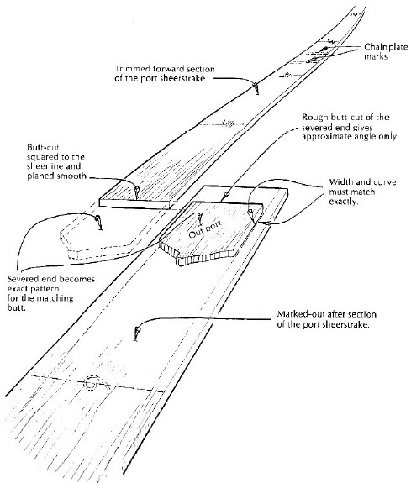
Figure 80. Butts mated by use of the severed end

Fitting the aft port sheer strake the fit of the after part of the port sheer strake need to be done. The spiling board from the butt to and beyond the transom frame should be clamped. The station locations and the after end at the transom need to be marked. Indicate the exact distance to the butt from the end of spiling board should transfer all this information to the piece from which the plank will be cut. The widths for the bottom edge curve, from the diminish board, need to be laid off. The fitting sheer strake to transom was presented in figure 81.

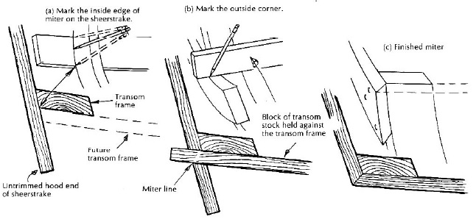
Figure 81. Fitting sheer strake to transom

The butt end to fit tight should be shaved and clamped into the transom frame, using the top edge on the marks. The well-set crosscut saw up the joint should be performed. this step should be repeated until the joint is airtight. The transom frame for the miter cut needs to be marked. Inside the line is the outer edge of the transom frame. The outer line is determined by laying a piece of 15/16-inch stock against the transom frame, under your plank end, and marking where the outside surfaces of each Intersect. The cut will be roughly 90 degrees to a tangent to the transom frame at the edge. To be sure that the plank is really at the right height on the transom, the sight from the plane of the cross and measure up to the height given in the offsets need to be done before marking. Taking the whole plank off before cutting will be the best solution because it's very with it helps with ergonomic. The inner face of the plank needs to be fit, to lie snugly for its entire width against the curved frame. The short bit of 1/4-inch-square lead bar, bent into a curve, as a guide in the following process should be useful. The mark out a twin to this plank before fastening it in place should be done. Correction the bevel on the transom frame where the plank lands should be don as well. All need to be clamped in place again and fasten off.

8.2.4. Fitting a butt block
The butt block needs to be fit. The butt block should be a piece of black locust or white oak, black walnut, or even dense mahogany overlapping the adjacent planks. Above and below, by about 3/8 inch, and with ends about that much short of touching the frames forward and aft of the butt. The block should be thicker than the plank stock, and it should be fitted exactly to the hollow and twist of the inner surface of the planking. Block should be held in place with C-clamps inside-out on the high corners. Three fastenings in each end, for 1 inch back from the butt, and two in each plank, a third of the way in from the edges and halfway from butt to frame. For 13 4-inch numbers, 14 screws need to be drilled, with counterbored 5/16 inch deep, for the end fastenings, and for number 8 copper rivets 10. The end holes, through the planks only with a 1/4-inch drill, need to be reamed. The clamps can be taken off, soak the contact surfaces and the ends of the block with strong poison, re-clamp, and fasten.
In starboard, the length of the lower edge is a piece 3 or 4 feet shorter, marking the top edge of this second plank from the bottom edge of sheer strake. The widths of the 10 match the sheer strake widths of the bottom edge with a batten, and saw out. To do the twin edges the lower edge of the second plank needs to be used as the top edge of a third one. The process should be repeated, to get the lower line edge, saw out, and mark the twin. There are five planks ready 10 bevel, that need to be fastened, according to the strength of the original spilling. It calls proliferation. The butt block was presented in figure 82.

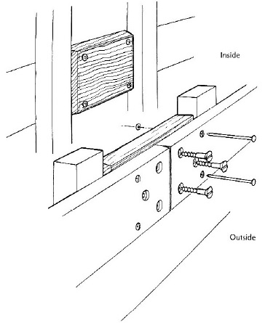
Figure 82. Butt block

8.2.5. Seam bevels
In beveling the main aim is to have all the scams open the same widths on the outside, and light-tight on the inside. With this thickness planking, the opening for caulking should not be over 1/8 inch anywhere on the boat. A joint that is tight both outside and in can be caulked, and is forgivable but not to be praised. A joint that is tight on the outside and open inside needs a very slick system of caulking a seam endwise. The Figure 9-10 Seam bevels was presented in figure 83.

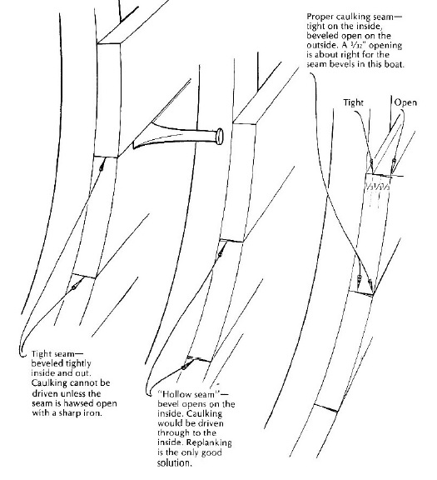
Figure 83. Seam bevels

The bottom edge of the sheer strake was left exactly square after it came from the saw. The plank square should be left open the edge, with the beveling on the edge of the plank that is to fit against it. The frames are practically straight and need only plane a uniform out the gauge of about 32 inches the whole length. Two cross-sections one from the sheer strake down past the turn of the bilge, and the other through the reversed bend in wav of the tuck. The plank bevels—from in gauge to out gauge was presented in figure 84.

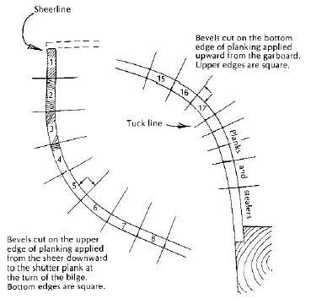
Figure 84. Plank bevels—from in gauge to out gauge

Plank number 2 in the drawing must be bevelled off on the outer edge to about 87 degrees. The third plank, where the frame has begun to curve, needs no bevel at this point. The fourth one needs culling down on the inside edge, in order to keep the seam uniform with those above it. This need for in gauge calling reverse bevel increases progressively, the hardest part of the bilge curve, reaching a maximum of 16 degrees (106 degrees minus 90 degrees) on the top edge of plank n umber 6. The bevel starts the other way on plank number 7, after that going back to the 87-degree outgauge was necessary on plank number 2. The bevel needs to be done every 2 feet, and mark the angle on your bevel board. The taking bevels was presented in figure 85.
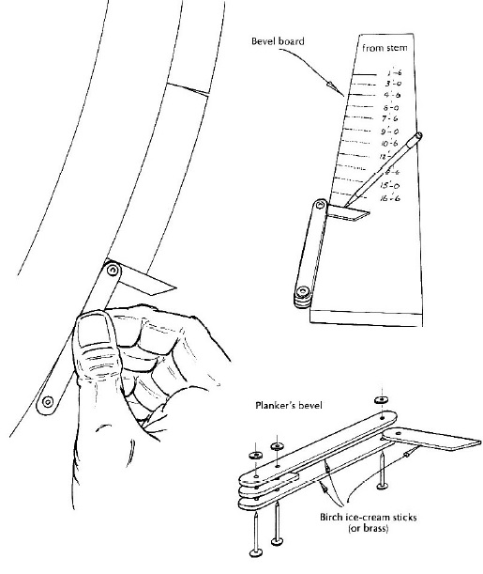
Figure 85. Taking bevels

Considering the other half of the section through the tuck. The plank up from the garboard leaves the top edge of each plank square fitted, making the planks narrower. The cutback of the outer edge reaches a maximum of 23 degrees (90 degrees minus 67 degrees) on the lower edge of number 17, which is fitted to the square top edge of number 18. The bevel on any given plank must be constantly changing, from bow to stern, if the seams are to be constant, uniform, and caulkable. Therefore bevels need to be made.

8.2.6. The spilling batten
To match spellings, there must be used crooked round-edged boat boards or straight stock. Medium widths from 6 to 12 inches, with 8-inch and 10-inch boards making up most of the batch, at the curves you must fit to. Boards need to be bent edgewise with not too big pressure. The spilling batten needs to be about 4 inches wide to bend edgewise evenly, forcing it up in the middle, tenderly, and clamp it in place. The widest necessary gap should be marked as a line. Marked on the batten through the overlapping lines will show how much alteration must be made, shifted from the wide gap to the narrow one. The spilling batten on the stock to be marked, spring its middle slightly down, thereby making the top-edge line transferred with arcs at 18-inch intervals, is straight than it appears on the unsprung batten. The batten has recorded and allowed for the stresses that the plank will undergo, and kept the bending mostly within the middle third of its length as well. Cuts are very nearly true to the actual shape required. Edge-setting the spiling batten to get a more comfortable fit of edge-set plank was presented in figure 86.

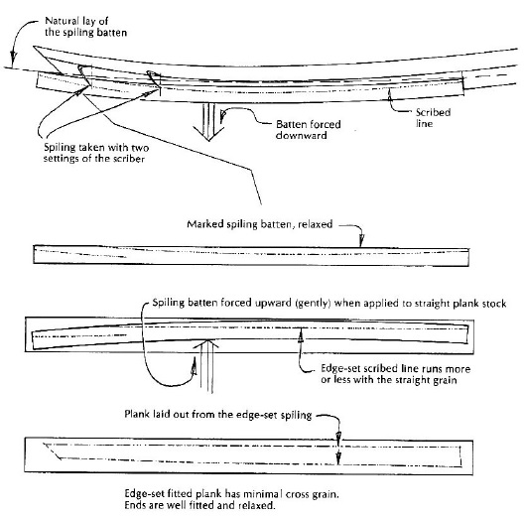
Figure 86. Edge-setting the spiling batten to get a more comfortable fit of edge-set plank

After being laid out with care new plank sprung on, the burrs and heads up the rivets on the lower edge need to be done. Instead of riveting the lower edge with screws should be fastened. The garboard also should be planked to the flat of the deadrise. The seams need to be upgraded with extra cotton.

8.2.7. The planking process from the garboard up
In this stage, the upper part of the hull should be planked. The next step is to plank up the bottom, starting with the lowermost plank called the garboard. The diminished board needs to be put aside, continuing the planking section of the boat below the tuck ribband instead. Closing this section with planks to the moment that easily be shaped to fit the hollow of the wineglass, and not too hard to fit. The Narrow-plank approach was presented in figure 87.

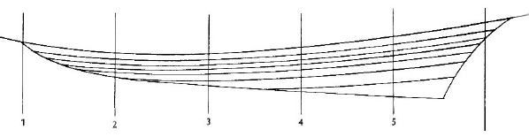
Figure 87. Narrow-plank approach

In a similar way, the Germanbuilt Concordia yawls and the Swedish Folkboats are lined out, and they must be acknowledged as splendid jobs of boatbuilding. There is a lot of for or against arguments of this narrow-plank approach, but it needs to remember, that sharp ends where they run out on the keel rabbet. The Nat Hcrreshoff used to build this whole thing up out of deadwood, spring a colossal batten keel to the top of it, and start the planking from there. These types of boats after 40 or 50 years that they were put together can be still useful.

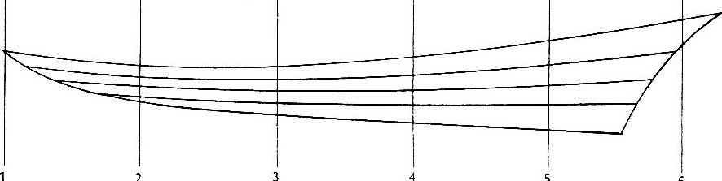
2
5
6
Figure 88. Four equal tapering strips

Plank layout, using stealers can use about 10 fits, but the planks would be unnecessarily narrow at the forward end, with four thin and hard-to-caulk ends running out 111 the rabbet. The difficulties are with the three upper planks but if you shaped them out of 3-inch stock, they would still not fit into that reversed curve. The curved upper planks was presented in figure 89.

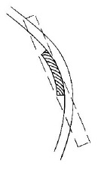
Figure 89. Curved upper planks

Curved upper planks should be made of one-halt that width, you can get them out of 1 1/4-inch stock. The standard of 1-inch lumber can be used. Bout can hold out 60 to 80 board feet, of random widths and lengths, but the rest of the planking stock should be treated by the surface planer. The problem can be found in 10 have lewer planks at the forward end, two each 4 ½ -inches wide at station number 2, and at least twice aft, where the hollow is greatest. This proliferation can accomplish by fitting stealers, by a system of butting two against one, or by a combination of the two devices.
The garboard needs to be considered again, letting its top edge back to the first bay forward of station number 3 halfway from rabbet to ribband. The remainder of the garboard can be left as drawn because it is not in the region of great curvature. Plank layout with stealers was presented in figure 90.

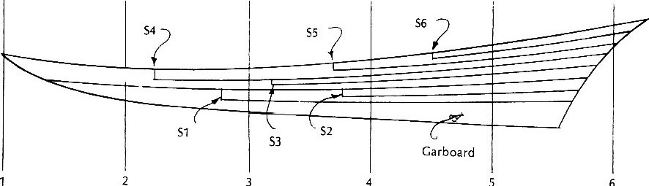
4
3
5
6
Figure 90. Plank layout with stealers

Plank from forwarding full width up to the ribband line, and aft to the first bay aft of station number 2 need to be used. The plank should be cut down to half-width get the bay aft of number 3 and halved again. Stealer S3 needs to be filled up to the sternpost in a line. Four equal tapering strips represents the middle of the third plank as originally drawn. The narrow planks need to be fit that quick turn in the tuck. From the bay aft of station number 2, there is a need to, go to the bay forward of number 4, and halve it, as the line to the sternpost. This is the top edge of the number 3 plank. From the new stealer at S5, halve it at S6, that is the bay midway between number 4 and number 5, to aft. The last stealer is from S6 aft and needs to be fit at the end up with eight planks at the sternpost. If the greatest girth aft, from the rabbet on the keel to the line of the ribband between number 5 and number 6 which is 36 inches. Theoretically, the garboard at this point is 9 inches wide; the next five planks are each 4 ½ inches wide around 2 ¼ inches wide.
Butts on adjacent strakes need to be separated by not less than three bays. However, butts in the same bay to be separated by three planks with stops. Stops need to be approached to scatter them widely. With the lengths of stock keep them in the region of least twist. The butt blocks should be fit and fastened below the tuck blocks must be hollowed precisely to fit the round and twisted of inner face of the planks. The butt blocks at the stealer ends should be wider than normal, to spread the load over more area. The unstable butt needs to be fastened with 1/4-inch bronze carriage bolts at the ends. Always needs to be caulk butts and filled flush with the proper filler. Caulked and filled flush with seam compound, they will inevitably show a hairline crack in the paint, the full width of the butt joint. Theoretically, seam filler has 50, 80, or 100% of elasticity. When bedding rails, molding, winches the material shouldn't be squeezed. The compound needs to be inset a day or two, and then tighten up fastenings and clean off the sticky stuff. Some work during boatbuilding using beads and blobs instead sealer.

8.2.8. Fitting the garboard plank
The garboard can be made in one piece, using plank 10 inches or wider at the butt end, and 33 feet long. To do it in two lengths, as long as it fits the butt block properly. The spilling board of the 20-foot should be clean and clamped into place, tapping, slacking and readjusting, until it settles down, and within scriber distance of the rabbet. The line with the scribers plumb vertical should be drawn to the curve at the forward end, to relax into an attitude at right angles to the line of the rubbet. All pertinent information needs to be put on the board before it moves. The exact locations of all station marks. The bay where the stealer starts requires widths 10 3/4 foot intervals. Since this garboard is to fill one-fourth of the space to be covered. Tack a cross-staff at the after end to mark the line of the cut to the sternpost rabbet. To indicate the spot on spilling board with corresponds with the end of the keel rabbet. The spilling reaches all the way to the stern rabbet. The end shape of the garboard established by temple was presented in figure 91.

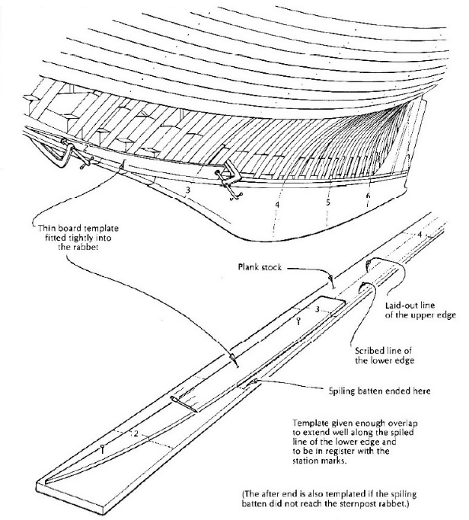
Figure 91. End shape of the garboard established by temple

The spiling board on the stock needs to be placed, by enough room to reach the sternpost rabbet. The line transfer notations of widths, that's why the locations of station num bers 1 and 2 need to be marked. The cut and fit an exact pattern needs to be marked from the thin pine, ¼ inch by 6 inches, and about 6 feet long for the forward end of the garboard. Between station numbers 1 and 2, reaching a bit higher on the stem rabbet than the proposed top of the garboard. When the pattern is still tacked in place, mark station number 1 on its lower edge, 10 corresponding exactly with the same mark on your original spiling, and on the plank. Station marks need to lay on the pattern to the line, to finish out the shape of the forward end of the garboard in the rabbet. Using a hand ripsaw on the last 3 feet at the forward end, the lower edge should be cut. The bevels and dress off the lower edge need to be marked a twin to this one before will be moved another inch. The spiling board clamped into the garboard space was presented in figure 92.

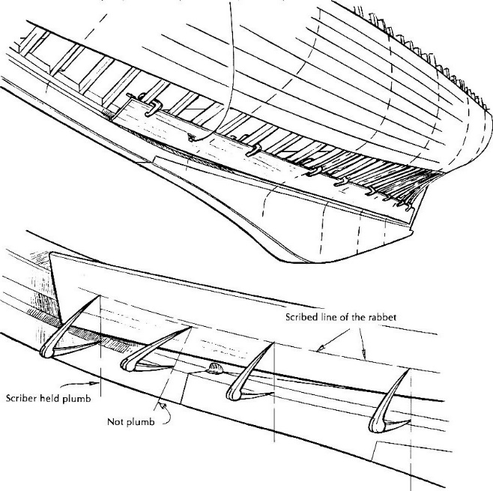
Figure 92. Spiling board clamped into the garboard space

If the stock is good, tough wood, not too terribly dry, can be use as cold, its mean without preliminary steaming. In the other case should be steamed after 10 or 12 feet for half an hour. The garboard can be tight on the outside, in places, and you don't know how much gap there may be on the inside. The after end, which lies in the rabbet on the sternpost, may not present a good consistent seam or may be reluctant to go all the way in this case the back rabbet needs fairing off. The inner face of the plank probably will need more rounding off at the top, to allow good contact with the frames and the back rabbet on the keel.
To build stopwaters the sharp spur auger, 1/2 inch diameter, with a good worm that will follow the seam need to be used. The centre face of the rabbet should be bored through until the tool will show on the other side of the backbone, and bore back from there to clean out the hole. With the same auger, bore a hole through a scrap of hardwood about an inch thick. This is a die, through which are going to extrude a dowel. The 2-foot length of straight grained white pine heartwood needs to be sawed out, that's accord over 1/2 inch square. The auger needs to be started on the end of the stick. To bore a hole right up the middle, as soon as the spur cutters have defined the perimeter of the Intended dowel. The plane needs to be done in the beginning from eight sides and sixteen, at the end in hardwood die. Evenly worked down, barely compressing the outside fibers in the passage can drive it through the die. The stopwater stock need to be proceeded to drive into the holes bored in the ship's backbone. The ends flush with a fine-toothed need to be cut by a saw or a very sharp chisel. How to install inside stopwaters was presented in figure 93.

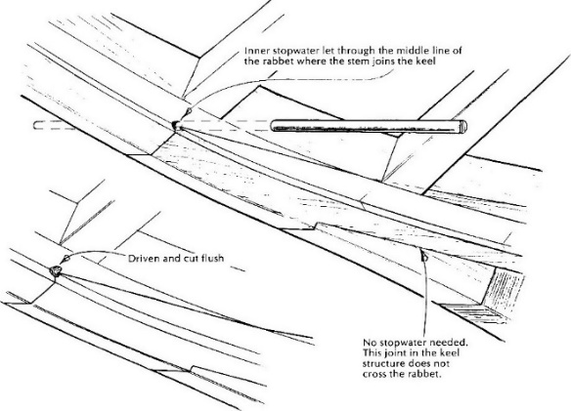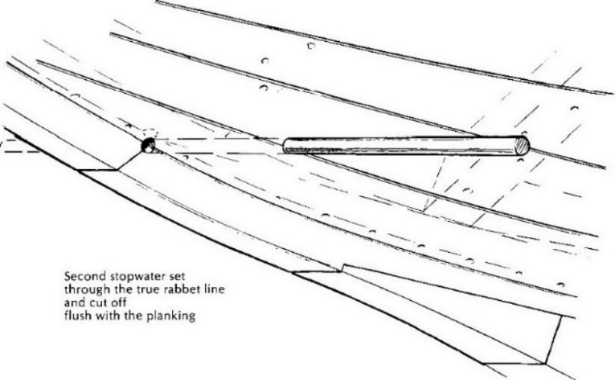
Figure 93. Installing inside stopwaters

The floors are fastened at the end. The screws should be driven by the good screwdriver bit or 1/2-inch-chuck electric drill. The switch needs to be let off at exactly the right instant so that the screw will fetch up snug when the chuck comes to stop, with no momentum left to jump the bit out of the slot. The shutter can be mounted by fastening the screws or rivets. To fit the shutter measurements, the tack of the spiling board to the frames down the middle of the gap needs to be filled. The scribed lines representing both edges of the proposed shutter need to be set by dividers. These scribed lines may cross and recross each other. To transfer this shape to the uncut plank need to proceed as during the normal spiling, in acceptance that two edges instead of one give no change in the spread of the dividers. The actual measurements of the gap at a few points help to widths derived from double spiling are indeed correct. This system works very well on a relatively wide and straight board, but it is very unhandy for a long, narrow, curved gap requiring a piece of spiling board cut to shape, tacked together, and ruined for further legitimate use. The sciribing the shutter plank was presented in figure 94.

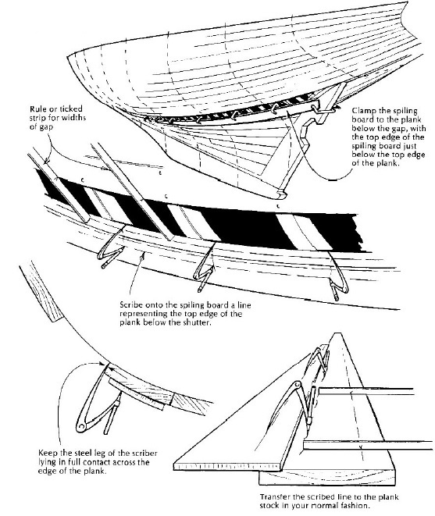
Figure 94. Sciribing the shutter plank

The basic tool for riveting is a burr-setter. The tools can be prepared from the 4-inch length of hard steel tube, ¼ -inch inside diameter, or be drilled from 3/16 -inch hole lengthwise, about one inch deep, at the end of a piece of 3/8 -inch rod. The burrs can fit tightly enough, that there is no need to drive it, and will stay in place until the rivets are headed up. The burr needs to be set down tightly against the wood, then with the end cutters nip off all the excess nail. If the burrs are a loose fit, the cutters sideways need to be rocked to increase the pressure on the handles. This motion spreads the end slightly and helps to keep the burr from popping off before getting to it with a riveting hammer. The end cutters are not quite too enough to handle the number 8 wire. The smallest set of bolt-cutters with but wiggle the handles up and down can helps to get that spreading effect over the burr. The tools for riveting was presented in figure 95.

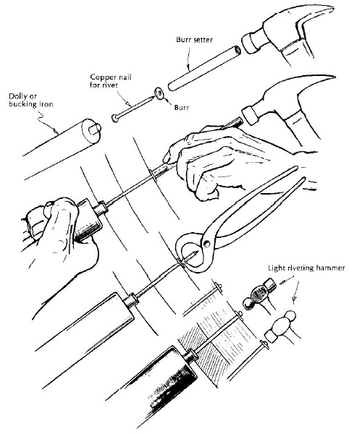
Figure 95. Tools for riveting

The riveting can be also conducted by drilling and tapping a hole in the end, thread and screwing in a stub of 3/8-inch steel rod, and filing this to a slight taper. On the other end of the rivet, moderately light machinists (ball peen) with a 12-inch handle hammer use are needed. The weight of the hammer can be increased according to the pointed force. The gently hit, with the round face of the hammer can help to pull the rivet tight.

Unit 9. Gaining knowledge on assembly, joining and fastening of bent elements.

9.1. Parallel connections

9.1.1. Connecting with a notch
Parallel longitudinal joints are used to connect elements in order to increase their width or thickness. These connections are most often used for butt joints was presented in figure 96, as well as rebate and "foreign-tongue" joints were presented in figure 97.

a)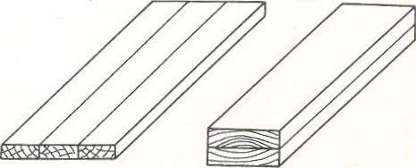b)
Figure 96. Contact connectors
a) increasing width; b) increasing the thickness

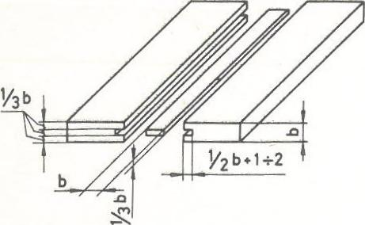
Figure. 97. Connection "on a foreign tongue„

The rebate joints are most often used for making smooth overlapping plating (on the so-called rebate) or gluing the sides for small boats, and the joints "for a foreign tongue" when making cockpit walls, hatch covers, flap stroke or engine housings on larger yachts. aesthetic appearance and the fact that the joints remain tight even during shrinkage of the wood. When joining long boards with a rebate joint or "on a foreign tongue", you need to use a mechanical circular saw or milling machine, while when making shorter reb joints, you can proceed as shown in figure 98.

a)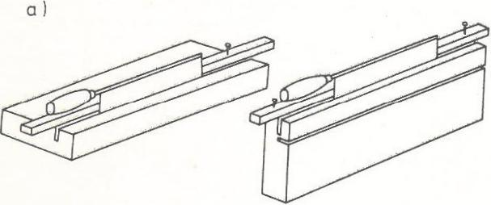
b)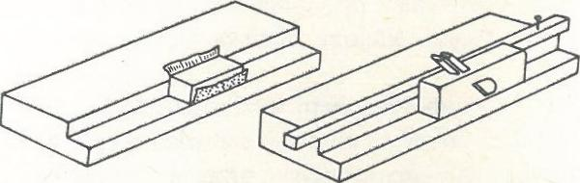
c) 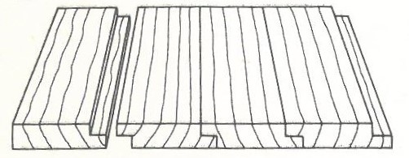
Figure 98. Rebate joint; a) cutting a circle with a ridge; b) flattening and sanding the frame; c) ready connection

Parallel butt joints are used to connect elements lengthwise. Of these connections, three are most often used, namely a bevel without a profile, commonly known as a bevel, an overlap connection, and a skew butt joint. Bevelling is used for joining boards for the keel, stem, sternframe and for joining plywood sheets. The rule should be that the bevel length is equal to or greater than ten times the thickness of the joined element. Frontal parallel connections are shown in figure 99.

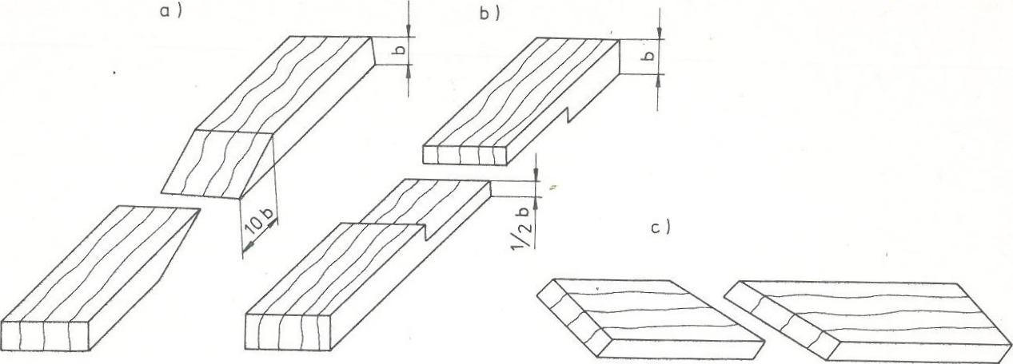
Figure 99. Parallel front connections; a) no-profile miter; b) simple overlap; c) contact oblique

The lap joint is used, for example, when joining stringers, and the butt joint is used to join the straw sheathing to connect "straws" along the length. The most reliable of the corner joints is the fin and groove joint This joint prevents warping of the wood and prevents it from swelling and shrinking. The fin joints are shown in figure 100.

a)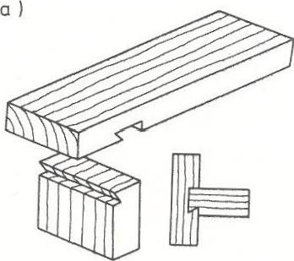b)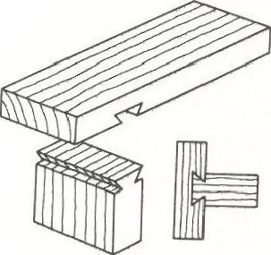
Fig. 100. Fin joint; a) unilateral; b) two-sided

When making this connection, the element with the fin is processed first. In this element, at the joint, a perpendicular cut is made with the help of a ridge (along the auxiliary guide bar), and then a miter is made with a flat chisel.
When making a fin groove, both the outer and inner edges of the groove are marked on the wood surface. Starting from the inside edges, the slope of the groove is cut with a back saw, and then the wood marked by the saw cut is removed with a chisel. Another solution used is a socket and spigot connection. The socket and spigot connection are shown in figure 101.

a)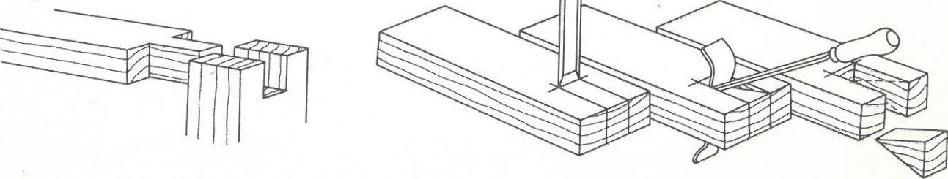b)
Figure 101. Socket and spigot connection; a) finished tenon and seat; b) making the nest

The width of the seat and spigot should be at least one third of the board thickness. Sockets are always made in vertical elements, and pivots in horizontal elements. Still other joints of this kind are the dovetail and dovetail joints. This type of connection is made when connecting elements exposed to high tensile or compressive forces. The workflow for cutting fingers and dovetails is shown in figure 102.

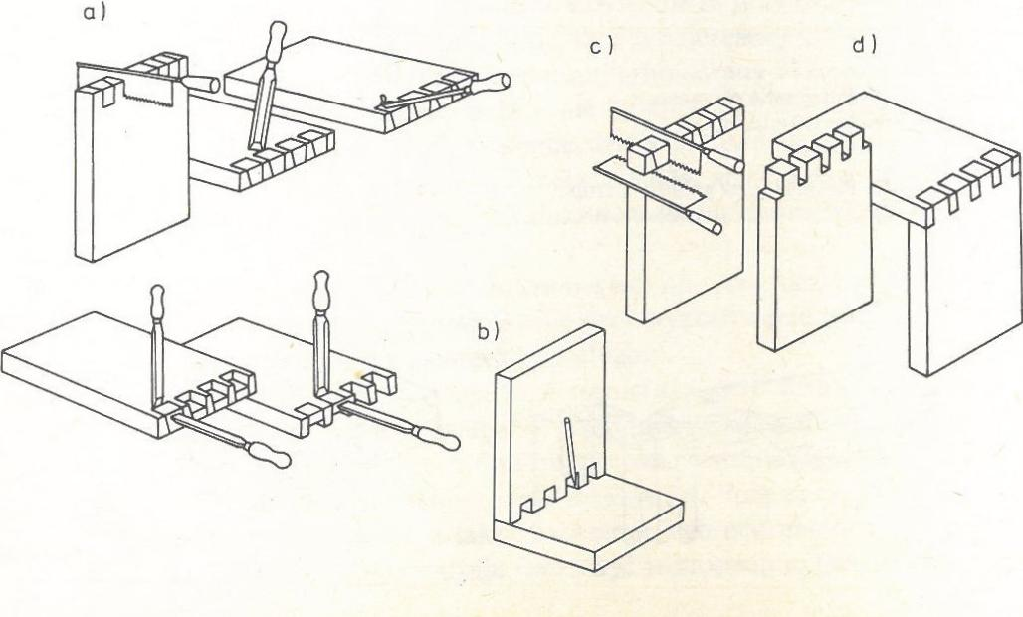
Figure 102. Finger and dovetail joint: a) making dovetails, b) finger tracing, c) cutting a dovetail, d) ready connection

9.1.2. use of nails
First, the fingers are machined (with a back and a flat chisel) and then the fingers, which must be fitted to the ready-made joints. Apart from gluing and carpentry joints, many different metal connectors are used in boatbuilding to connect elements. The most frequently used are nails, rivets, screws and bolts, while rivets and screws are also used to connect metal parts. The correct hammering of nails were shown in figure 103.

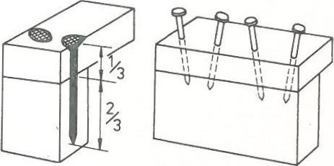
Figure 103. Correct hammering of nails

Nails are most often used to fasten the slats to each other with the straw sheathing, to fasten the deck plywood in conjunction with gluing, for example, to connect the boards or plywood across the sides. Nails used to build boats should be copper or zinc plated or cadmium plated. The mere hammering of nails, which seems easy, requires some skill and meeting several conditions. If you want to hammer the nail in, you should put it diagonally in the right, previously marked place, where you can better see the marked point when applying the nail in this way, then position it vertically and hold.
When two boards are joined together perpendicularly, the nail is held correctly if 1/3 of its length is on the upper board and 2/3 on the lower board (on the left figure). If the nail enters the other board from the front side, it does not provide a very tight connection. In order to strengthen this connection, nails should be hammered diagonally, alternately with the left and right bevel (on the right figure).
With thin boards or strips, nails often break. This can be avoided by drilling small holes under the nails or by cutting off the ends of the nails. Another way is to compress the nails, which is achieved by hitting the sharp end of the nail placed on the washer with its head down several times with a hammer.
When nails are to provide an exceptionally strong connection - for example, when joining boards or plywood to the side - nails should be used that are longer than the total thickness of the joined elements. The tips of the nails protruding on the other side are bent into the shape of a hook with a hammer and a round bar, an old file or a thick nail, and then the hook goes into the wood. The Bending nails with a rod was shown in Figure 104).
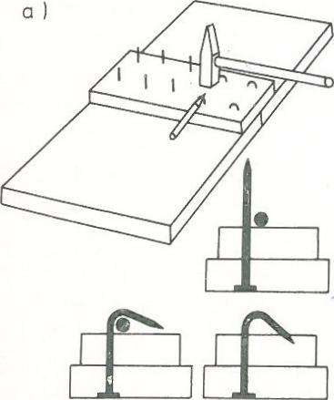
Figure. 104. Bending nails with a rod;

Nail bending is used not only when joining elements on the overlay, but also in the case of bevelling, when the length of the bevel is less than required. The bending process can be simplified by drilling a hole in the hammer head slightly larger than the diameter of the nails being bent and then bending them as shown in Figure 105.

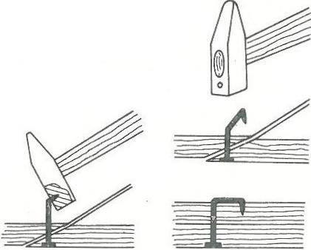
Figure 105. Bending nails with a hammer with a hole

In case when the nail head is to be invisible, then it should be plunged 2-3 mm into the wood with a punch, and the hole should be smoothed. This process is presented in figure 106.

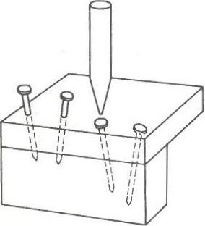
Figure 106. Driving nails

When removing a curved nail with pliers, a board with dimensions of approximately 5x5 cm should be placed under the pincers next to the nail. In this way, first of all, better operation of the lever is obtained, and secondly, by distributing the pressure over the entire surface of the board, wood dents are avoided. This process is presented in figure 107.

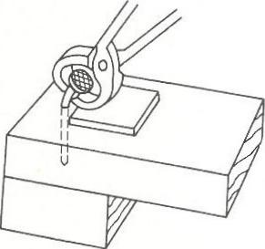
Figure 107. Nail pulling

9.1.3. Drilling and riveting
The basic metal fasteners in boatbuilding are screws. The connection with screws is a very durable connection, provided that you follow a few basic rules regarding the selection of the size of the screws and the method of screwing them in. The first rule is that it holds the joint better with more small screws than with fewer large screws. The second rule: screws of different lengths are used for the same elements made of hard and soft wood. Screws are smaller for hardwood than for softwood. According to the third rule, you should never hammer the screws in with a hammer, because they only hold the screw for which the appropriate hole has been drilled.
The drilling operation itself is quite laborious and requires high accuracy. First, a hole is drilled with a diameter slightly smaller (for softwood) or equal (for hardwood) and a depth corresponding to the length of the unthreaded part of the screw. Secondly, a hole is drilled for the threaded part. The diameter of this hole should correspond to the diameter of the screw core, measured approximately in the middle of its length. The third hole is a drilling with a diameter slightly larger than the screw head and the depth depending on how deep the screw head is to be recessed. For the pegs, the cornices must be deeper. The correct way of making holes for screws is shown in figure 108.
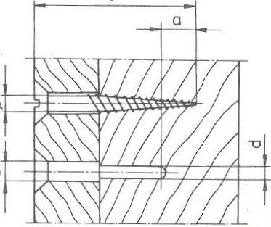
Figure 108. Proper driving of screws into wood
(for very large screws a = 0)

These holes - called cornices - are drilled only in hardwood and when the screw head is to be pinched, e.g. when making sheathing. The drilling diameters depending on the screw diameter and the type of wood (hard or soft) are given in Table 1.

Table 1. The drilling diameters
Screw diameters [mm] | Hard wood |  | Soft wood
 | D  [mm] | d  [mm] | D  [mm] | d  [mm]
2.7  3.0  3.5  4.0  4.5  5.0  5.5  6.0  8.0 | 2.8  3.2  3.6  4.2  4.6  5.2  5.8  6.2  8.2 | tap  tap  tap  2.5  3.2  3.2  3.5  4.0  4,8 | tap  tap  tap  tap  4.5  5.0  5.5  6.0  8,0 | tap  tap  tap  tap  tap  tap  3.2  4.0  4.8

Drilling holes for screws can also be made with a special, triple drill, with which all three holes of different diameters are made at once. Such a drill should be made of steel sheet with a thickness of 1.5 mm. First, a blade (I) is cut from the sheet, which has three essential dimensions: dimension “a” equal to the diameter of the drill hole under the screw head, dimension "b" equal to the diameter of the unthreaded part of the screw and dimension "c" equal to the diameter of the threaded part of the screw measured in the middle of the length thread. After making the blade, sharpen its edges with a fine saw, and then turn the part of the drill with dimensions "b" and "c" to the right by a small angle of about 5°. Next, make a mandrel (2) of 30 mm long. This shank is used to fix the drill bit in the drill chuck. At one end of the shank, cut a 1.5 mm wide and 7 mm deep groove with a hacksaw into which the upper part of the drill is inserted and then both parts are drilled out with a drill bit diameter 2.5 mm Both parts are riveted with a rivet 2.5 mm in diameter Special triple drill bit for drilling for screws was presented in figure 109.

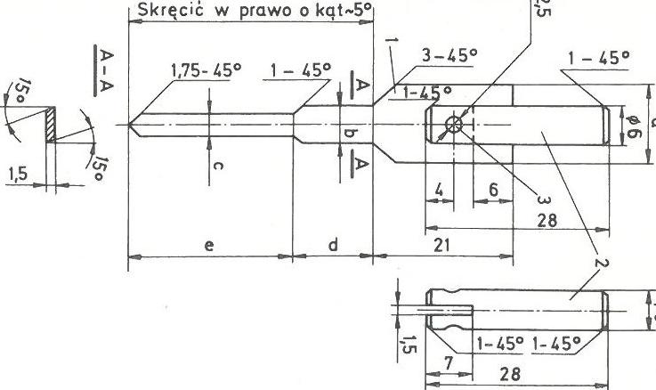
Figure 109. Triple drilling bit for screws; 1 - drill blade, 2 - mandrel, 3 - rivet

After the drill is made, be sure to harden it by heating a gas stove over the burner and immediately putting it in cold water. Examples of dimensions of such drills for screws with diameters of 4, 5, 6, 8 mm are given in Table 2.

Table 2. Blade dimensions
Screw diameters [mm] | Blade dimensions [mm]
 | a | b | c | d | e
4  5  6  8 | 8.5  10  12  16 | 3.8  4.8  5.8  7.8 | 3  3.5  4  5.5 | depending on the length of the screw, equal to the length of the unthreaded part of the screw | depending on the length of the screw, equal to the length of the unthreaded part or slightly knit

When you need to use a small number of screws, the best way is to use a screwdriver with a suitable blade, and for more screws - with a carpenter's crank with an appropriate screwdriver bit. The blade of the screwdriver should be selected so that its width is equal to the diameter of the screw head and that it fits into the head groove without play. This prevents the screw heads from being injured and can be tightened tightly. To facilitate the path of the screws, you can coat them with soap or a drop of varnish before screwing them in.

For drilling holes to a specific depth (e.g. for screws), a simple limiter can be made, which will ensure a constant drilling depth. Such a limiter can is also made of hard wood, e.g. oak, beech or ash. It has the shape of a cylinder (2) with a diameter approximately twice the diameter of the drilled hole. Drill a hole in the roller with a drill bit (3), which will then be used to drill the required holes. After drilling, the cylinder should be cut to the required length, then put on the drill bit and you can continue to work with the certainty that all holes will have the same depth. The limiter made of metal has several advantages, first of all, it can be moved on the drill and fixed in any position with a screw (4), and thus the depth of the drilled hole can be freely adjusted. Drilling holes to a certain depth using the limiter is shown in figure 110.

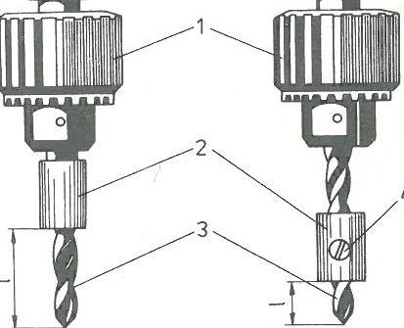
Figure 110. Drilling holes to a certain depth; a) fixed limiter; b) movable limiter 1 - drill spindle, 2 - limiter, 3 - drill, 4 - locking screw

When it is necessary to screw a screw in a hard-to-reach place, where you cannot put your hand in, it is enough to insert the screwdriver blade into the groove in the screw head and fix it with a piece of plaster or adhesive tape. If most of the adhesive sticks to the screwdriver, then after screwing in the screw, the adhesive can be removed together with the screwdriver. The Driving screws in hard-to-reach places was presented in figure 111.

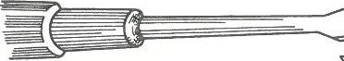
Figure 111. Driving screws in hard-to-reach places

The connection with rivets is inseparable - to remove them, you have to destroy the rivets by cutting their heads. In boatbuilding, riveting is most often used to install the plating and attach the stringers to the frames. Long, nail-like copper rivets and washers made of the same material are used for riveting. Both of these elements can be made by yourself with fairly simple tools. The tool for making rivets and nails is shown in figure 112.

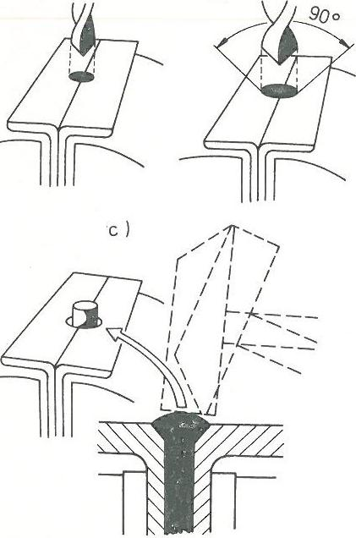
Figure 112. The method of making copper rivets or nails;
a) drilling a hole, b) performing a boring for the rivet head, c) making the rivet head.

To make it, you need two pieces of steel angle, approximately 4 mm thick and 30 mm wide or more. Place the two pieces of the angle bar together with the sides to each other and twist in a vice, and then drill a hole at the joint with a diameter of 0.5 mm smaller than the diameter of the rivet or nail (a). These holes can be drilled more, which will allow you to make several rivets at the same time. Then use a metal drill bit with a diameter equal to the required diameter of the rivet head to drill the hole needed to form this head (b). Between both parts of the angle bar, cut pieces of copper wire are inserted in such a way that they protrude from the top along the length of about 1.5 times the rivet diameter, and then the whole is tightly twisted in a vice. The last step is shaping the rivet head, which is performed with light blows of the hammer (its sharp and blunt edge) in such a way that it fills the entire boring in the angles without delamination or cracks (c).
The rivet washer die is also a tool used in boatbuilding and useful in building a boat. The die of rivet washers should be made of steel and hardened. Two punches should also be made for the die, one of which is used to cut the washer itself, and the other to punch a hole in it and give it a cup-shaped shape. The sheet is inserted into the slot in the die, then the first punch is used to cut the washer, and then the second cutter to cut the hole in the washer. The washer must have a concave shape and an outer diameter approximately four times the diameter of the rivet, and the hole in it must be such that the rivet passes through it tightly. The tool for cutting rivet washers is presented in figure 113.

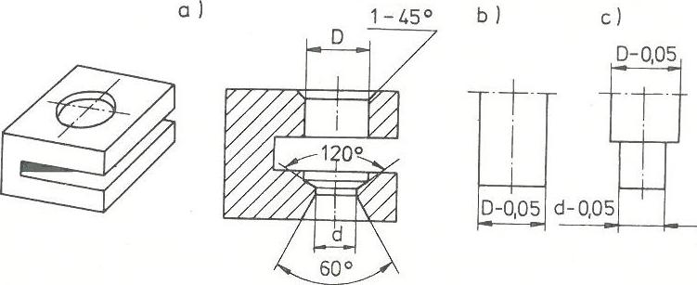
Figure 113. A device for cutting rivet washers; a) die, b) washer cutter, c) hole cutter

To improve the riveting process, it is worth making one more tool, the so-called a hammer-tapping block that is used to hold the rivet head while riveting. This device is made with an ordinary hammer, whereby it must first be quenched by heating to a high temperature and put aside for some time to cool slowly. In the hammer head, drill a hole with a diameter of 10-15 mm (depending on the diameter of the rivet head) and a depth of about 30 mm. Then, the tapping block itself should be bored with an outer diameter equal to the hole in the hammer, and the other end of the tapping block should be rolled to the diameter of the rivet head. The tapping block is pushed into the hole in the hammer and it is ready for riveting. The Riveting of wooden elements was presented in figure 114.

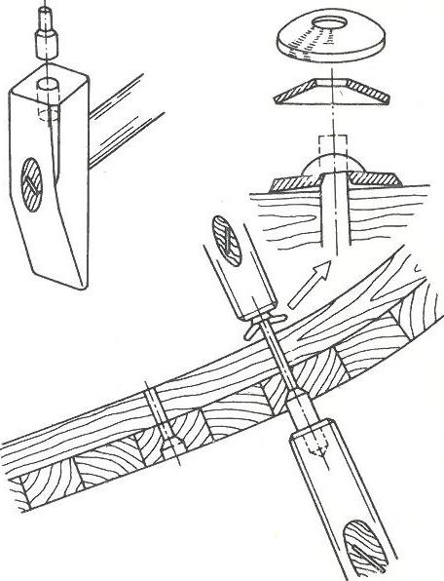
Figure 114. Riveting of wooden elements; a) tapping litter; b - riveting process

Riveting (e.g. of the sheathing) is performed in such a way that the frame and the sheathing are first drilled through with a bit smaller than the rivet's diameter, and then from the outside with a bit slightly larger than the rivet head. The drilling depth should be 3-6 mm. From the sheathing side, hammer the rivet, put a washer from the inside and pull out the free end of the rivet as far as it will go. One person places a hammer-tapping block under the head of the rivet, and the other person uses a hammer to tap the free end of the rivet. The flattened end of the rivet and the straightening pad pull the joined elements together.

Literature
Appel, H.R., Wender, I . & Miller, R .D. (1969). Conversion of urban refuse to oil. U .S. Bureau of Mines, Technical Progress Report 25.
Appel, H.R., Fu, Y .C., Illing, E .G., Steff gen, F .W. & Miller, R .D. (1975). Conversion of cellulosic wastes to oil. U .S. Bureau of Mines, echnical Progress Report RI 8013,27.
Burmester, V.A. (1973). E ffect of heat-pressure treatments of semi-dry wood on its dimensional stability. Holz als Roh- und Werkstoff, 31(6):237-243.
Freed, S .A. & Bab y, R .S. (eds.) (1983). La grande aventure des Indiens d´Amérique du Nord. (The great adventure of Indians in North America.) Sélection du Reader’s Digest, Cop. Paris, IS BN 2-7098-0074-8.
Garrote, G ., Domínguez, H. & Parajó, J.C. (1999). Hydrothermal processing of lignocellulosic materials. Holz als Roh- und Werkstoff, 57(3):191-202.
Gefeller, B., Pizzi, A., Zanetti, M., Properzi, M., Pichelin, F ., Lehmann, M. & Delmotte, L . (2004). Solid wood joints by in situ welding of structural wood constituents. Holzforschung, 58(1):45-52.
Haller, P. & Wehsener, J. (2004). Festigkeitsuntersuchungen an Fichtenpressholz (FPH). (Investigation of the strength of compressed wood of pine.) Holz als Roh- und Werkstoff, 62(6):452-454.
Heger, F . (2004). Etude du phénomène de l’élimination de la mémoire de forme du bois densifié par posttraitement thermo-hydro-mécanique. (Study of the phenomenon of the elimination of the shape memory by thermo-hydro-mechanical post-processing of densified wood.) PhD. T hesis N o. 3004, EPFL , Lausanne, Switzerland.
Hill, C. (2006). Wood modification – Chemical, thermal and other processes. John Wiley & Sons, Ltd. West Sussex, England, IS BN 0-470-02172-1.
Hon, D .N.-S. (ed.) (1996). Chemical modification of lignocellulosic materials. Marcel Dekker, Inc., New York and Basel, IS BN 0-8247-9472-9.
Hon, D .N.-S. & Shiraishi, N . (eds.) (1991). Wood and cellulosic chemistry. Marcel Dekker, Inc., New York and Basel, IS BN 0-8247-8304-2.
Inoue, M., Norimoto, M., Tanahas hi M. & Rowell, R .M. (1993). S team or heat fixation of compressed wood. Wood and Fiber Science, 25(3):224-235.
Ito, Y ., Tanahas hi, M., Shigematsu, M. & Shinoda, Y . (1998a). Compressive-molding of wood by highpressure steam-treatment: Part 2. Mechanism of permanent fixation. Holzforschung, 52(2):217-221.
Ito, Y ., Tanahashi, M., Shigematsu, M., Shinoda, Y . & Otha, C. (1998b). Compressive-molding of wood by high-pressure steam-treatment: Part 1. D evelopment of compressively molded squares from thinnings. Holzforschung, 52(2):211-216.
Kamk e, F .A. (2004). A novel structural composite from low density wood. I n: Proceeding of the 7th Pacific Rim Bio-Based Composites Symposium. N anjing, China, pp. 176-185.
Kamk e, F .A. & Sizemore, H. (2005). Viscoelastic thermal compression of wood. US Patent Application No. US 2005/0006004A1.
Khamousk i, A.N. (1999). Handicrafts, a means of expanding jobs, social justice. Iran Commerce Magazine,
Kollma nn, F . (1936). Technologies des Holzes. (Wood technology.) Verlag von Julius S pringer, Berlin.
Kutnar, A., Kamk e, F .A. & Sernek, M. (2008a). T he mechanical properties of densified VTC wood relevant for structural composites. Holz als Roh- und Werkstoff, 66(6):439-446.
Kutnar, A., Kamk e, F .A., Nairn J.A. & Sernek, M. (2008b). Mode II fracture behavior of bonded viscoelastic thermal compressed wood. Wood and Fibre Science, 40(3):362-373.
Kyomori, K., Shigema tsu, M., Onwona-Agyema n, S . & Tanahas hi, M., (2000). Virtual models of the molding process of wood compressed by the high-pressure steam technique: towards the development of an aid-system for designing and manufacturing. I n: Proceedings of the 6th International
Symposium on Virtual System and Multimedia (VSMM 2000), T hawahites, H., (ed.). Gifu, Japan, pp. 403-408.
Morsing, N . (2000). Densification of wood: The influence of hygrothermal treatment on compression of beech perpendicular to the grain. PhD. T hesis N o. R 79, Department of Structural Engineering and Materials, Technical University of D enmark.
Navi, P. & Girardet, F . (2000). E ffects of thermo-hydro-mechanical treatment on the structure and properties of wood. Holzforschung, 54(3):287-293.
Navi, P. & Heger, F . (2005). Comportement thermo-hydromécanique du bois. (Behaviour of thermo-hydromechanical processed wood.) Presses polytechniques et universitaires romandes, L ausanne, IS BN 2-88074-620-5.
Navi, P., Girardet, F ., Vulliemin, P., Spycher, M. & Heger, F . (2007). Effects of post-treatment parameters on densified wood set-recovery. I n: Proceedings of Third International Symposium on Wood
Machining, N avi, P. & Guidoum, A., (eds.). PPUR , Lausanne, Switzerland, pp. 69-72.
Norimoto, M. & Gril, J. (1993). S tructure and properties of chemically treated woods. I n: Recent Research on Wood and Wood-based Materials, Shiraishi, N ., Kajita, H. & Norimoto, M., (eds.). E lsevier, Barking, U K, pp. 135-154.
Ormarss on, S . & Sandberg, D . (2007). Numerical simulation of hot-pressed veneer products: moulding – spring-back – distortion. Wood Material Science and Engineering, 2(3/4):130-137.
Pizzi, A., Leba n, J.-M., Zanetti, M., Pichelin, F ., Wieland, S . & Properzi, M. (2005). S urface finishes by mechanically induced wood surface fusion. Holz als Roh- und Werkstoff, 63(4):251-255.
Rapp, A.O. & Sailer, M. (2001). O il heat treatment of wood in Germany: state of the art. I n: Review on heat treatment of wood. Proceedings of special seminar of Cost Action E22: Environmental Optimization of Wood Protection, R app, A. (ed.), Antibes, France, pp. 45-62.
Rapp, A.O., Brischke, C. & Welzbacher, C.R. (2006). Interrelationship between the severity of heat treatments and sieve fractions after impact ball milling: a mechanical test for quality control of thermally modified wood. Holzforschung, 60(1):64-70.
Schrepfer, V. & Schweingruber, F .H. (1998). Anatomical structures in reshaped press-dried wood. Holzforschung, 52(6):615-622.
Shigematsu, M., Fuka ya, M., Sasak i, Y . & Tanahas hi, M. (1998). Three dimensional image analysis on molding process of wood compressed by high-pressure steam technique. I n: Future fusion: Application realities for the virtual age. Proceedings of 4th International Conference on Virtual Systems and Multimedia, (VSMM’98), Thwaites, H., (ed.), Ohmsha, Tokyo, vol.2, IS BN4-274-90268-4, pp. 372-379.
Stamm, A.J. (1964). Wood and cellulose science. T he R onald Press Company, New York.
Stamm, A.J. & Seborg, R .M. (1941). R esin-treated, compressed wood. Transaction of the American Institute of Chemical Engineers, 37:385-397.
Stamm , A.J, Burr, H.K. & Kline, A.A. (1946). S taywood. Heat stabilized wood. Industrial and Engineering Chemistry, 38(6):630-634.
Stamm , B. (2006). Development of friction welding of wood – physical, mechanical and chemical studies. PhD. Thesis N o. 3396, E PFL , Lausanne, Switzerland.
Stamm , B., Natterer, J. & Navi, P. (2005). Joining wood by friction welding. Holz als Roh- und Werkstoff, 63(5):313-320.
Stevens, W.C. & Turner, N . (1970). Wood bending handbook. Woodcraft supply Corp., Woburn, US A.
Suthoff, B., Schaaf , A., Hentschel, H. & Franz, U . (1996). Method for joining wood. O ffenlegungsschrift DE 19620273 A1. D eutsches Patenamt.
Tanahas hi, M. (1990). Characterization and degradation mechanisms of wood components by steam explosion and utilization of exploded wood. Wood Research, 77:49-117.
Tanahashi, M., Kyomori, K., Shigema tsu, M. & Onwona-Agyema n, S . (2001). D evelopment of compressive molding process of wood by high-pressure steam and mechanism of permanent fixation for transformed shape. I n: First International Conference of the European Society for Wood Mechanics, Navi, P., (ed.). L ausanne, S witzerland, pp. 523-524.
Vorreiter, L . (1949). Holztechnologisches Handbuch, Band I. (Wood technology handbook, volume 1.) Verlag G eorge F romme & Co., Wien.
Welzba cher, C.R., Wehsener, J., Rapp. A.O. & Haller, P. (2008). T hermo-mechanical densification combined with thermal modification of N orway spruce (Picea abies Karst.) in industrial scale: Dimensional stability and durability aspects. Holz als Roh- und Werkstoff, 66(1):39-49.
Yao, Y ., Yoshioka , M. & Shiraishi, N . (1994). S oluble properties of liquefied biomass prepared in organic solvents I . T he soluble behavior of liquefied biomass in various diluents. Mokuzai Gakkaishi, 40(2):176-184.
Abbott, M . (1989). Green Woodwork. Working with wood the natural way. Guild of M aster Craftsman Publications L td., East Sussex, IS BN 0-946819-18-1.
Aldred, C. (1954). F ine wood-work. I n: Singer, C., Holmyard, E .J., & Hall, A.R. (eds.). A history of technology. Volume 1: From early times to fall of ancient empires. Oxford University Press, New York, London.
Adler, B. (1902). D ie Bogen N ordasiens. (The bow from north Asia.) Internationales Archive für Ethnographie, 15:1-27.
Belter, J.H. (1847). Machinery for sawing arabesque chairs. U .S. Patent N o. 5208.
Belter, J.H. (1856). Bedstaed. U .S. Patent N o. 15552.
Belter, J.H. (1858). Improvement in the method of manufacturing furniture. U .S. Patent N o. 19405.
Belter, J.H. (1860). Bureau. U .S. Patent N o. 26881.
Bevington, J.H. (1891). Spinning tubes. U .S. Patent N o. 444 721.
Bramwell, M . (ed.) (1976). The international book of wood. M itchell Beazley Publisher Ltd., London, IS BN 0-85533-081-3.
Bugge, A. (1953). Norwegian stave churches. D reyers F orlag, O slo.
Claesson Rålamb, Å. (1691). Skepsbyggerij eller adlig öfning tionde tom. (Shipwrightry or noble practice.), Stockholm.
Crumlin-Pedersen, O . (1970). S kind eller T ræ. (Skin or wood.) I n: Hasslöf, O ., Henningsen, H. & Christensen,
A.E. (eds.). Sømand, fisker, skib og værft: introduktion til maritim etnologi. (Sailor, fisherman, ship and shipyard: introduction to maritime ethnology.) R osenkilde og Bagger, Copenhagen, IS BN 87-505-0072-4.
Crumlin-Pedersen, O . & Olsen, O . (eds.) (2002). The Skuldlev ships I. Topography, archaeology, history, conservation and display. Volume 4.1 in the series S hips and Boats of the North, T he Viking Ship Museum, R oskilde, IS BN 87-85180-467.
Diener & Roth (1941). Ein Faβ. (One barrel.) D iener & R oth F assfabrik in S tuttgart.
Digby, A. (1954). Boats and ships. I n: S inger, C., Holmyard, E .J. & Hall, A.R. (eds.) (1954). A history of technology. Volume 1: From early times to fall of ancient empires. Oxford U niversity Press, New York, London.
Dunbar, M . (1984). Make a Windsor chair with Michael Dunbar. T he T aunton Press, Newtown, Connecticut, ISBN 0-918804-21-3.
Edlin, H.L. (1949). Woodland crafts in Britain. An account of the traditional uses of trees and timbers in the British countryside. B. T . Batsford LTD , L ondon.
Exner, W.F. & L auboeck, G. (eds.) (1922). Das Biegen des Holzes. Ein für Möbelfabrikanten, Wagen- und Shiffbauer, Böttcher und anderen wichtiges Verfahren. (Wood bending, an important process for furniture makers, wagon- and shipbuilder, coopers and others.) 4th ed. Verlag von Vernh. F riedrich
Voigt, L eipzig. Gragg, S . (1808). Elastic chair. U .S. Patent, Boston M A 31 august, 1808. (The Patent O ffice records concerning this patent were destroyed in the 1836 fire. The full patent is not now available in the Patent Office records, but can be found at James M adison U niversity, Carrier L ibrary.)
Godal, J.B. (1995). T he use of wood in boatbuilding. I n: O lsen, O ., S kamby M adsen, J., & Rieck, F . (eds.) (1995). Shipshape – essay for Ole Crumlin-Pedersen on the occasion of his 60th anniversary, February 24th 1995. pp. 271-283, R oskilde, Denmark.
Godley, A.D. (tr.) (1920-1925). Herodotus. The Persian wars (books 1-9). L oeb classical library, volumes 1-4.
Halldin, G. (ed.) (1963). Svenskt skeppsbyggeri – en översikt av utvecklingen genom tiderna. (Swedish shipwrightry – an overview of the development through the ages.), Allhems F örlag, M almö, S weden.
Hebert, L . (1848). The Engineers and mechanics Encyclopædia: Comprehending practical illustrations of the machinery and processes employed in every description of manufacture of the British Empire. Thomas Kelly, L td, London.
Henning, A. (1942). D as S chweissen thermoplastischer Kunststoffe. D eutsche R eich Patent 739 340, 1938. (The welding of thermoplastic materials.) Kunststoffe, 32:103-109.
Holan, J. (1990). Norwegian wood – a tradition of building. R izzoli I nternational Publications, I nc., New York, IS BN 0-8478-0954-4.
Hort, A. (tr.) (1916). Theophrastus. Enquiry into plants (book 5). Loeb classical library, volume 1. 5th ed. 1990, Harvard U niversity Press, L ondon, IS BN 0-674-99077-3.
Indruszewski, G. (2004). Man, ship, landscape. Ships and seafaring in Oder mouth area AD 400-1400.
A case study of an ideological context. PNM , Publications from the N ational M useum, Studies in Archaeology & History, Vol. 9, Copenhagen.
Insulander, R . (1997). T he F enno-Urgian two-wood bow – a missing link. Bulletin of primitive technology, 14(2):35-39.
Insulander, R . (1998). T jurved – ett historiskt material med framtida potential. (Compression wood – a historical material with potential.) Flora och Fauna, 93(4):175-178, ISSN 0014-8903.
Insulander, R . (1999). D en samiska pilbågen rekonstruerad: en jämförande analys av fynd från S verige, Norge och F inland. (Reconstruction of the saami bow: a comparsion between finding in Sweden, Norway and F inland.) Fornvännen, 94(2):73-87, ISSN 0015-7813.
Kilby, K. (1971). The cooper and his trade. John Baker L td, L ondon, IS BN 0-212-98399-7.
Killen, G. (1994). Egyptian woodworking and furniture. S hire E gyptology S eries N o. 21, S hire Publication Ltd., Buckinghamshire, IS BN 0-7478-0239-4.
Killen, G. (2000). Wood – Procurement and primary processing. I n: N icholson, P.T. & Shaw, I . (eds.).
Ancient Egyptian materials and technology. Cambridge U niversity Press, Cambridge, pp. 353-368, IS BN 0-521-45257-0.
Knight, E .V. & Wulpi, M . (eds.) (1927). Veneers and plywood. Their craftmanship and artistry, modern production methods and present-day utility. T he R onald Press Company, New York.
Kollmann, F . (1955). Technologie des Holzes und der Holzwerkstoffe. Zweiter Band. (Technology of wood and wood products. S econd volume.) S pringer-Verlag, Berlin.
Latham, B. (1957). Timber – Its development and distribution. A history survey. George G. Harrap & Co, Ltd, L ondon.
Lauer, J.-P. (1933). F ouilles du service des antiquités à saqqarah (secteur nord, Novembre 1932-mai 1933). (Excavations of the D epartment of Antiquities at S aqqara (north sector, N ovember 1932-May 1933)) Annales du service des antiquités de L’Égypte, 33:155-166.
Lesko, L .H. (1994). Pharaoh’s workers: The villagers of Deir el Medina. Cornell University Press, I thaca, London, IS BN 0-8014-2915-3.
Linné, C.v. (1732). I ter L apponicum. D ei gratia institutum 1732. I n: S mith, J.E. (1811). Lachesis Lapponica or a Tour in Lapland, now first published from the original manuscript journal of the celebrated Linnaeus. L ondon.
Linné, C.v. (1737). Flora Lapponica. (The flora of L apland.) S chouten, Amsterdam.
Luca s, A. (1936). T he wood of the third dynasty, ply-wood coffin from S aqqara. Annales du service des antiquités de L’Égypte, 36:1-4.
Makkonen, O . (1969). Ancient forestry: an historical study. Part II : the procurement and trade of forest products. Acta Forestalia Fennica, 95:1-46.
McGrail, S . & McKee, E . (1974). Building and trials of the replica of an ancient boat: the Gokstad færing. Part 1. Building the boat. N ational M aritime M useum, M aritime M onographs and reports, N o. 11.
McGrail, S . (ed.) (1982). Woodworking techniques before A.D. 1500. Papers presented to a symposium at Greenwich in September, 1980, together with edited discussion. National Maritime Museum, Greenwich, Archaeological S eries N o. 7, BAR I nternational S eries 129, IS BN 0-8605-4159-2.
Montet, P. (1946). La vie quotidienne en Egypte au temps des Ramsès. (Daily life in Egypt in the time of Ramses.) L ibrairie Hachette.
Newberry, P.E. (1893). Archaeological survey of Egypt, Part I. Beni Hasan. Griffith F .L. (ed.), Kegan Paul, T rench, T rübner & Co L td., L ondon.
Nicolaisen, I . & Damgård-Sørensen, T . (1991). Building a longboat. An essay on the culture and history of a Bornean people. T he Viking S hip M useum, R oskilde, D enmark, IS BN 87-85180-16-5.
Nikkilä, E . (1947). En satakundensisk Äsping och dess europeiska motsvarigheter. (A satakundensisk Äsping (a type of boat) and its E uropean analogues.) Folk-liv: Acta Ethnologica Europaea, 11:33-46.
Olsen, O . & Crumlin-Pedersen, O . (1967). A report of the final underwater excavation in 1959 and the salvaging operation in 1962. Acta Archaeologica, 38:73-174.
Ostergard, D .E. (1987). Bent wood and metal furniture 1850-1946. T he American F ederation of Arts, New York, IS BN 0-295-96409-X.
Petrie, W.M.F. (1933). E gyptian S hipping. Ancient Egypt and the east, I:1-14.
Podmaniczky, M . (2003). T he incredible elastic chairs of S amuel Gragg. Magazine Antiques, 165(May):138-146.
Rackham, H. (tr.) (1945). Pliny. Natural History (books 12-16). Loeb classical library, volume 4. 5th revised ed. 2005, Harvard U niversity Press, L ondon, IS BN 0-674-99408-6.
Rausing, G. (1967). The bow: Some notes on its origin and development. Acta Archaeologica L undensia, No. 6, L und, S weden.
Reed, L .M. (1890). Heater for cooperage purposes. U .S. Patent N o. 426325.
Richter, G.M.A. (1966). The furniture of the Ancient Greeks, Etruscans and Romans. Phaidon, L ondon.
Rivers, S . & Umney, N . (2005) Conservation of furniture. E lsevier, Butterworth-Heinemann, O xford, ISBN 0-7506-09583.
Rosenberg, G. (1937). Hjortspringfundet. (The Hjortspring find), N ordiske F ortidsminder 3(1), Gyldendal, Copenhagen.
Schefferus, J. (1673). Lapponia. ex officina Christiani Wolffii, F rankfurt am M ain.
Schwartz, M .D., Stanek, E .J. & True, D .K. (1981). The furniture of John Henry Belter and the rococo revival. E. P. Dutton, N ew Y ork, IS BN 0-525-93170-8.
Sentance, B. (2003). Wood – the world of woodwork and carving. T hames & Hudson L td., L ondon, IS BN 0-500-51120-9.
Šimoníková, J. (1992). The furniture of Bystřice pod Hostýnem. T on, Bent wood furniture factories, Bystřice pod Hostýnem, Czech R epublic.
Singer, C., Holmyard, E .J. & Hall, A.R. (eds.) (1954). A history of technology. Volume 1: From early times to fall of ancient empires. O xford U niversity Press, N ew Y ork, L ondon.
Steinway, C.F.T. (1880a). Screw-clamp for wood-bending machines. U .S. Patent No. 229198.
Steinway, C.F.T. (1880b). Upright piano-forte. U .S. Patent N o. 230354.
Steinway, C.F.T. (1885). Piano-frame. U .S. Patent N o. 314742.
Suthoff, B., Schaa f, A., Hentschel, H. & Franz, U . (1996). Verfahren zum reibschweißartigen Fügen von Holz. (Method for joining wood.) O ffenlegungungsschrift DE 196 20 273 A1. D eutsches Patent und M arkenamt.
Suthoff, B. & Kutzer, H.-J. (1997). Verfahren zum reibschweißartigen Verbinden von Holz. (Method for joining wood.) O ffenlegungungsschrift DE 19746 782 A1. D eutsches Patent und M arkenamt.
Tarn, W.W. (1948). Alexander the great, Volume II. Sources and studies. (Appendix 24), Cambridge University Press, Cambridge.
Twede, D . (2005). T he cask age: the technology and history of wooden barrels. Packing Technology and Science, 18(5):253-264.
Vegesac k, A.v. (1987). Das Thonet Buch. (The T honet book.) Bangert Verlag, M ünchen, IS BN 3-925560- 09-2.
Vegesac k, A.v. (1996). Thonet – Classic furniture in bent wood and tubular steel. Hazar Publishing L td., London, IS BN 1-874371-26-1.
Vill, V.I. & Shternin, L .A. (1957). The basic technology of friction welding. (translated title) Glavelektroadard 4.
Vill, V.I. (1959). F riction welding of metals. (translated title) Mashgiz, Moskow Leningrad.
Vinson, S . (1994). Egyptian boats and ships. S hire E gyptology series No. 20, S hire Publication L td., Buckinghamshire, UK, IS BN 0-7478-0222-X.
Ward, C. (1976). Boat-building and its social context in early E gypt: interpretations from the First Dynasty boat-grave cemetery at Abydos. Antiquity, 80(307):118-129.
Åström, K. (1993). S kidan från Kalvträsk. (The ski from Kalvträsk.) Västerbotten, 74(3):129-131, ISSN 0346-4938.

